Black Honey

Announce brand new album ‘Written & Directed’
Due January 29th 2021

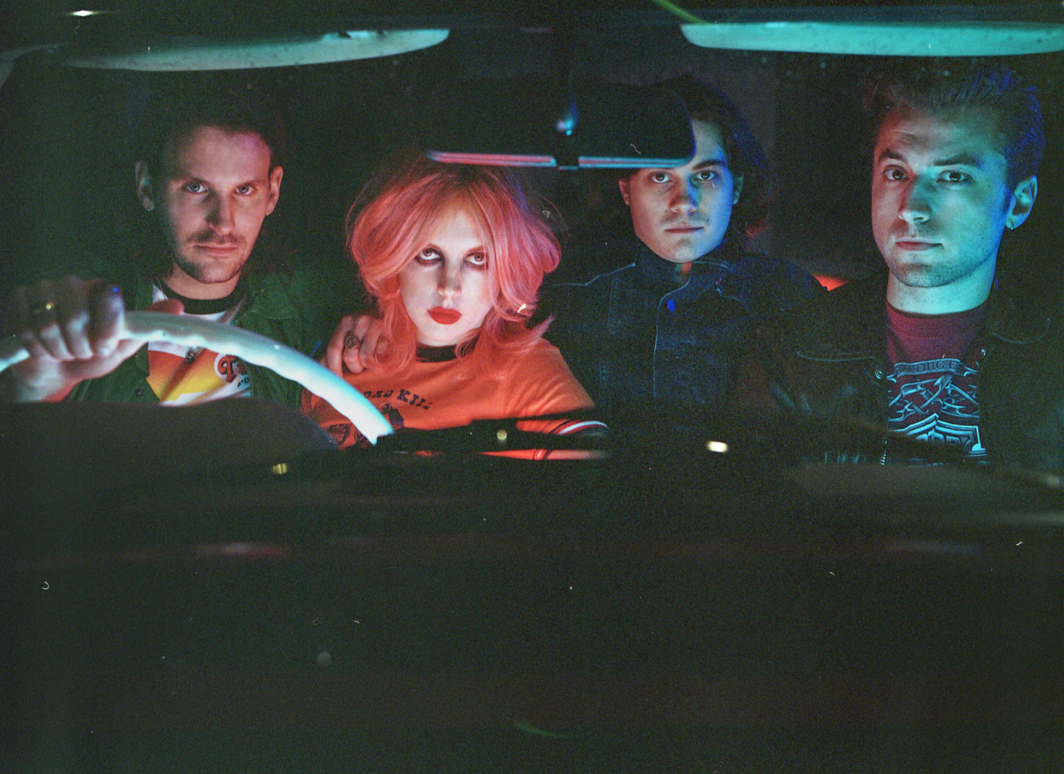

“I made this record for young women to feel invincible.”
Izzy B. Phillips, Black Honey

Having last week been pre-empted by the landing of their colossal new single ‘Run For Cover’, today Black Honey have announced their brand-new album – ‘Written & Directed’. ‘Written & Directed’ will be released on the 29th of January 2021 on Foxfive Records – you can pre-order it HERE (add link).

‘Written & Directed’ is Black Honey’s second album. It follows their outstanding self-titled debut released back in 2018 when the world that surrounded the Brighton fourpiece looked and felt like a very different place. Black Honey however are still the bad-ass, truly original band they have always been, they’ve just graduated from the intriguingly anomalous newcomers to becoming one of UK indie’s most singular outfits. They've travelled the world and released a Top 40 album; graced the cover of the NME and become the faces and soundtrack of Roberto Cavalli's Milan Fashion Week show; smashed Glastonbury and supported Queens of the Stone Age, all without compromising a shred of the wild, wicked vision they first set out with.

It's now time for the next instalment of their story – ‘Written & Directed” – which see’s Black Honey deliver one, very singular, message – a 10 track mission statement that aims to unashamedly plant a flag in the ground for strong, world-conquering women. For fierce frontwoman and album protagonist Izzy B. Phillips – it’s the most important message she could send to inspire her cult-like fanbase and fill the female-shaped gap that she felt so acutely when she was growing up and discovering rock music for the first time.

Written throughout 2019 and recorded in fits and spurts between touring, ‘Written & Directed’ is drenched with a hedonistic, anything-goes attitude. It’s also the most full-throttle collection of music that Black Honey have ever-written – egged-on by their run of shows supporting long-term friends and collaborators Royal Blood. Exploring everything from womanhood, to identity and power, it’s an album that revels in the rich history of pop culture, throws a wink to its rock-and-roll heroes, but ultimately (and in true Black Honey fashion) it stands on its own two feet.

With a typically hyper-visual world referencing grindhouse cinema, kitschy pulp films and a flip-reverse of female cinematic representation all primed to unfurl and explode around them, 'Written & Directed' is the sound of Black Honey strapping in and saddling up, of harnessing their quirks, and, as the Phillips has always hoped, riding them joyously into the sunset.

- I Like The Way You Die
- Run For Cover
- Beaches
- Back Of The Bar
- Believer
- I Do It To Myself
- Disinfect
- Summer ‘92
- Fire
- Gabrielle

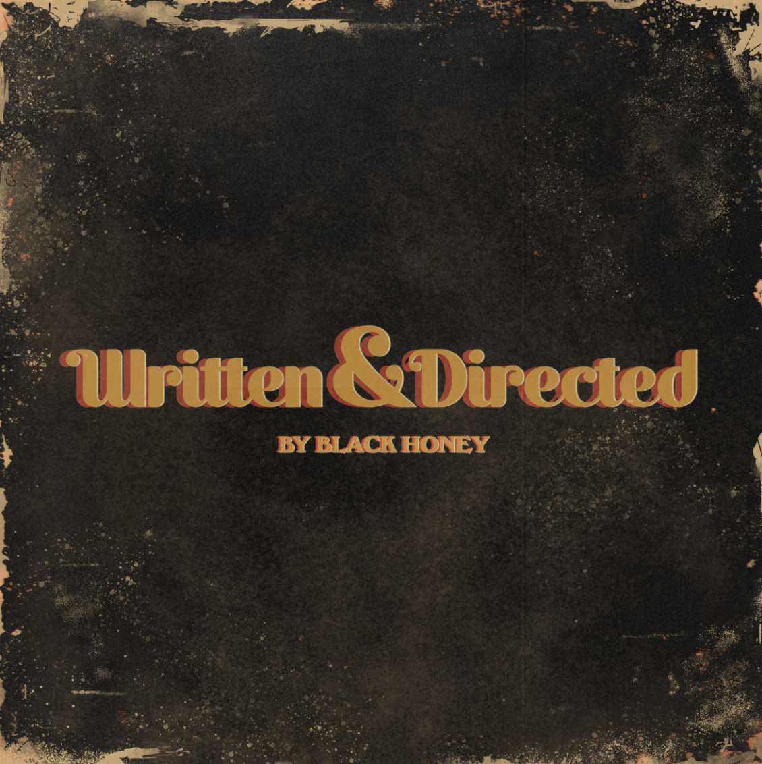

Follow Black Honey
Facebook | Instagram | Spotify | Twitter | Website

For more info contact warren@chuffmedia.com on 07762 130510

