THE WHO
‘WHO’

BRAND NEW ALBUM FROM THE LEGENDARY ROCK BAND RELEASED 22nd NOVEMBER 2019
ON POLYDOR RECORDS

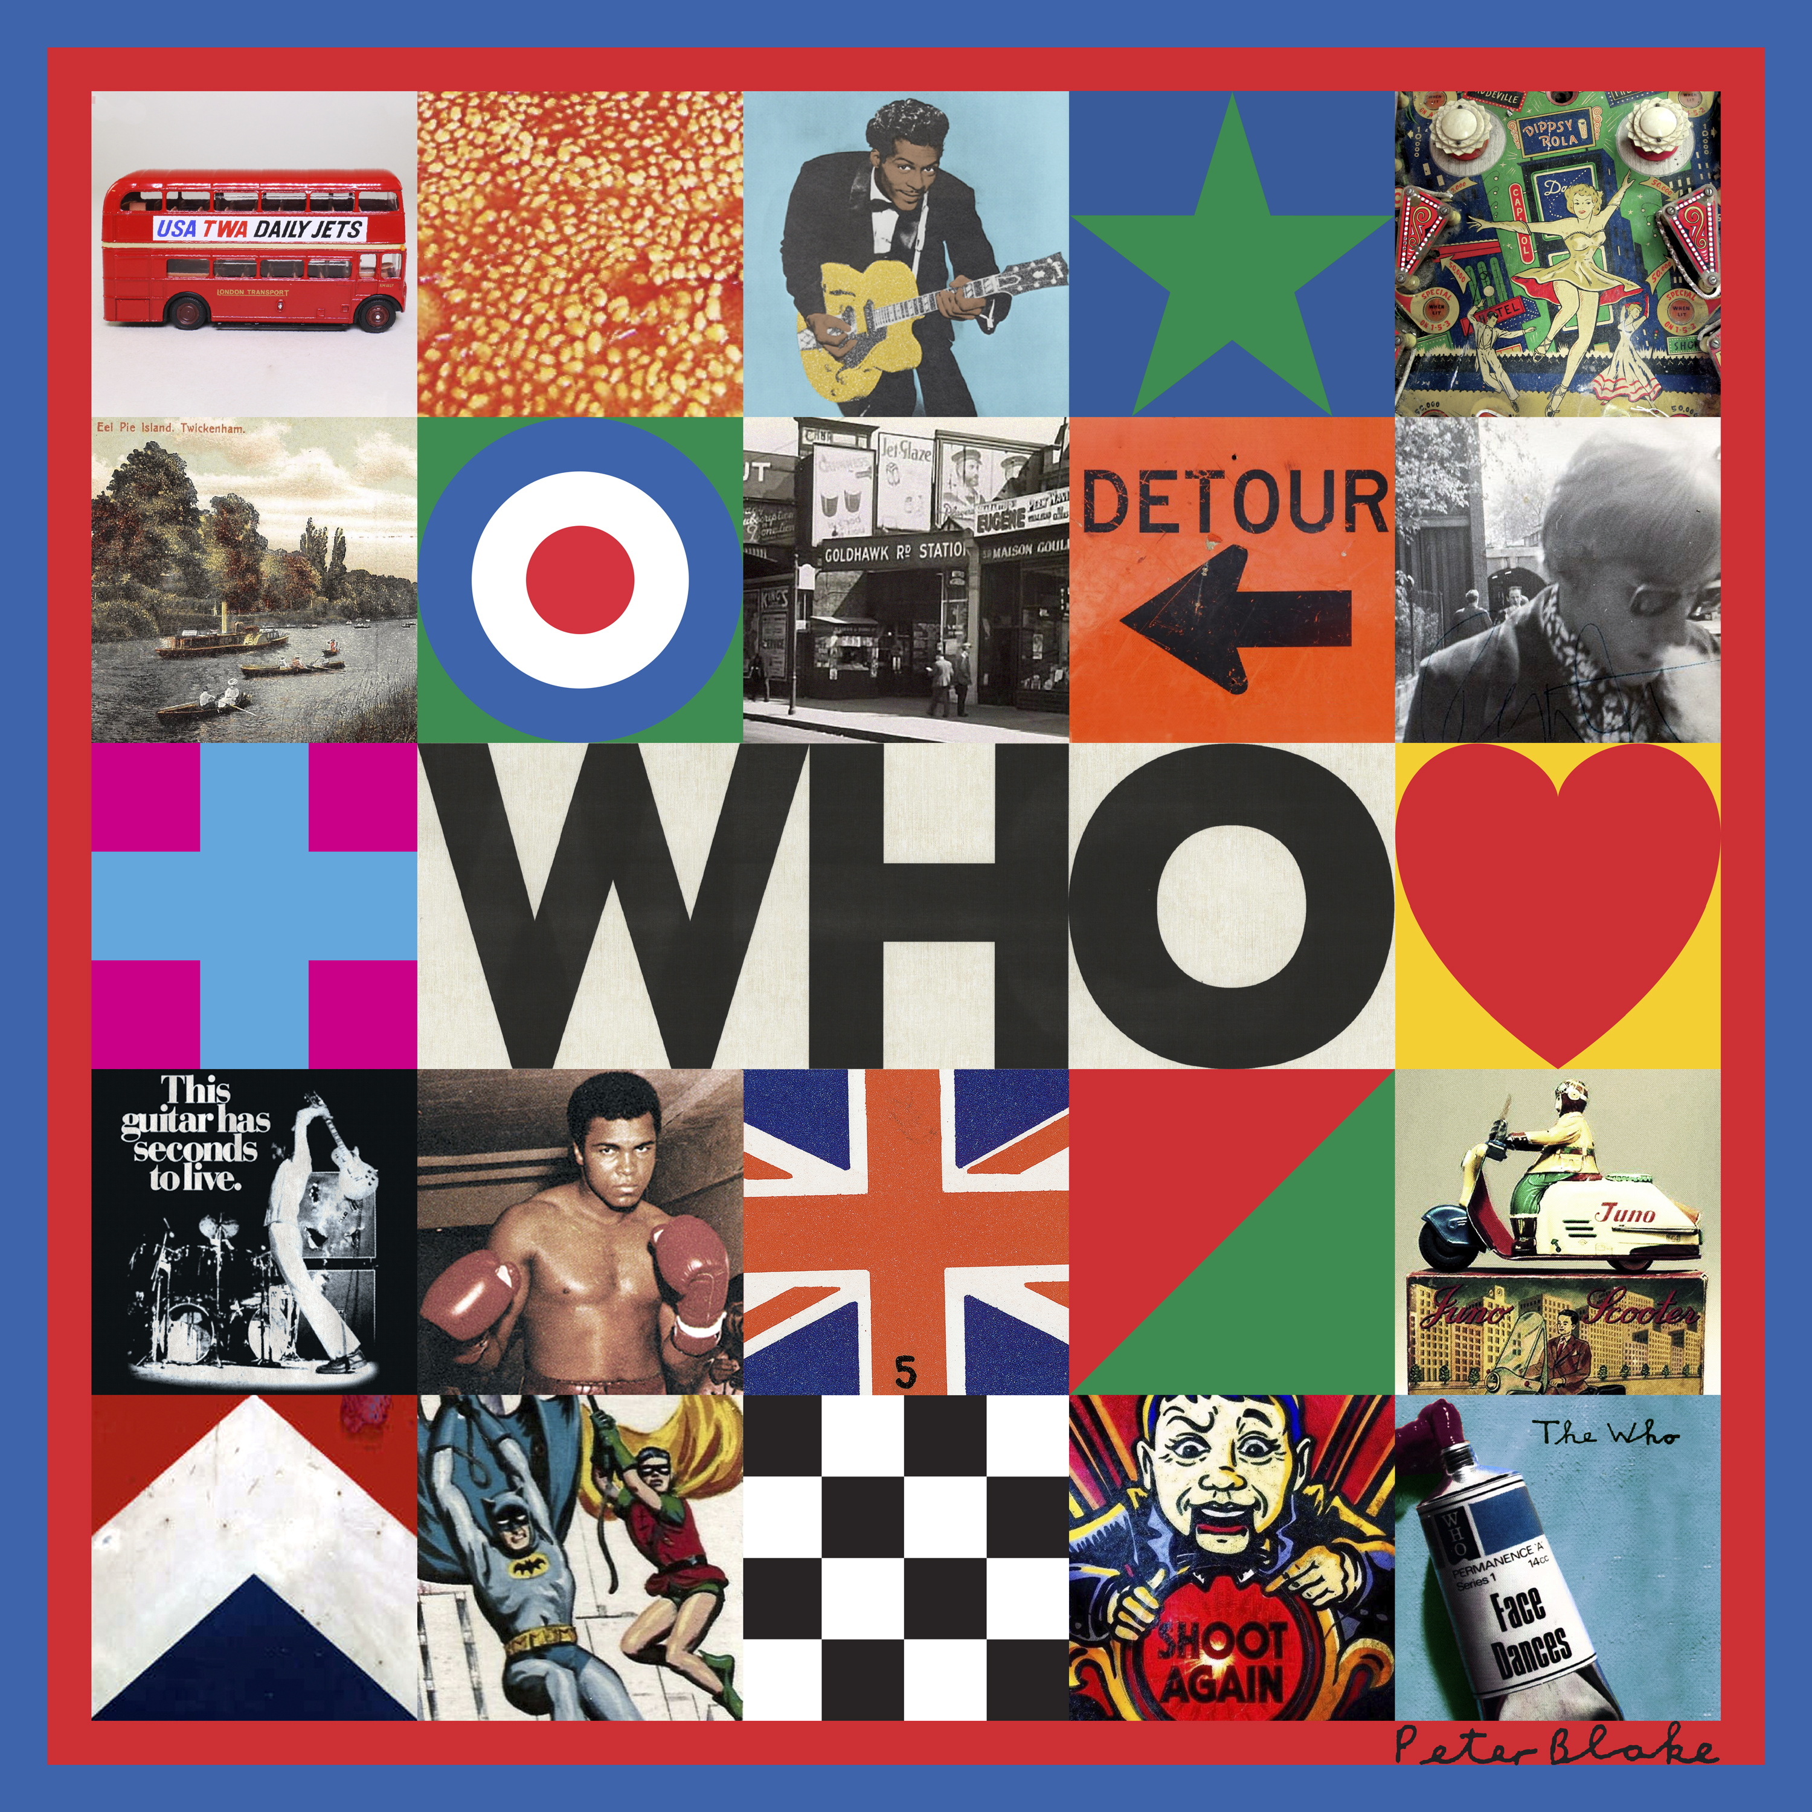

FIRST ALBUM IN THIRTEEN YEARS AVAILABLE ON LTD EDITION DOUBLE VINYL / DIGITAL / CD & CASSETTE ANNOUNCED AT ARTWORK UNVEILING AT THE PACE GALLERY IN NEW YORK

‘BALL & CHAIN’ AVAILABLE ON ALL STREAMING SERVICES NOW

PRE-ORDER THE ALBUM NOW http://thewho.lnk.to/NewAlbumWE

UK TOUR WITH A FULL ORCHESTRA - SPRING 2020

LONDON 13th September 2019 The Who has one of the greatest rock legacies in music history, they’re one of the all-time great live bands, have sold over 100 million records world including 9 US & 10 UK top ten albums and 14 UK top ten singles in a career spanning six decades.

Now Fifty-five years after they made their first recordings, The Who is back with their first new album in thirteen years entitled WHO due for release on 22nd November 2019 and is preceded by BALL AND CHAIN, which is available on all streaming services now.

The eleven-track album was mostly recorded in London and Los Angeles during Spring and Summer 2019 and was co-produced by Pete Townshend & D. Sardy (who has worked with Noel Gallagher, Oasis, LCD Soundsystem, Gorillaz) with vocal production by Dave Eringa (Manic Street Preachers, Roger Daltrey, Wilko Johnson).

Singer Roger Daltrey and guitarist and songwriter Pete Townshend are joined on the album by long-time Who drummer Zak Starkey, bassist Pino Palladino along with contributions from Simon Townshend, Benmont Tench, Carla Azar, Joey Waronker and Gordon Giltrap.

The artwork for WHO was unveiled last night in New York at the opening of the brand new eight-storey Pace contemporary art gallery where the band also performed a short acoustic set. The album cover has been created by famed pop artist, Sir Peter Blake who first met the band in 1964 at a taping of the legendary TV show Ready Steady Go. Sir Peter designed and contributed a painting to the sleeve of The Who’s album Face Dances in 1981.

The songs on WHO cover a myriad of subjects including the Grenfell Tower fire, musical theft, spirituality, reincarnation, the power of memory and ‘an old rock star that has lost his marbles’. Singer Roger Daltrey rates it amongst their strongest “I think we’ve made our best album since Quadrophenia in 1973, Pete hasn’t lost it, he’s still a fabulous songwriter, and he’s still got that cutting edge”.

Pete Townshend "This album is almost all new songs written last year, with just two exceptions. There is no theme, no concept, no story, just a set of songs that I (and my brother Simon) wrote to give Roger Daltrey some inspiration, challenges and scope for his newly revived singing voice. Roger and I are both old men now, by any measure, so I’ve tried to stay away from romance, but also from nostalgia if I can. I didn’t want to make anyone feel uncomfortable. Memories are OK, and some of the songs refer to the explosive state of things today. I made new home studio demos of all these songs in the summer of 2018 using a wide collection of instruments old and new. We started recording as The Who in March 2019, and have finished now in late August just in time to make some vinyl………maybe even some cassettes……ready for release in November”.

Two songs on the record the epic ‘Ball And Chain’ and string-laden ‘Hero Ground Zero’ recently got their world premiere when the band played with a 40-piece orchestra to a packed Wembley Stadium. Spring 2020 will see the band embarking on a UK tour featuring an orchestra, the dates are listed below.

THE WHO ‘WHO’ TRACKLISTING

All This Music Must Fade
Ball And Chain
I Don't Wanna Get Wise
Detour
Beads On One String*
Hero Ground Zero
Street Song
I’ll Be Back
Break The News**
Rockin’ In Rage
She Rocked My World
All songs written by Pete Townshend except
*Pete Townshend/Josh Hunsacker **Simon Townshend
Produced by Pete Townshend & D. Sardy
Roger Daltrey Vocal production Dave Eringa
Mixed by D. Sardy

THE WHO UK TOUR 2020

March 16 – Manchester Arena
March 18 – Dublin 3 Arena
March 21 – Newcastle Utilita Arena
March 23 – Glasgow SSE Hydro Arena
March 25 – Leeds First Direct Arena
March 30 – Cardiff Motorpoint Arena
April 1 – Birmingham Resorts World Arena
April 3 – Nottingham Motorpoint Arena
April 6 – Liverpool M&S Bank Arena
April 8 – SSE Wembley Arena
Tickets go on sale 10am 20th September at https://www.livenation.co.uk/artist/the-who-tickets

Facebook: https://www.facebook.com/thewho
Twitter: https://twitter.com/thewho
Instagram: https://www.instagram.com/thewho/
YouTube: https://www.youtube.com/user/TheWhoVEVO
Website: https://www.thewho.com/
Album pre-sale https://store.thewho.com/

ABOUT THE WHO

The Who are one of the top three greatest rock legacies in music history has sold over 100 million records world including 9 US & 10 UK top ten albums and 14 UK top ten singles.
They have played over well over 2000 gigs in a career spanning over 50 years including venues such as Woodstock, Monterey Pop, Glastonbury (twice), Hyde Park (four times), The Isle Of Wight (three times), Desert Trip, Shea Stadium, The Superbowl half time show and Live Aid to name but a very few.
The band is in the Rock And Roll Hall Of Fame, the UK Music Hall Of Fame and has lifetime achievement awards from The Brits and The Grammys and in 2008 were the first rock band ever to be awarded the prestigious Kennedy Center Honors.
Emerging in the mid-1960s as a new and incendiary force in rock n' roll, their brash style and poignant storytelling garnered them one of music's most passionate followings, with the legendary foursome blazing a searing new template for rock, punk, and everything after.
Inducted into the Rock n' Roll Hall Of Fame in 1990, the band has sold more than 100 million records worldwide, placing 27 top-forty singles in the United States and United Kingdom and earning 17 Top Ten albums, including the 1969 groundbreaking rock opera Tommy, 1971's pummeling Live At Leeds, 1973's Quadrophenia and 1978's Who Are You. The Who debuted in 1964 with a trio of anthems “I Can’t Explain,” “The Kids Are Alright” and “My Generation.” Since then they have delivered to the world hits such as “Baba O’Riley,” “Won’t Get Fooled Again,” “Pinball Wizard,” Who Are You,” and,” You Better You Bet.”
In 2008, they became the first rock band ever to be awarded the prestigious Kennedy Center Honors. The Who has performed all over the world including global music events for the Super Bowl XLIV Halftime Show in 2010 and closing the Summer Olympics in 2012. The Who continued their charity work by playing a concert in January 2011 to raise money for trials of a new cancer treatment called PDT. In December 2012 they performed at the Hurricane Sandy Benefit in New York.
Alongside his groundbreaking work with the Teenage Cancer Trust in the UK, in November 2012 Daltrey, with Townshend at his side, launched Teen Cancer America, $1 from each ticket sold for the 2019 MOVING ON! TOUR which each night features a full orchestra will benefit Teen Cancer America (www.teencanceramerica.org)
With both Roger and Pete delivering their own memoirs in recent years (Pete’s Who I Am was released to much acclaim in 2012, and Roger’s autobiography, Thanks A Lot Mr. Kibblewhite; My Story, was embraced by critics in 2018) it’s fitting that the two remaining WHO members have shared their incredible legacy in literary fashion, for few bands have had a more lasting impact on the rock era and the reverberating pop culture than The Who.

For more information and press enquiries please contact:

Warren Higgins
warren@chuffmedia.com
020 8281 0989

