U2
SONGS OF EXPERIENCE

New studio album 1st December

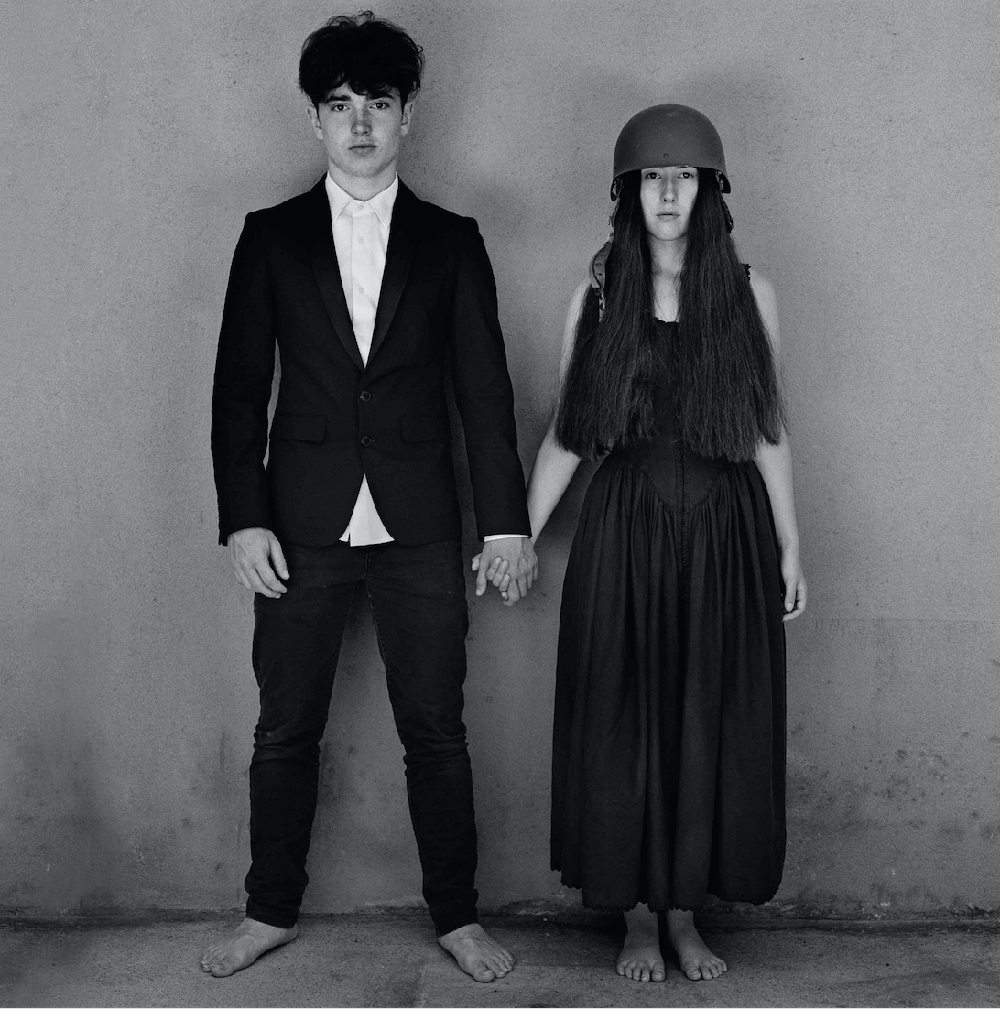

New single ‘Get Out of Your Own Way’ - listen here
https://u2.lnk.to/GetOutOfYourOwnWayPR

North American tour dates announced for 2018

Island Records have announced the release of Songs of Experience, the 14th studio album from U2, which contains 13 new songs and will be released on 1st December 2017 on digital and CD as Standard and Deluxe, and as a double vinyl album.

A new single – the second to be taken from the record – titled ‘Get Out Of Your Own Way’ is out now. First single ‘You’re The Best Thing About Me’ was released on 6th September and album track ‘The Blackout’ was previously released as a performance video in August.

Live Nation have announced U2’s North American dates for the eXPERIENCE + iNNOCENCE Tour running from 2nd May, details below. Further dates to be announced in 2018.

Recorded in Dublin, New York and Los Angeles, Songs of Experience was completed earlier this year with its subject matter influenced by Brendan Kennelly’s* advice to Bono, to “…write as if you’re dead”. The result is a collection of songs in the form of intimate letters to places and people close to the singer’s heart: family, friends, fans, himself.

Songs Of Experience is the companion release to 2014’s ‘Songs Of Innocence’, the two titles drawing inspiration from a collection of poems, Songs of Innocence and Experience, by the 18th century English mystic and poet William Blake.
Produced by Jacknife Lee and Ryan Tedder, with Steve Lillywhite, Andy Barlow and Jolyon Thomas, the album features a cover image by Anton Corbijn of band-members’ teenage children Eli Hewson and Sian Evans.

The full track listing for Songs of Experience is:

1. Love Is All We Have Left
2. Lights of Home
3. You’re The Best Thing About Me
4. Get out of Your Own Way
5. American Soul
6. Summer of love
7. Red Flag Day
8. The Showman (Little More Better)
9.The Little Things That Give You Away
10. Landlady
11. The Blackout
12. Love Is Bigger Than Anything in Its Way
13. 13 (There is a Light)

To pre order the album, along with upcoming tour information, visit www.U2.com

For deluxe tracklistings, visit http://www.u2.com/news/title/new-song-new-album-new-tour

For more information contact Warren, Jenny or Simon @chuffmedia.com
020 8281 0989

Notes to Editors:

*Brendan Kennelly - Irish poet, novelist and Professor Emeritus at Trinity College, Dublin.

U2 eXPERIENCE + iNNOCENCE Tour 2018 ITINERARY

May 2 Tulsa, OK BOK Center
May 4 St. Louis, MO Scottrade Center
May 7 San Jose, CA SAP Center
May 11 Las Vegas, NV T-Mobile Arena
May 15 Los Angeles, CA The Forum
May 22 Chicago, IL United Center
May 26 Nashville, TN Bridgestone Arena
May 28 Atlanta, GA Infinite Energy Arena
June 5 Montreal, QC Bell Centre
June 9 Uniondale, NY NYCB Live Home of the Nassau
Veterans Memorial Coliseum
June 13 Philadelphia, PA Wells Fargo Center
June 17 Washington, DC Capital One Arena
June 21 Boston, MA TD Garden
June 25 New York, NY Madison Square Garden
June 29 Newark, NJ Prudential Center

www.U2.com

