ENTER SHIKARI RELEASE AMBITIOUS NEW ALBUM ‘NOTHING IS TRUE & EVERYTHING IS POSSIBLE’ TODAY

“It's the sound of grand ambition being realised.” **** Q Magazine

“Enter Shikari's most ambitious album yet. The album that will define them for years to come." Kerrang!
“… as the album charges so confidently towards innovation it would be foolish to suggest it’s anything other than brilliant ... they’re now distinct leaders, paving a new and exciting trail for those in their ever-growing shadow.” 8/10 Gigwise

Today Enter Shikari release their ambitious sixth studio album ‘Nothing Is True & Everything Is Possible’, through So Recordings. Listen in full here.

’Nothing Is True & Everything Is Possible’ is a punk, electronic, orchestral opus, produced by Rou Reynolds the renowned frontman at the centre of this pioneering and uncompromising musical force. A poignant soundtrack for the new decade, this is an album about possibility, the unnerving irony of endless possibility, the band asking themselves what they can achieve as the world questions “what is possible?”.

Rou Reynolds comments:

"On one hand, of course we'd love to be able release this album in a less tumultuous period. To be able to tour it around the world and enjoy all the trappings of international rock stardom that we deserve.

But maybe there's something quite apt about releasing this record right now? Forced to promote our grand artistic endeavour via inadequate wifi signal. One would have thought, in recognition of the fact that the exact sort of societal change I've been writing about mankind needing for the past decade is now playing out in real time in our real lives, the Gods would have cut us some slack, but it looks like we're in the same boat as the rest of you. Albeit infinitely more talented.

Stay home, and keep washing those hands (and listen to our record).”

The last decade has seen Enter Shikari’s stature increase year on year, a rare career story which has taken them to 4 Top 10 albums, millions of streams, huge sell out world tours (most recently in Russia and two American), as well as multiple awards, last year crowned Best British Band by Rock Sound, with Best Album from Kerrang! for ‘The Spark’ at 2018’s Awards.

Enter Shikari have announced an extensive UK / European tour for Autumn / Winter 2020 which has seen unrivalled demand. This will be the band’s first headline tour since the mammoth ‘Stop The Clocks’ Tour which ran from December 2018 until April 2019.

UK Tour dates below:

NOVEMBER 2020
Wed 11 UK. Southampton - Guildhall
Thu 12 UK. Manchester - Victoria Warehouse
Fri 13 UK. Cardiff - Great Hall
Sat 14 UK, London - Alexandra Palace
Mon 16 UK. Middlesbrough - Town Hall
Wed 18 UK. Edinburgh - Usher Hall
Thu 19 UK. Nottingham - Rock City
Fri 20 UK. Nottingham - Rock City
Sat 21 UK. Birmingham - O2 Academy

Tickets available here: www.entershikari.com/shows

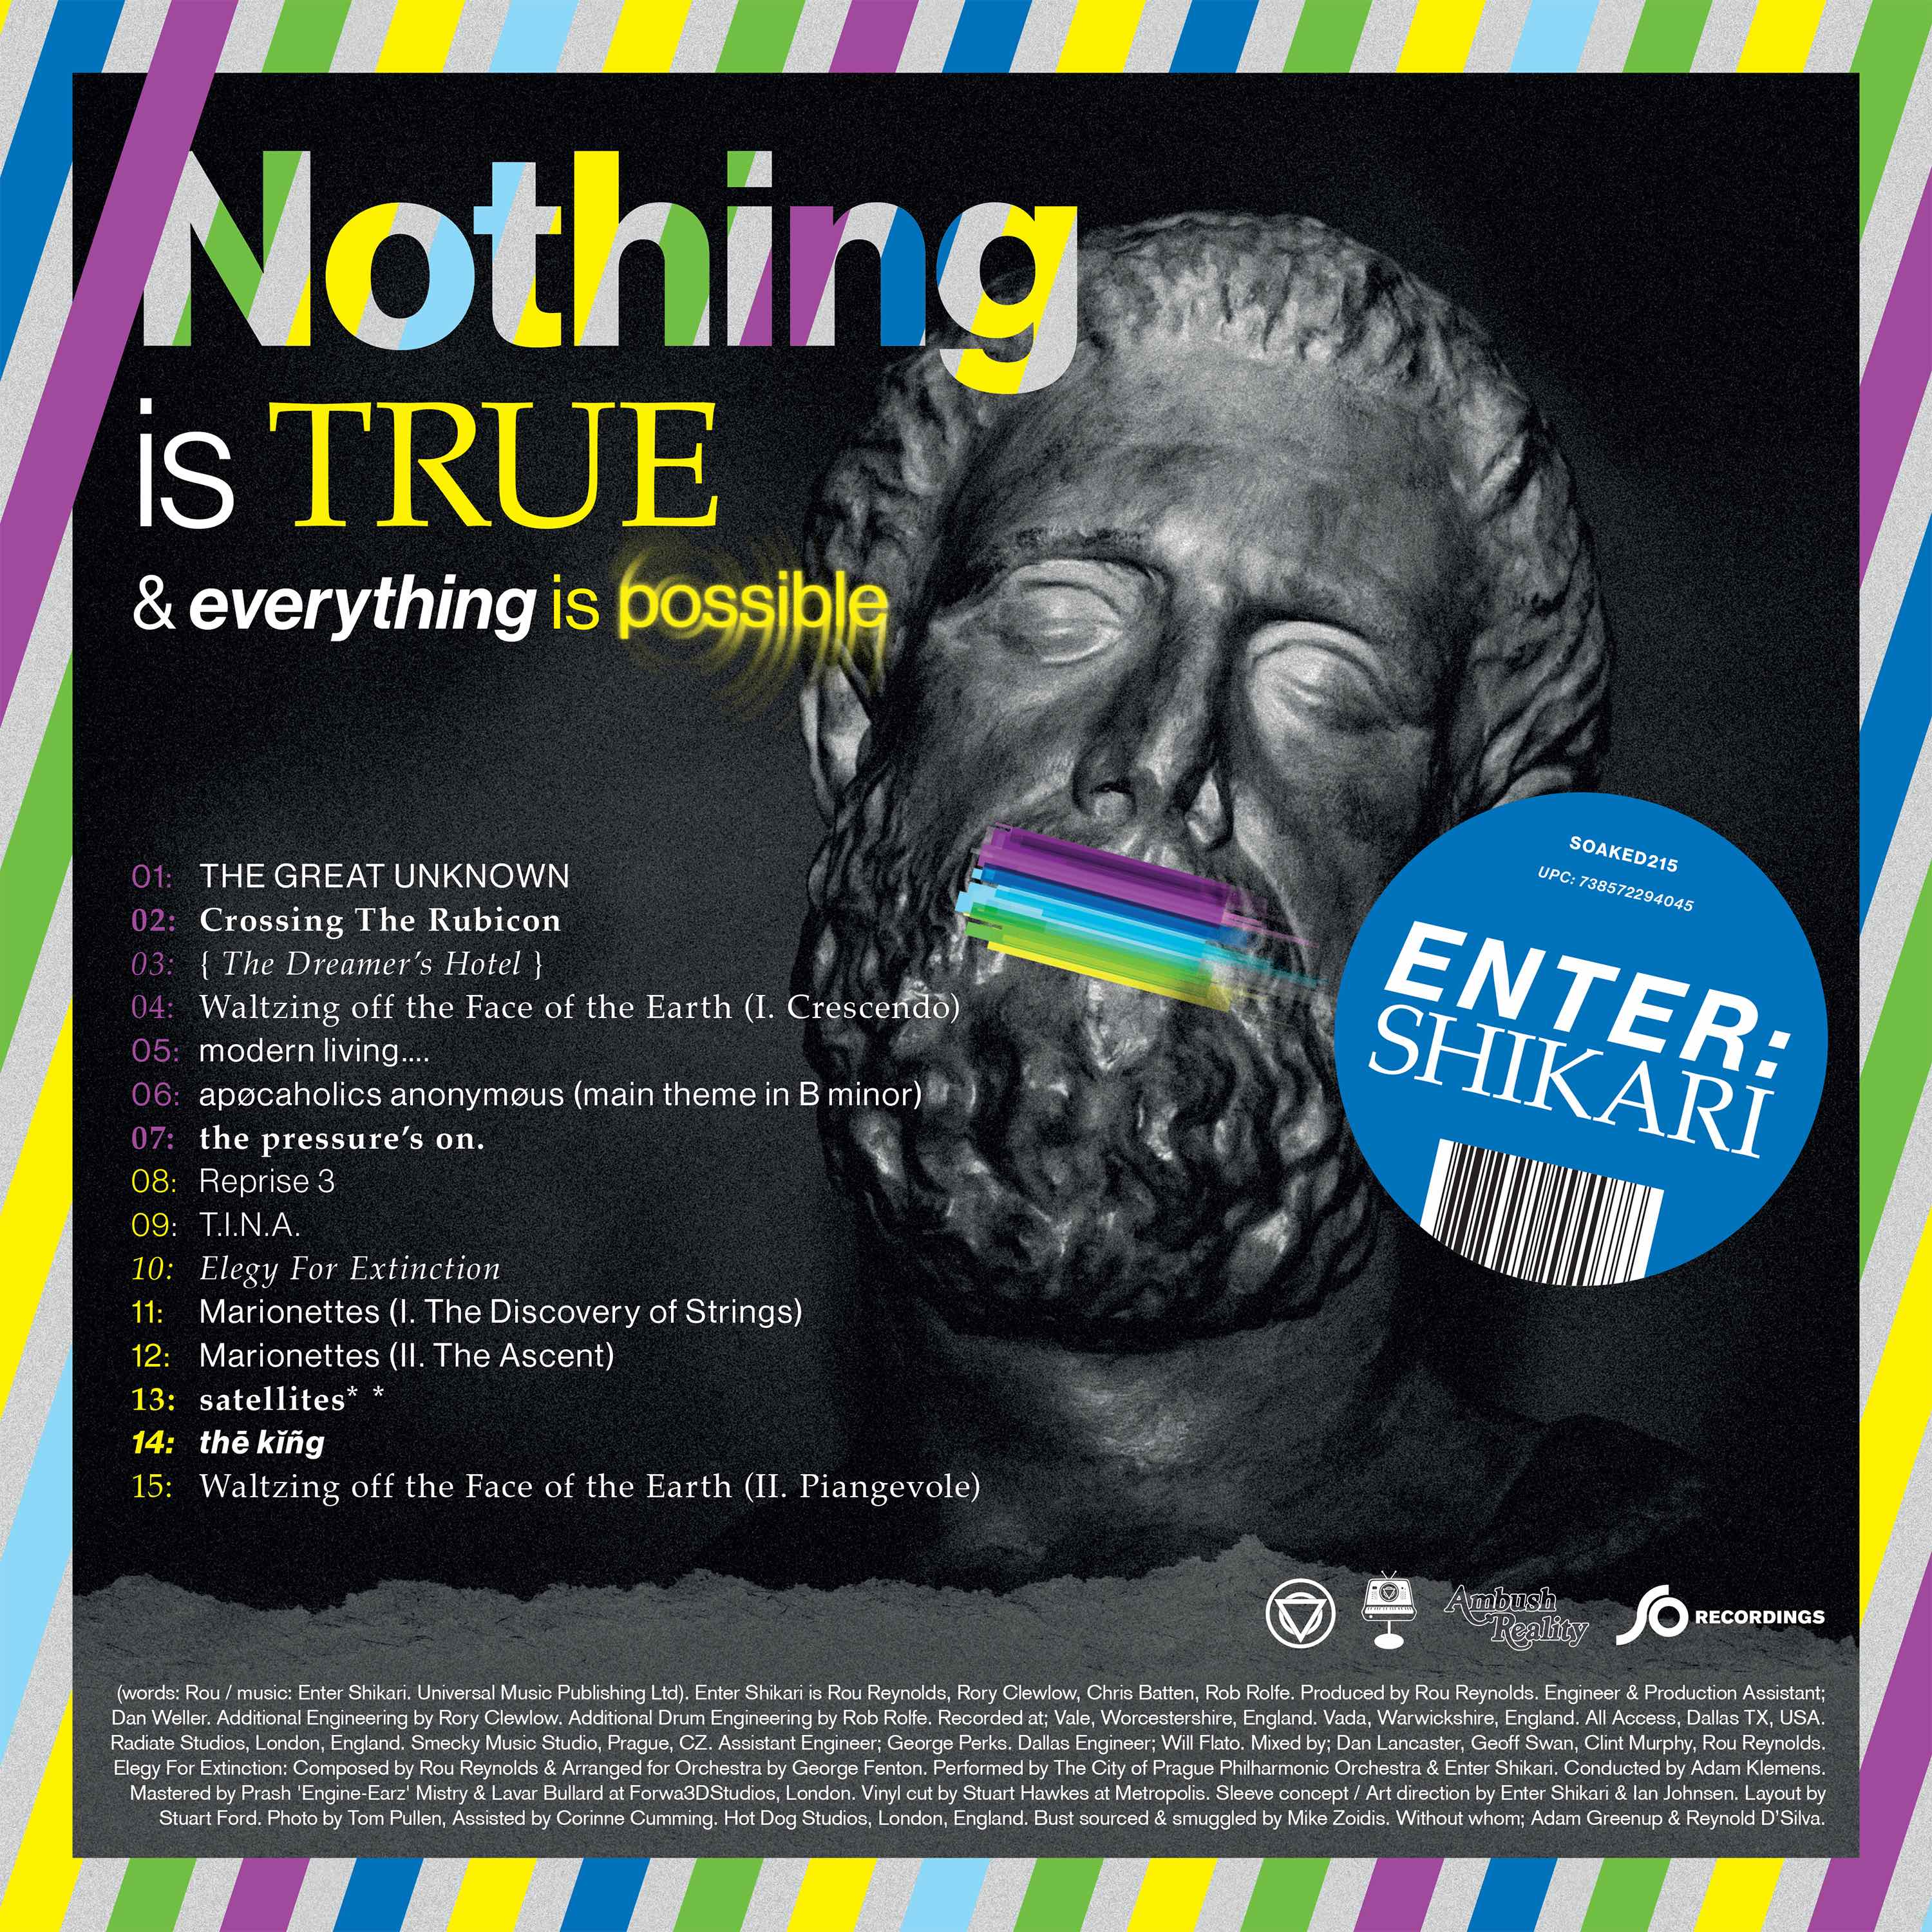

’Nothing Is True & Everything Is Possible’ tracklist:
- 1.The Great Unknown
- 2.Crossing The Rubicon
- 3. { The Dreamers Hotel }
- 4. Waltzing off the Face of the Earth (I. Crescendo)
- 5. modern living…
- 6. apocoholics anonymous (main theme in B minor)
- 7. the pressure’s on
- 8. Reprise 3
- 9. T.I.N.A
- 10.Elegy For Extinction
- 11. Marionettes (I. The Discovery of Strings)
- 12. Marionettes (II. The Ascent)
- 13. satellites
- 14. the king
- 15. Waltzing off the Face of the Earth (II. Piangevole)

Watch ‘The Dreamer’s Hotel’ video

Official Website | Facebook | Twitter | Instagram

For more information and press enquiries please contact:
Jenny Entwistle
jenny@chuffmedia.com
020 8281 0989

