Photo credit: Derek Ridgers (High res)

ENTER SHIKARI ANNOUNCE NEW ALBUM ‘NOTHING IS TRUE & EVERYTHING IS POSSIBLE’

LISTEN TO ‘{ The Dreamers Hotel }’

ENTER SHIKARI TO PLAY 5 SPECIAL INTIMATE UK ALBUM LAUNCH SHOWS

You can’t trust your own eyes
And you only hear lies
Our future’s been denied
And there’s nowhere to hide
Now that nothing is true
And everything is possible

It was all leading to this. The definitive Enter Shikari album ‘Nothing Is True & Everything Is Possible’, released 17 April 2020 through So Recordings. First single ‘{ The Dreamers Hotel }’ premiered as Annie Mac’s Hottest Record last night and is available here. The band will play 5 special intimate UK shows to launch the album. Details below.

‘Nothing Is True & Everything Is Possible’ is produced to dazzling effect by renowned frontman and visionary Rou Reynolds, from a band at the peak of their creative output with a unique story, underlining their 13-year succession as a pioneering and uncompromising musical force. This is an album about possibility, the unnerving irony of endless possibility, the band asking themselves what they can achieve as the world questions “what is possible?”.
’Nothing Is True & Everything Is Possible’ is a lucid soundtrack for a new decade, with a poignant social commentary that expertly leads the listener from pure pop to scorching punk-rock fury, through four-to-the-floor beats and beautiful orchestral composition. ’Waltzing Off The Face Of The Earth’ (I. Crescendo) and (II. Plangevole) draws you into the madness of modern life, “you can’t trust your own eyes, and you only hear lies, our future’s been denied and there’s nowhere to hide now that nothing is true and everything is possible.” ‘Elegy For Extinction’ is a classical gem recorded in Prague with the City Of Prague Symphony Orchestra, and arranged by renowned film & television soundtrack composer George Fenton (Gandhi, Blue Planet, Planet Earth, Groundhog Day, My Name Is Joe), and the first single ‘{ The Dreamers Hotel }’ a lavishly produced anthem.

The inspiration for ’Nothing Is True & Everything Is Possible’ came while putting together their book ‘Dear Future Historians’ published by Faber, which charts the lyrical creativity of the band. Reynolds comments:

“Looking at all we had achieved, gave us a better sense of perspective and confidence……. What are we capable of? What is possible? These questions are part of Shikari’s DNA. But now we reflect a society where possibility itself has drifted from something of optimistic opportunity to something quite frightening.”

Rou Reynolds is post-punk’s renaissance man; a musician, producer, composer, published author, and campaigner, who has spent much of the last few years as an advocate of mental health charities following his well-documented struggles on Enter Shikari’s critically acclaimed album

‘The Spark’ (2017). Alongside Reynolds stands the vital Rob Rolfe (drums), Chris Batten (bass) and Rory Clewlow (guitar) making up one of the UK’s truly great British bands, almost uniquely the same four friends that started Enter Shikari at school,16 years later still united by a shared vision.
The last decade has seen Enter Shikari increase their stature year on year, a rare career story which has taken them to 4 Top 10 albums, millions of streams, huge sell out world tours (most recently in Russia and two American), as well as multiple awards, last year crowned Best British Band by Rocksound, with Best Album from Kerrang! for ‘The Spark’ at 2018’s Awards.

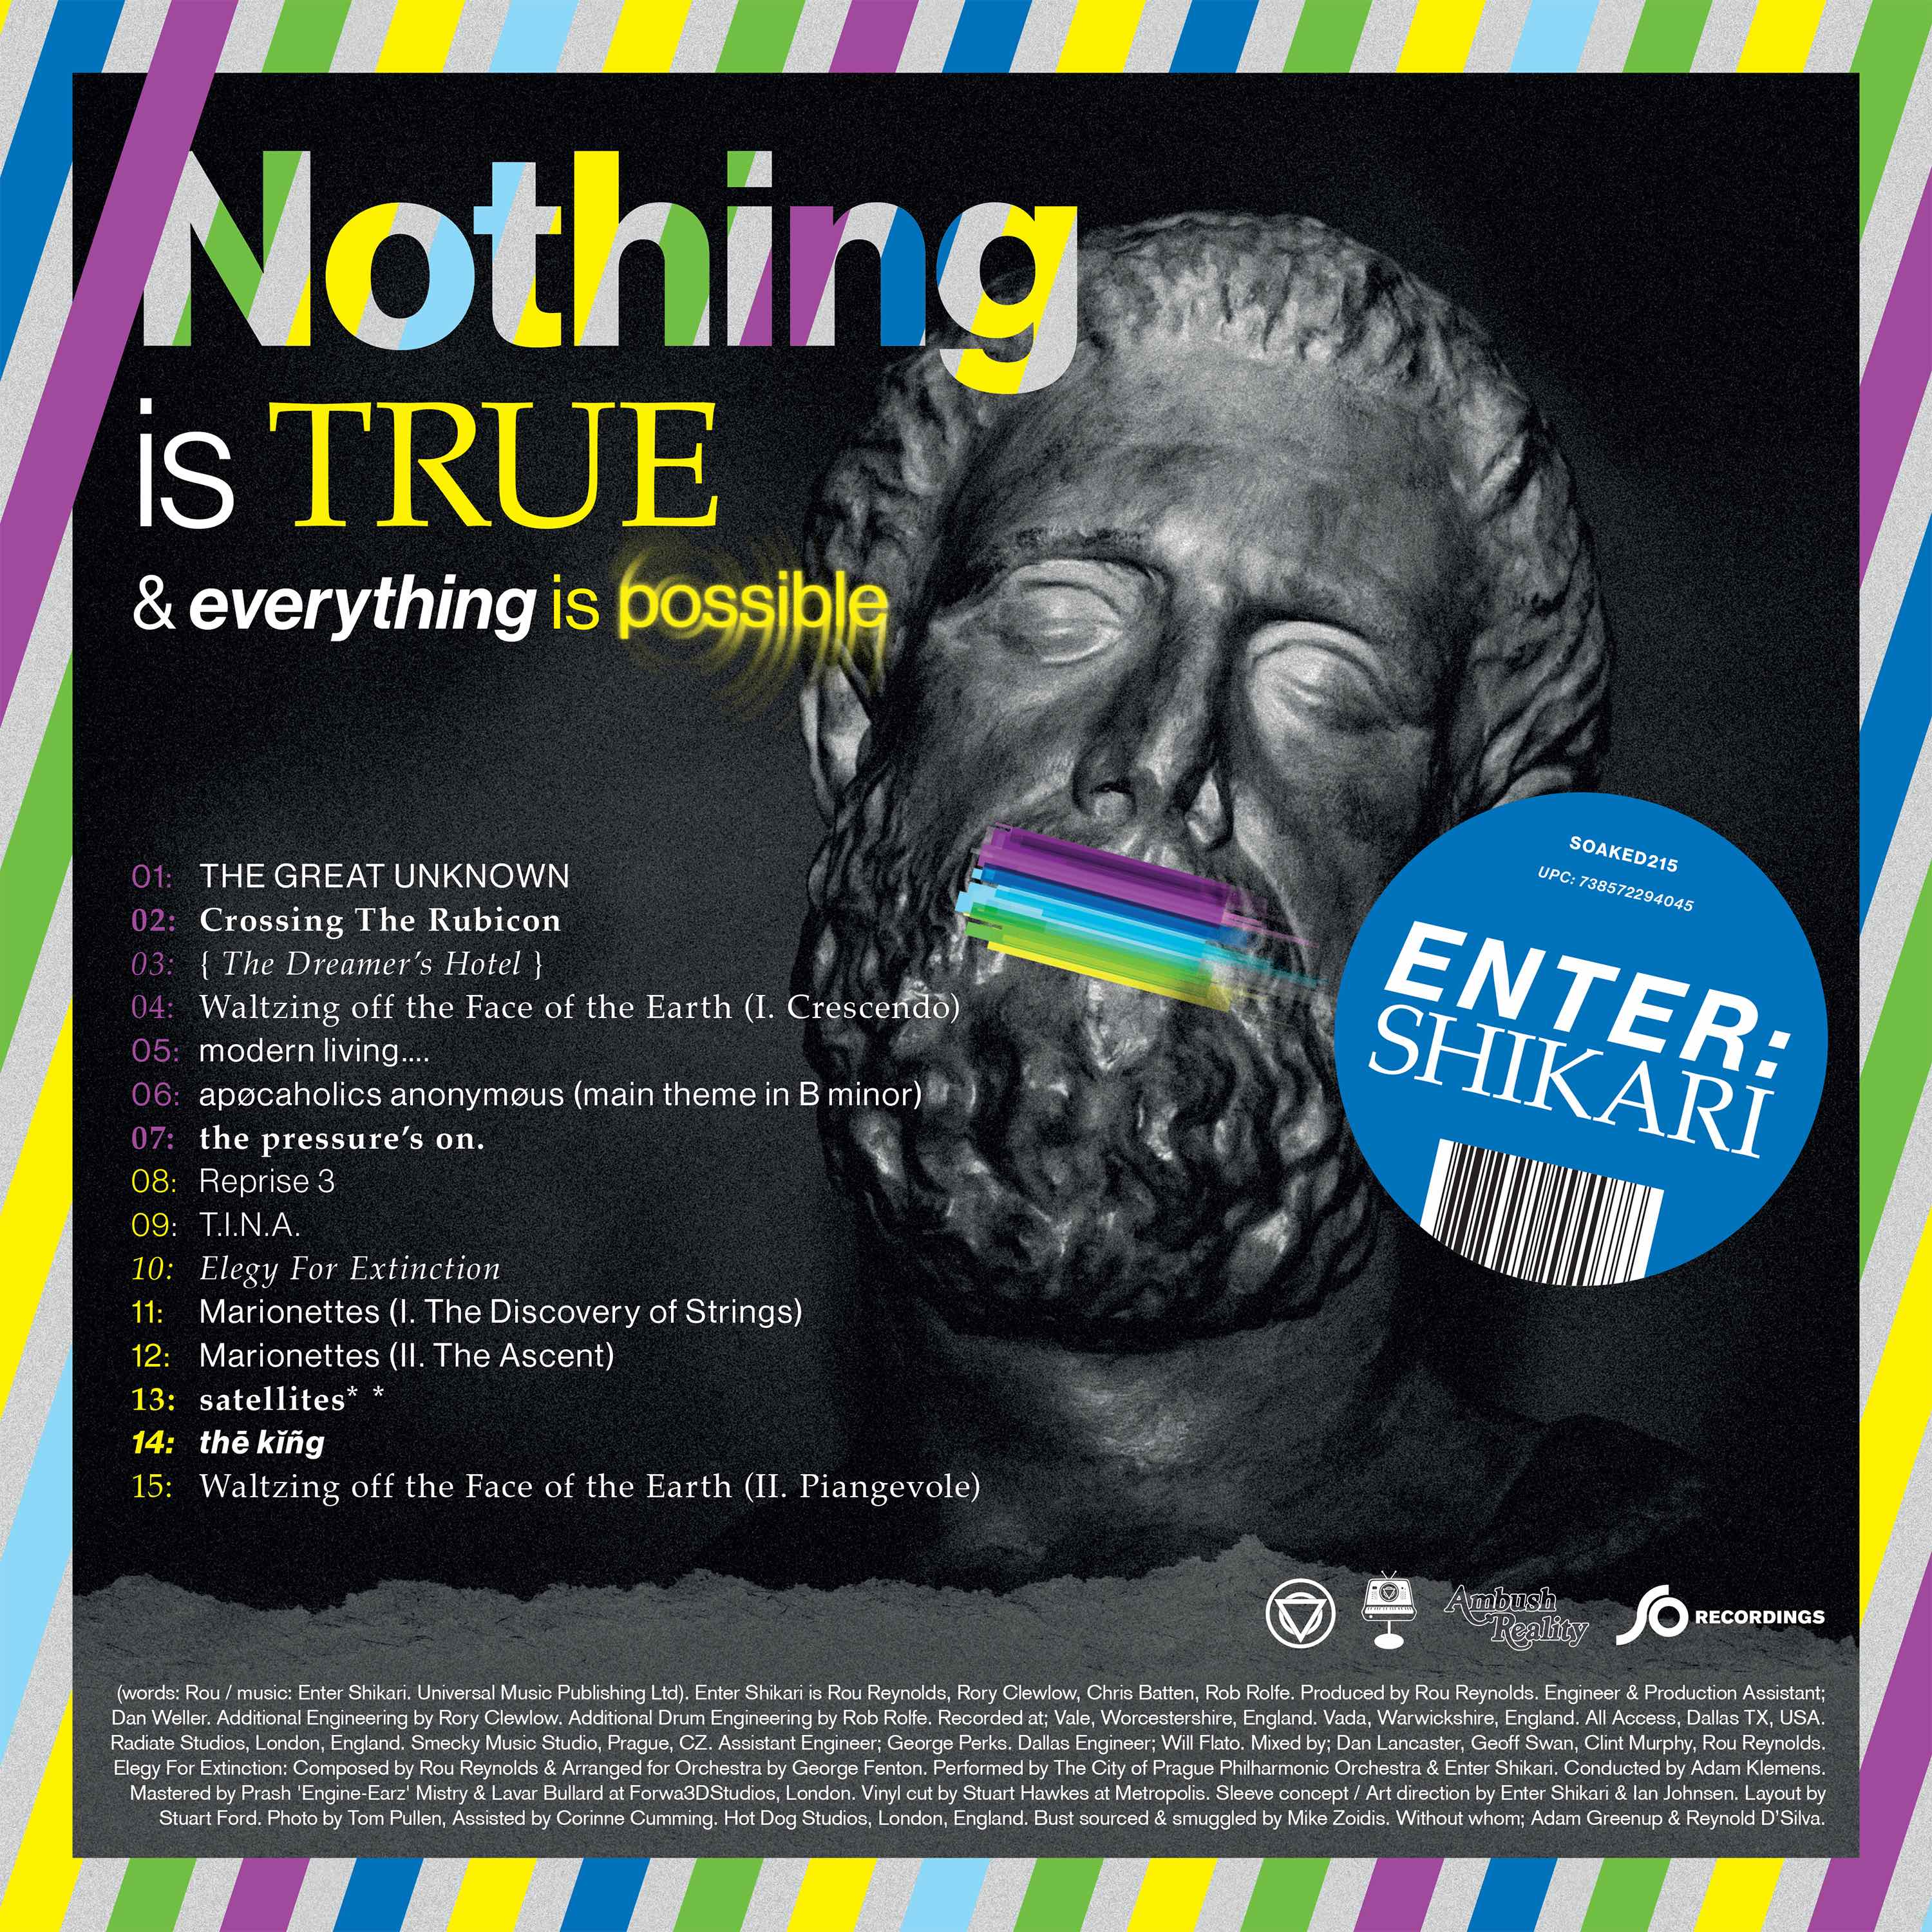
High res artwork
’Nothing Is True & Everything Is Possible’ tracklist:
- 1.The Great Unknown
- 2.Crossing The Rubicon
- 3. { The Dreamers Hotel }
- 4. Waltzing off the Face of the Earth (I. Crescendo)
- 5. modern living…
- 6. apocoholics anonymous (main theme in B minor)
- 7. the pressure’s on
- 8. Reprise 3
- 9. T.I.N.A
- 10.Elegy For Extinction
- 11. Marionettes (I. The Discovery of Strings)
- 12. Marionettes (II. The Ascent)
- 13. satellites
- 14. the king
- 15. Waltzing off the Face of the Earth (II. Piangevole)
To be amongst the first to hear ’Nothing Is True & Everything Is Possible’ pre order here: https://orcd.co/nothingistrue

Album launch shows:
18th April – Sheffield, Leadmill
19th April – Glasgow, St Lukes
20th April – Liverpool, Invisible Wind Factory
22nd April – London, Subterania
23rd April – Bristol, SWX

Tickets will be available to those who pre-order the album from the online band store and to members of the band’s Future Historians fan club.

Official Website | Facebook | Twitter | Instagram

For more information and press enquiries please contact:
Jenny Entwistle
jenny@chuffmedia.com
020 8281 0989

