ANOTHER SKY ANNOUNCE THEIR DEBUT ALBUM
‘I SLEPT ON THE FLOOR’
DUE FOR RELEASE ON 7TH AUGUST VIA FICTION RECORDS

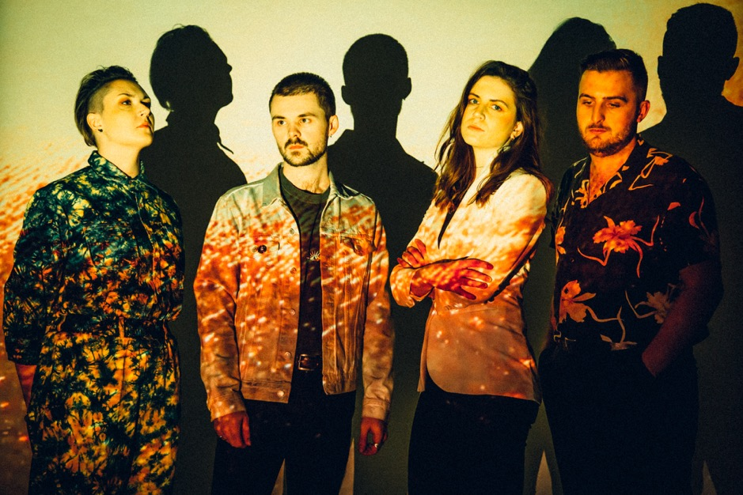
Credit – Parri Thomas, image here

“PEOPLE SAY I SOUND LIKE A MAN. MAYBE THAT MEANS THEY’LL LISTEN”
CATRIN VINCENT, ANOTHER SKY

WATCH / LISTEN TO NEW SINGLE ‘FELL IN LOVE WITH THE CITY’
Another Sky have announced the release of their debut album ‘I Slept On The Floor’, due for release on 7th August via Fiction Records. They have also released their brand new single ‘Fell In Love With The City’, by far their most ambitious and euphoric track to date, which premiered last night as Annie Mac’s Hottest Record on Radio 1 and launches in video form today.
The band have also announced a headline show in London at EartH for 11th November 2020, as part of their already announced run of UK dates through November and December. Pre-sale tickets for London will be available at 10am on Thursday 25th June with general sale on Friday 26th June. Tickets for the rest of the tour are on sale now.
Pre-order ‘I Slept On The Floor’ here. The album will be available in the below formats, with special bundles offered via the band’s store.
-Limited Edition Dark Green Vinyl with 12x12 poster
-Standard Vinyl
-Mintpack CD
On the single, Catrin Vincent (vocalist / lyricist) had to say:
"I hate breakup songs. I don't know why, it’s the most universal feeling. Maybe because the world has so many of them. Moving to London was a dramatic shift from small-town life where it didn’t even occur to me I could do music, where this vision of me as a housewife who never amounted to anything felt inescapable, in to a bigger world, of people from all over, of new ideas and a new version of myself.”
On the music video, which was directed by Vincent herself:
“We asked if any of our fans had an old mini DV tape camera, and they came through (thanks so much Peter Kavanagh, Victoria Wai and Henry Kenyon). We tried to capture the excitement of being on the road for the first time, replicating the feeling of moving to London seven years ago. “Fell In Love With The City” is the second song we ever wrote as a band and we wanted to make a video that embodied the way you'd film a partner, but you're filming a city instead".

Since the release of their debut single in 2018, Another Sky have flawlessly merged hard-hitting, difficult topics with unparalleled cinematic sounds. Catrin Vincent’s poetic rage has been titular in Another Sky’s story, grappling with the topics of toxic relationships, childhood trauma, systematic elitism, Brexit Britain, the rise of Donald Trump and much more. However, the band’s debut album is never didactic; it’s more of a personal diary, with a tentatively hopeful outlook.

A statement from Catrin on “I Slept On The Floor”:
“People say I sound like a man. Maybe that means they’ll listen.
‘I Slept On The Floor' is an amalgamation of the ever-shifting life I have shared with Another Sky over the last six years, searching for resolution between my hometown-self and the self a new city brought me. It was why in 2017, at St. Pancras Church, Another Sky performed in the dark as silhouettes, big illuminated circles behind each of us.

People left asking if the singer was a woman or a man. I wanted to ask why it mattered.

I wanted the band to be a mirror, reflecting the darkness back at itself. I thought I had found myself in that darkness.

I grew up in a white picket fence town with a fear of beds, preferring to sleep on the floors of bathrooms in case I got sick at night. My anxiety was so suppressed, so unacknowledged by my environment that my body broke to get my attention. I became very unwell. My body tried to tell me, "you can't mould yourself into their ideal," but I didn't know there was an alternative. I was malleable soil instead, filling a vase, growing into a shape I couldn't see.

You can't see the walls around you if they look like the edges of the Universe.

In 2013, I moved to London and thought I'd found a bigger, better vase. Suddenly I was exploding into a world of a million possibilities, but rather than finding myself bursting at the seams, I couldn't find the edges of myself at all.

Just as my hometown had shaped me, so did London begin to. Among the rising rents and an increasingly hostile political landscape, the pressure to define my limits grew. The world didn't stop breaking me down just because I had moved on from the confines of my childhood.

I Slept On The Floor documents the childhood rejection we carry with us into adulthood. This album is about only understanding a place once you've left it."

Album Tracklisting
- How Long?
- Fell In Love With The City
- Brave Face
- Riverbed
- The Cracks
- I Slept On The Floor
- Life Was Coming In Through The Blinds
- Tree
- Avalanche
- Let Us Be Broken
- All Ends
- Only Rain
LIVE DATES 2020
11th November – EartH, London (announced day of "Fell In Love With The City" release)
19th November – Think Tank, Newcastle
20th November – King Tut's Wah Wah Hut, Glasgow
21st November – Hyde Park Book Club, Leeds
26th November – The Bullingdon, Oxford
27th November – Star & Garter, Manchester
28th November– The Sunflower Lounge, Birmingham
3rd December – The Hope & Ruin, Brighton
4th December – Clwb Ifor Bach, Cardiff
5th December – The Louisiana, Bristol
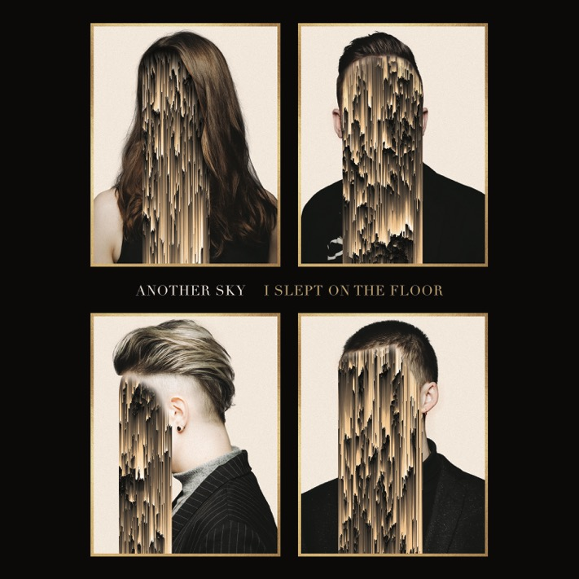
Album artwork Hi-Res here
www.underneathanothersky.com

For all press enquiries please contact:

Warren Higgins
warren@chuffmedia.com
020 8281 0989

