DEBUT ALBUM ‘HYPERSONIC MISSILES’ OUT NOW THROUGH POLYDOR RECORDS

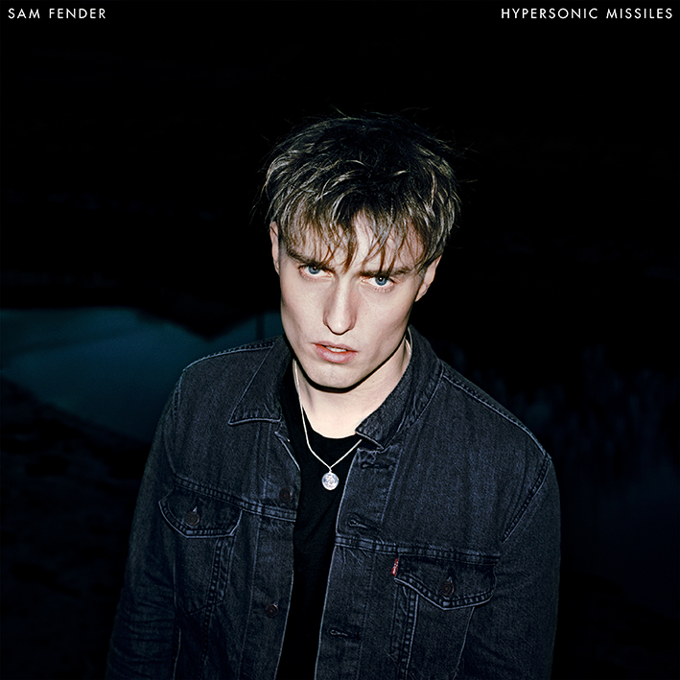

“[It’s] hard not to imagine the stadium potential of these songs… skyscraper guitars and choruses that accelerate into a surging, full-throttle blast” **** - Q
“excels at documenting small-town frustration…there are no easy answers here, but Sam Fender’s asking the right questions” **** - NME
“Gloriously anthemic… an album that sounds not just like a hit, but a loud announcement of a striking talent with the space and potential to mature and develop. Which might make it a perfect debut.” **** - The Guardian
“[an] astonishing debut…the early indications of somebody who could be the voice of a generation.” **** - The Independent
“What a joy to find a young British guitar-playing singer-songwriter wrestling with big issues of the world at large… Every song bristles with explosive ideas.”
**** - The Telegraph
“An impeccable record. Sam Fender’s debut is brave, confident and evocative” ******** - Clash
“Superb. Hypersonic Missiles is a triumphant debut” ********* - The Line of Best Fit

Sam Fender is very pleased to release his debut album, Hypersonic Missiles. It is out now via Polydor Records.

Hypersonic Missiles was written, recorded and produced at Fender’s own self-built warehouse studio in North Shields. It was recorded alongside long-standing friend and producer, Bramwell Bronte.

When Sam Fender won the BRITs Critics’ Choice award at the tail end of 2018, his name was added to a list of previous winners that includes the likes of Adele, Florence & The Machine, Sam Smith,
and Ellie Goulding. It’s a veritable hall of fame that feels a million miles away from the guitar-fuelled indie rock that Sam writes. It was deserved recognition for the hard-working Fender, but nobody was as shocked as he was when he first heard the news, driving past his old secondary school where a teacher once told him to put his musical aspirations to one side because it would
amount to nothing. “Absolutely crackers!” as Fender proclaimed upon reflection of receiving the award.

Sam Fender is a rare talent. A 25 year-old musician from the northeast of England who plays every gig as though it might well be his last, armed with this huge, cavernous vocal, guitar strapped on (a Fender, obviously), and fuelled by that seemingly old-school belief that great guitar music still has the power to change lives and influence people.

Straight out of school, Fender found work behind the bar in a local Shields pub (“a drinking town with a fishing problem” he’s joked on more than one occasion). He was discovered by his eventual manager when the pub’s landlord, recognising said manager, nudged Sam to go fetch his guitar and play something. Fender, usually castigated for musing on a guitar during work hours, picked it up and belted out two or three songs of his own. The pair have worked with each other ever since.

There’s a loose thread that has run through all of Sam’s songs to date and that’s in the focus of his lyrics. Observational, questioning and socially engaged, Sam has an innate gift for simplifying matters of the newsworthy and topical. “I don’t have answers only questions” he clarifies on the lead track, but there’s a canny simplicity here that seems to be touching and speaking plainly to people in their hundreds of thousands. Those words reflect conversations occurring right across the globe, amongst friends in cafes, pubs, and out on the terraces. Frustrations. Misunderstandings. Despair.

Dead Boys, a song that really raised the stakes for Sam soon after signing his record deal, tackles the taboo of male suicide. Having lost close friends to the epidemic and read up on the matter to better understand it, Fender was compelled to address it head on in song. The reaction was immediate. Aided by a stunning Vincent Haycock directed video, young men have since cautiously approached Sam after shows to thank him for writing it. Radio stations have received notes from their listeners on a similar theme. It’s touched a nerve, and got people talking. It’s done what good music can do and already become far bigger than just a belting tune. And on Hypersonic Missiles, there’s a sense that there are far more of those revelations still to come.

It’s a brave record too, with some of its subject matter cutting deep into the grain. The Borders recalls,“[you] pinned me to the ground/eight years old with a replica gun pushing in my skull saying you’re going to kill me if I tell/Never did and I never will/that house was living hell” and ‘you can’t stand me. I can’t stand me too’ it’s wrapped inside a direct and propulsive driven anthem, with sax flourishes in homage to his hero Bruce Springsteen. These are despatches from a gloomy and oft forgotten northern town, pea-soup fogged by hardship and a distinct lack of self-belief amongst its people.

New single Will We Talk? chugs incessantly, evoking the smash-and-grab sound of New York, but replaces the imagery of those bustling sidewalks with the WKD-drenched, neon-lit gutters of Newcastle. If it’s not already, this is destined to become a sturdy live favourite. A sub three-minute rock’n’roll anthem.

Like all artists of a certain persuasion, especially those who have read the back history of Oasis and their ilk every which way, Fender and his band of close pals took to the road. They took to it relentlessly, and to anywhere and to anyone who would have them. The crowds grew bigger, peppered by record label executives flying in from the far reaches of the world all reacting to excitable reports fuelled by the word of mouth. Sam wasn’t interested, releasing his self-penned garden shed demos online and limited-edition vinyl (funded solely by the shows) so that any new
fans who hazarded upon him in their local venues could listen to something at home too. It was a DIY enterprise in its purest sense. Of those early releases, only Play God and Leave Fast feature on Hypersonic Missiles (there’s no room for the biting Millennial nor Friday Fighting). The live show is an instant attraction. That powerful vocal sounds too big for anywhere other than a field, and that graft on the road now finds his songs belted back to him by both the youthful (and ever supportive) Radio 1/Radio X/Absolute Radio listeners, and an altogether gruffer chorus from the back of the room that finds their dads in fine voice too.

Sam’s shows now sell out instantly, with a hometown show at Tynemouth Castle in the summer shifting 4000 tickets quicker than most new artists manage in the capital to an eighth of the size. A recent trip to the US found the buzz and excitement had already stretched over to the Atlantic, with further sold out shows greeting this immensely likeable young Geordie.

As far as litmus tests go, Sam Fender has passed them all, and now with Hypersonic Missiles, Britain’s most likely to is absolutely going to.

LP Tracklisting: Hypersonic Missiles / The Borders / White Privilege / Dead Boys / You’re Not The Only One / Play God / That Sound / Saturday / Will We Talk? / Two People / Call Me Lover / Leave Fast / Use (live)

Sam Fender Live:

22nd November – Academy, Manchester SOLD OUT
23rd November – Guild of Students, Liverpool SOLD OUT
26th November – Rock City, Nottingham SOLD OUT
27th November – O2 Academy, Glasgow SOLD OUT
28th November – O2 Academy, Leeds SOLD OUT
30th November – Dome, Brighton SOLD OUT
1st December – O2 Academy, Bournemouth SOLD OUT
3rd December – Pavilions, Plymouth SOLD OUT
4th December – O2 Academy, Bristol SOLD OUT
5th December – O2 Academy, Birmingham SOLD OUT
7th December – O2 Academy, Newcastle SOLD OUT
8th December - O2 Academy, Newcastle SOLD OUT
10th December – O2 Academy Brixton, London SOLD OUT
11th December - O2 Academy Brixton, London SOLD OUT
13th December – Great Hall, Cardiff SOLD OUT
16th December – Dublin, Olympia SOLD OUT
17th December – Ulster Hall, Belfast SOLD OUT
19th December – O2 Academy, Sheffield SOLD OUT
21st December – O2 Academy, Newcastle SOLD OUT
22nd December - O2 Academy, Newcastle SOLD OUT

www.samfender.com

For more information and press enquiries please contact:
Jenny Entwistle / jenny@chuffmedia.com / 020 8281 0989

