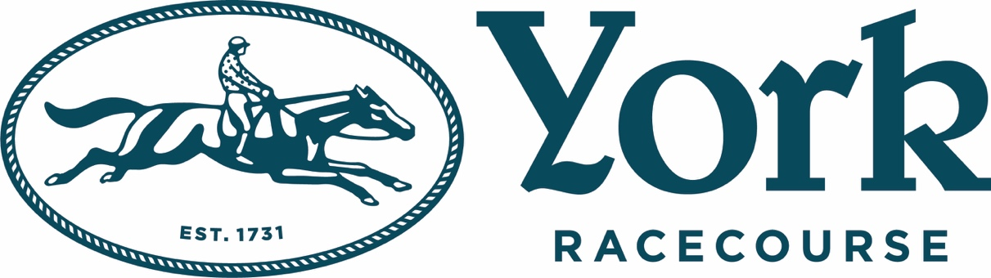

Racing. Music. Magic.
Only at York Racecourse this Summer
Top-tier racing, star-studded performances, and unforgettable summer vibes – all in the heart of Yorkshire!
York Racecourse is pulling out all the stops for 2025 with a blockbuster line-up of music and racing events that promise to light up the summer and bring some of the UK’s biggest pop stars to one of the country’s most iconic sporting venues.
SATURDAY 28TH JUNE – OLLY MURS
Brand new for 2025, Summer Music Raceday, taking place on the 28th June, is set to be the ultimate summer holiday kick-off. With seven races offering nearly £300,000 in prize money, the on-track action sets the tone before pop sensation Olly Murs ignites the evening with a high-energy live set.
Currently on his sold-out UK tour, Olly returns to the stage with chart-toppers like Troublemaker, Dear Darlin’, Dance With Me Tonight, and Heart Skips a Beat. With 4 UK No.1 singles and 5 No.1 albums to his name, the former X Factor runner-up has evolved into one of the UK’s most beloved and entertaining performers. Expect big vocals, slick moves, and future hits in what promises to be one of the standout nights of the year.
The following month, a firm Yorkshire favourite, the Music Showcase Weekend returns with two nights of spectacular post-race performances from international pop icons:
FRIDAY 25TH JULY – SOPHIE ELLIS-BEXTOR + NATASHA BEDINGFIELD
This is York Racecourse’s only evening show of the summer, and it promises glitter, glam and non-stop dancing after the crowd enjoys 6 races and the EBF Lyric Stakes!
Sophie Ellis-Bextor, known for her disco-pop classics Murder on the Dance Floor, Groovejet (If This Ain’t Love), and Take Me Home, rose to new fame during lockdown with her viral Kitchen Disco livestreams. She followed up with two Kitchen Disco albums and a sell-out live tour. Now, as Murder on the Dance Floor becomes a Gen Z anthem (thanks to Saltburn), Sophie’s star is shining brighter than ever.
“I absolutely love playing summer outdoor shows and I can’t wait to see you all at York Racecourse on Friday 25th July! Let’s have some fun!” – Sophie Ellis-Bextor

Joining her is Natasha Bedingfield, the powerhouse vocalist behind Unwritten, Pocket Full of Sunshine, and These Words. With over 10 million albums sold and numerous awards and nominations, Natasha’s feel-good anthems continue to inspire a new generation—Unwritten recently re-entered the UK Top 20 and joined Spotify’s exclusive Billions Club.
SATURDAY 26TH JULY – RONAN KEATING
Ronan Keating takes the stage after Saturday’s races in what promises to be an emotionally charged, hit-filled evening. With a career spanning nearly 30 years, the Boyzone legend turned solo superstar has sold over 20 million solo records and earned acclaim across music, film, and TV.
Expect a heartfelt performance featuring fan favourites like When You Say Nothing At All, Life Is a Rollercoaster, If Tomorrow Never Comes, and Lovin’ Each Day. Beyond music, Ronan is a beloved TV host and a passionate charity ambassador through the Marie Keating Foundation, proving that his talents – and heart – go far beyond the stage.
Saturday’s racing features the prestigious Group 2 Sky Bet York Stakes, often a stepping stone to the Juddmonte International, one of Britain’s richest and most prestigious races.
Awarded Racecourse of the Year 2024 by the Racecourse Association, York Racecourse is more than just a sporting venue. With top-class dining, local food heroes, and a famously warm Yorkshire welcome, it offers an unbeatable day out whether you're a seasoned racing fan or first-time visitor.
Get your tickets now and be part of Yorkshire’s biggest party of the year!

Ticket Information:
- From just £15 with early bird and group discounts available (book before 18th June)
- Accompanied under-18s only £10
- No booking fees, no parking charges
- Free shuttle buses or a 25-minute scenic stroll from York Station
- Tickets available now at: www.yorkracecourse.co.uk
For more information please contact Warren@chuffmedia.com on 07762 130510

