YARD ACT

ANNOUNCE SECOND ALBUM WHERE’S MY UTOPIA? - OUT 1 MARCH 2024 ON ISLAND

LEAD SINGLE & VIDEO ‘DREAM JOB’ OUT TODAY

MILLENNIUM SQUARE LEEDS SHOW ANNOUNCED (3 AUGUST)

UK & EU SPRING 2024 TOURING - INCLUDING EVENTIM APOLLO HAMMERSMITH (27 MARCH)

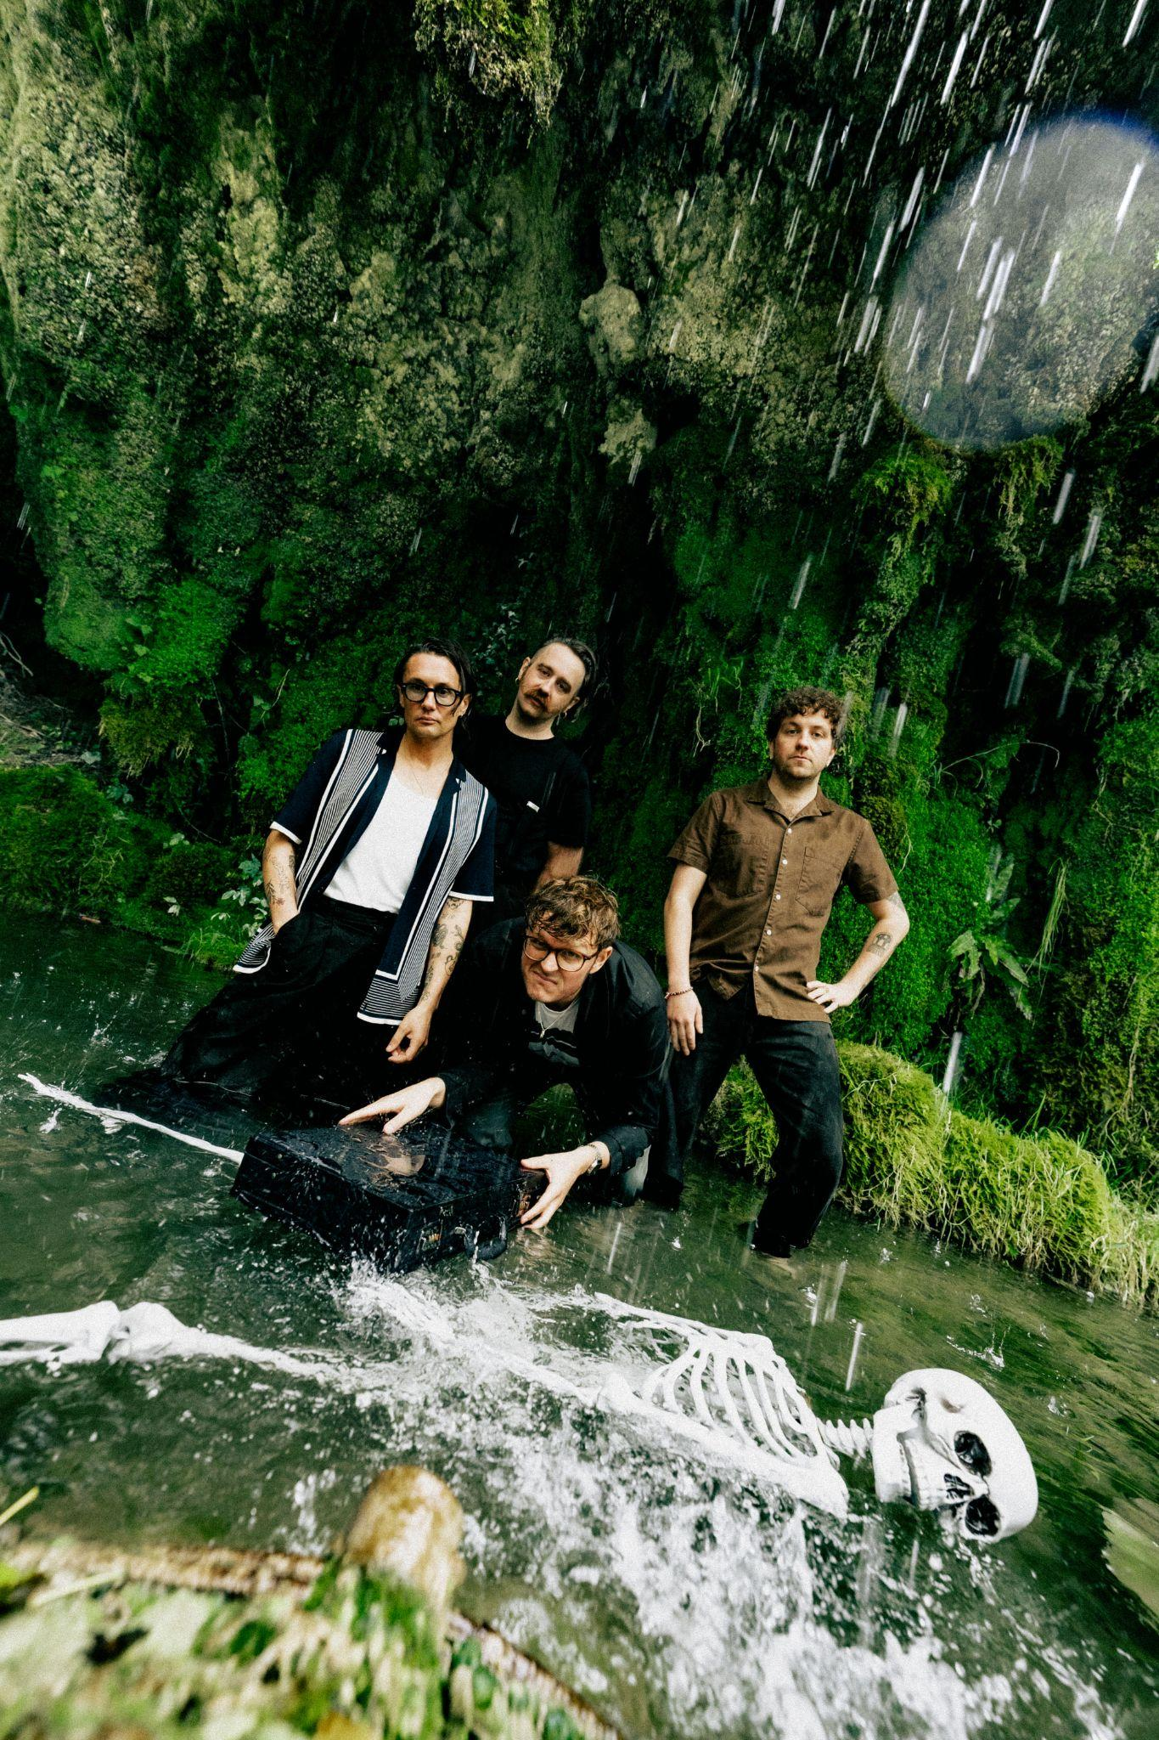

Photo credit: Phoebe Fox

Listen to ‘Dream Job’ HERE

Watch the ‘Dream Job’ video HERE

Preorder Where’s My Utopia? HERE

Yard Act have today announced their new album Where My Utopia? alongside its lead single & video ‘Dream Job’.

Out on 1 March 2024 via Island, Where’s My Utopia? is the follow up to the Leeds band’s critically-acclaimed debut record The Overload which arrived in January 2022. The Overload was shortlisted for the Mercury Prize after a slew of positive reviews, national radio playlistings and a placing at #2 in the Official Charts. The new album is a co-production between Yard Act and Gorillaz member Remi Kabaka Jr. ‘Dream Job’s video was directed by James Slater, the band and director’s 7th collaboration (“with many more to come”).

Having already announced a huge run of shows in the UK and EU for spring 2024 - including the Eventim Apollo Hammersmith on 27 March - Yard Act have today revealed plans for their biggest hometown show to date at the 5,750 capacity Millennium Square Leeds on 3 August. For access to tickets, preorder the album HERE. General sale for Millenium Square is on 10 November.

Speaking about ‘Dream Job’, Yard Act’s James Smith said: “‘Dream Job’ feels like an apt introduction to the themes explored on Where's My Utopia? - though not all encompassing. In part I was scrutinising and mocking myself for being a moaning ungrateful little brat, whilst also trying to address how the music industry is this rather uncontrollable beast that hurtles forward unthinkingly and every single person involved in it plays their part. Myself included, obviously. As with pretty much everything else going through my head last year, trying to find the right time to articulate the complexity of emotions I was feeling and the severity to which I was feeling them couldn't be found - or accommodated, so instead I tried to capture it in a pop song that lasts less than three minutes once the fog had cleared a bit. It’s good and bad. I'm still glad that everything that happened to me happened.”

Yard Act opened the main stage at Reading & Leeds Festival this summer as well as making appearances at Latitude (headlining the BBC Sounds stage, no less), Fuji Rocks, and Boardmasters. The band will return to North America in November with a run of headline shows across the US, culminating in a slot at Mexico City’s Corona Capital Festival. The Leeds band also shared a standalone single ‘The Trench Coat Museum’ this summer. Co-produced by the band and Kabaka Jr., ‘The Trench Coat Museum’ was instantly added to the BBC Radio 6 Music A-List upon release and sparked feverish discussion about the band’s next exciting chapter, which begins today.

Earlier this year, Yard Act delivered an unprecedented five night residency at their hometown’s Brudenell Social Club which was awarded four stars each in reviews from Rolling Stone UK, The Telegraph, and The Times. The band were joined by a stellar lineup of comedians; Phill Jupitus, Nish Kumar, Lolly Adefope, and Harry Hill. Yard Act also made their festival headline bow at Dot To Dot in Bristol & Nottingham, performed at Primavera (Barcelona, Madrid & Porto) and played their maiden shows in Australia and New Zealand, truly making their mark on the global stage in 2023.

***

What do you do when everything you’ve ever wanted suddenly lands in your lap, but the questions still keep on coming?

Since first steering their golden Rover into swift public acclaim back in 2020, Leeds quartet Yard Act have become one of the great indie success stories of the decade so far. Along the way, they’ve ticked off milestones ranging from a Number Two chart placing and Mercury Prize nomination for debut album The Overload, to a co-sign from Elton John who joined the band to guest on a string-laden reworking of album closer ‘100% Endurance’.

Yet, whilst the band’s trajectory continuously shot upwards, vocalist James Smith and his wife had also welcomed in a son. And it’s this duelling sense of responsibility and ambition, guilt, love, drive and everything in between that forms the narrative backbone of brilliantly exploratory second album Where’s My Utopia?

Written in snapshots of time between a relentless touring schedule, and produced jointly by the band and Gorillaz’ Remi Kabaka Jr, the quartet’s second act is a giant leap forward into broad and playful new sonic waters. “The main reason that ‘post-punk’ was the vehicle for Album One was because it was really affordable to do, but we always liked so much other music and this time we've had the confidence to embrace it,” James explains. Across the record, influences ranging from Fela Kuti to Ennio Moricone via Spiller’s ‘00s pop smash ‘Groovejet’ make themselves known.

It’s a celebratory palette upon which Smith allowed himself to reach lyrically deeper into himself than ever. Gone, largely, are the outward-facing character studies of yore, replaced with a set of songs that stare fully into the headlights of life, wrangling with the frontman’s own fears and foibles to create a sort of Promethean narrative - but with jokes. “You can commit to the idea that we’re just animals who eat and fuck and then we die, and that’s fine,” he suggests. “But for me, creativity always seems to be the best way of articulating the absolute minefield of what human existence is.”

***

Praise for Yard Act’s The Overload:

“lives up to its hype with flying colours”
DIY 5*

“A stellar debut”
Rolling Stone UK 5*

“We hope the rest of 2022’s musical output is as good as this album.”
Dork 5*

“will remain omnipresent in the music press for another 12 months to come”
The Forty Five 5*

“a resounding success”
The Scottish Express 5*

“A debut album bursting with character”
Uncut 4 ½ *

“an album of deeply relatable storytelling for the plight of the ordinary people”
The Line Of Best Fit 4 ½ *

“An exhilarating record”
MOJO Album of the Month 4*

“witty post-punks confront post-Brexit Britain”
The Guardian Album of the week 4*

“The much lauded rock band from Leeds justifies the hype with a set of 11 smart, fierce tracks”
The Telegraph Album of the week 4*

“an exciting prospect for 2022”
The Times 4*

“an overload of good ideas”
The Daily Star 4*

“rabble-rousing, likeable post-punk rock”
The Sun 4*

“Seldom do you hear such sentimentality and beauty in music as brusque as this”
NME 4*

“the greatest lyrical party you will have in a long time”
Gigwise 4*

***

See Yard Act live in 2023/24:

2 Nov | Iceland Airwaves, Reykjavik, IS
4 Nov | Warsaw, Brooklyn US
5 Nov | Underground Arts, Philadelphia US
6 Nov | Ottobar, Baltimore US
7 Nov | Motorco Music Hall, Durham US
9 Nov | The Basement East, Nashville US
10 Nov | The Earl, Atlanta US
11 Nov | Toulouse Theatre, New Orleans US
14 Nov | Mohawk, Austin US
15 Nov | Deep Ellum Art Company, Dallas US
17 Nov | Corona Capital Festival, Mexico City, MX

2 Dec | Maho Rasop Festival, Bangkok, TH
3 Dec | Clockenflap Festival, Hong Kong, HK
5 Dec | Shangri-la, Osaka, JP
7 Dec | Club Quattro, Tokyo, JP

13 Mar | The Nick Rayns LCR (UEA), Norwich, UK
14 Mar | Rock City, Nottingham , UK
15 Mar | O2 Academy, Glasgow, UK
16 Mar | O2 Apollo, Manchester, UK
17 Mar | Northumbria University, Newcastle, UK
19 Mar | Mandela Hall, Belfast, UK
20 Mar | Vicar Street, Dublin, IE
22 Mar | Invisible Wind Factory, Liverpool, UK
23 Mar | O2 Academy, Bristol, UK
25 Mar | The Dome, Brighton, UK
27 Mar | Eventim Apollo, London, UK

04 Apr | Stereolux, Nantes, FR
05 Apr | Cabaret Sauvage, Paris, FR
06 Apr | Rock School Barbey, Bordeaux, FR
08 Apr | LAV, Lisbon, PT
09 Apr | Mon, Madrid, ES
11 Apr | La 2, Barcelona, ES
12 Apr | Le Transbordeur, Lyon, FR
13 Apr | Locomotiv Club, Bologna, IT
14 Apr | Santeria Toscana 31, Milan, IT
16 Apr | Mascotte, Zurich, CH
17 Apr | Muffathalle, Munich, DE
18 Apr | Festsaal Kreuzberg, Berlin, DE
20 Apr | Slaktkyrkan, Stockholm, SE
24 Apr | Uebel & Gefährlich, Hamburg, DE
25 Apr | Paradiso Main Hall, Amsterdam, NL
26 Apr | Doornroosje, Nijmegen,NL
27 Apr | Kantine, Cologne, DE
28 Apr | Les Nuits Botanique, Brussels, BE

30 May | Belly Up Tavern, Solana Beach, CA
31 May | The Regent Theater, Los Angeles, CA
1 Jun | Pappy and Harriet's, Pioneertown, CA
3 Jun | The Catalyst Atrium, Santa Cruz, CA
4 Jun | The Independent, San Francisco, CA
6 Jun | Mississippi Studios, Portland, OR
7 Jun | Rickshaw Theatre, Vancouver, BC
8 Jun | The Crocodile, Seattle, WA

3 Aug | Millenium Square, Leeds, UK

***

Yard Act - Where’s My Utopia? - out 01/03/2024 via Island

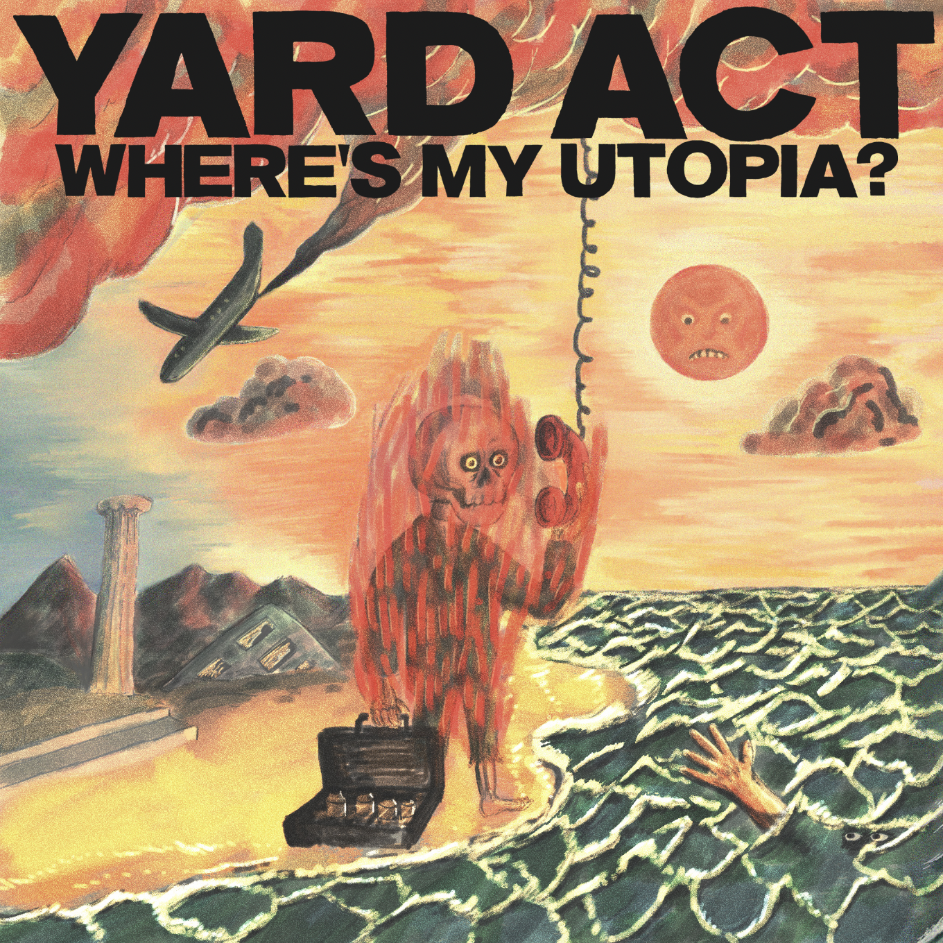

1. An Illusion
2. We Make Hits
3. Down By The Stream
4. The Undertow
5. Dream Job
6. Fizzy Fish
7. Petroleum
8. When The Laughter Stops (ft. Katy J Pearson)
9. Grifter's Grief
10. Blackpool Illuminations
11. A Vineyard for the North

For more info contact Warren warren@chuffmedia.com

