



**Debut album *Congregation* out today**

**Listen** [**HERE**](https://witchfever.lnk.to/Congregation)

**Release shows start tonight**

**in Brighton, London, Leeds, and Manchester**

**On sale now**

**Part of The Great Escape, First Fifty**



*Congregation album artwork | Download* [*here*](https://www.dropbox.com/s/ey4ahucefhhkvq5/WF%20Album%20Cover.jpg?dl=0)

——

**Praise for *Congregation*:**

*“A vulnerable, accomplished but, most importantly, empowering debut.”* - **DIY ★★★★**

*“Reminiscent in parts of the early HC glories of GBH and the Exploited, but with a contemporary spin which makes it more than clear that non-male voices have a front-line place in hardcore punk, Congregation cements Witch Fever as true protagonists in the hard’n’heavy UK scene.” -* **Gigwise** 8/10

*“it’s clear that Witch Fever’s journey is just beginning, and this is the platform from which they can blaze a blinding trail, smash that stubbornly patriarchal system, and keep living deliciously.”* - **Kerrang! Magazine** 5/5

*“Raw Rampant an Unapologetic” -* **UPSET ★★★★★**

——

Refusing to be confined by gender or genre, **Witch Fever** have always defied expectations as individuals in society. Now, they’re defying expectations as a band. **Debut album *Congregation* is out today,** and is the sound of punk without boundaries of any kind, and with it they are ushering in a new era of heavy music that’s accessible, confrontational and, most importantly of all, a huge pressure release.

Produced by Pigs x7’s Sam Grant, the album is 13-tracks that incorporate everything sludge to new wave without lingering in one sound for too long. Lyrically, *Congregation* draws largely on Walpole’s experience of growing up in a Charismatic Church – a form of Christianity that emphasises the work of the Holy Spirit, spiritual gifts, and modern-day miracles. She left the church when she was 16, and her parents followed suit two years later. Guitarist Alisha Yarwood also grew up in a church, though not to the same extent as Walpole, and all members agree that the themes of the album – control, abuse of power and patriarchal violence – resonate beyond a religious framework.

**Listen to *Congregation*** [**HERE**](https://witchfever.lnk.to/Congregation)

QUOTE

To celebrate the release, the share track ‘At The Core’ XXX, which joins previous singles ‘Beauty and Grace’ (listen [here](https://witchfever.lnk.to/Congregation/youtube)), ‘Blessed Be Thy’ (video [here](https://youtu.be/65XHZ1cp9AA)), ‘Congregation’ (video [here](https://youtu.be/Hauht0yPCuE)), and ‘I Saw You Dancing’ (video [here](https://youtu.be/TKNjCj0sjes)).

While the subject matter of their songs is often heavy, Witch Fever’s attitude certainly isn't. Their videos have always been vivid and playful, showing the band having as much of a laugh on set as they do at their shows or in the studio, plus a wardrobe that’s very London Fashion Week meets Berlin club night.

**Witch Fever are:**

Amy Walpole: Lead vocals

Alex Thompson: Bass and backing vocals

Alisha Yarwood: Guitar

Annabelle Joyce: Drums

——

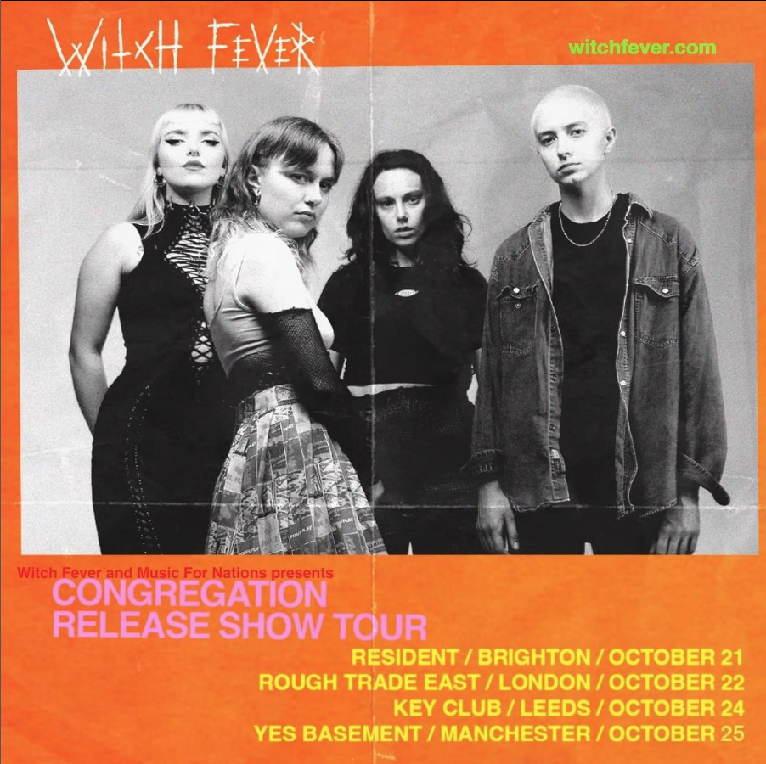

**Tour Dates**

Tonight they’ll perform in Brighton, as well as playing in London, Leeds, and Manchester, taking place 21st - 25th October. Plus they were chosen as part of The Great Escape’s First Fifty acts which showcases the hottest artists, where they will perform at The Victoria Dalston on 15th November.

**Tickets on sale** [**HERE**](https://www.witchfever.com/events/)

——



*Photographer Credit: Nic Bezzina | Download* [*here*](https://www.dropbox.com/s/dpkti5yz4r12mhu/220805_WitchFever_0514.jpg?dl=0)

——

**About Witch Fever:**

Witch Fever’s debut album culminates in what the band like to call “full rage mode”. Since their formation in 2017, the Manchester quartet have had a reputation for making riff-heavy, lyrically furious music that consistently bursts out of the confines of one genre. But their first full-length project, *Congregation* – out via Music For Nations / Sony on October 21st – sees them going further out of their comfort zone, and to further extremes.

First meeting through Manchester’s close-knit alternative music scene, Witch Fever – Amy Walpole (vocals), Alex Thompson (bass), Alisha Yarwood (guitar) and Annabelle Joyce (drums) – have spent five years making gains within an industry that still skews overwhelmingly male when it comes to punk. Their raucous on stage presence, followed by last year’s *Reincarnate* EP has seen their sound develop in intensity as well as scope.

*Congregation* captures Witch Fever at their heaviest and most challenging yet. Produced by Pigs x7’s Sam Grant at Blank Studios in Newcastle, the album’s 13-tracks incorporate everything sludge to new wave without lingering in one sound for too long. Some songs like “Deadlights” and “Bloodlust” power along with a more toothy evolution of the “doom punk” Witch Fever started out playing, while the title-track marks a complete departure into delirious post-punk, dragging along at a stalking pace with a sludgy Warpaint-inspired bass riff. Walpole’s voice has also evolved in every respect – the rasps are raspier, the screams more guttural, and the melodic moment cut through with a powerful grace and clarity.

“It just goes heavy,” Thompson says of the opening track and lead single “Blessed Be Thy” – a crunchy wall of noise rock along the lines of early Show Me The Body. “It was literally the last song we wrote before we went into the studio but came together really quickly. I think it still has an essence of some of our older material, so it’s a good way to bridge the gap.”

Writing for the album began after the release of last October’s *Reincarnate* EP, which Upset described as “powerful”, “breathtaking” and harnessing an anger that is “anthemic and somehow inspiring in a way that modern punk isn't always.”Though Witch Fever have been together since 2017, the priority was always gigging; *Congregation* gave them the opportunity to consider their sound in a wider context. Thompson and Yarwood in particular found themselves exploring space and experimentation rather than trying to knock out one blistering riff after another (though there are plenty of those also). As a result, every track is built like a brick house – strong riffs and rhythm, but plenty of space within.

The album’s sound matches the intensity of the lyrics, which draw largely on Walpole’s experience of growing up in a Charismatic Church – a form of Christianity that emphasises the work of the Holy Spirit, spiritual gifts and modern-day miracles. Both of her parents had joined when they were younger, after moving away from home, so Walpole was born into it. “This is the thing with churches, they go out and prey on vulnerable people,” she says. “Everyone in that church ended up being financially stuck there. Everyone pays to help keep the church running, which makes it very hard to leave once you start paying significant amounts of money.”

Walpole left the church when she was 16, and her parents followed suit two years later. “I think the breaking point was that [the church] didn’t take mental health seriously at all,” she says. “They were under the impression that you were paying for a sin, or it was your fault, or you weren’t praying hard enough.”

Yarwood also grew up in a church, though not to the same extent as Walpole, and all members agree that the themes of the album – control, abuse of power and patriarchal violence – resonate beyond a religious framework.

“I think I understand and relate to Amy’s lyrics in that it’s like, God is the ultimate patriarchal symbol,” says Thompson. “Especially the guilt and the shame that’s placed on women’s bodies and female autonomy in the church historically. I also relate to the expression of anger and, especially as a kid, being told to be quiet or behave nicely or sit still. There’s this very silent, unemotional person that a woman is meant to be. I felt that a lot in my upbringing.”

Yarwood agrees. “Every one of us probably has grown up being told that you’re not supposed to do something, or you’re supposed to act and behave a certain way. Witch Fever is the complete opposite of that. I don’t want to be ladylike, I don’t want to have to be anything – so being in this band is kind of like the ultimate fuck you.”

“That church is just a reflection of wider society and how it’s patriarchal and how it’s run,” Walpole adds. “It’s not even specifically Christianity or faith, it’s that the men who run it have fucked it. They get this tiny ounce of power and run with it. I’m not even convinced half of them believe in God, to be honest. It’s just so easy to use the fear of God to control people.”

*Congregation* builds towards an unexpectedly blunt finale, which feels like a sonic representation of Witch Fever kicking off whatever remains of the “silent, unemotional” repression of their upbringings. While most of the songs approach their subject matter quite poetically and metaphorically, closing track “12” – aka “full rage mode” – feels like something’s been unleashed. “He’s dead and I’m alive / I can feel the weight of him behind my eyes,” Walpole shouts repeatedly over two minutes of driving punk. The track reaches full crescendo with the line “I never got an apology”, delivered in a raw scream. The fact that it arrives off the heels of “Slow Burn”, a clean, introspective grunge track that would make for a more traditional closer, makes it hit even harder.

“As soon as we wrote that song I knew that I wanted it to be the end of the album,” says Walpole. “Our producer was like, have you considered ending it on [“Slow Burn”], because it’s super soft and nice? And I was like no, we’re ending it on the hardest track. We were never going to end it on a quiet track. Lyrically it’s probably the most confronting, and the most difficult one to hear.”

Throughout the lyrics, Walpole takes words with religious connotations – imagery of blood, tongues, the body – and twists them around. In some instances they’re trivialised or mocked, in others their power is subverted. “Blessed By Thy” is the title of a song Walpole used to sing every weekend in church (“When I told my mum she fucking lost it, she thought it was so funny,” Walpole laughs. “And then she Googled to see whether it was a copyright issue”), but she uses the language and cadence of a hymn to deliver her own message. “Blessed be thy shame / It makes us remember truth / A slow decline, the cursed divine / A place to hang your youth”.

“It’s sort of like, men have used these same words to control me and now I’m taking the power away from the words in the way they used them,” says Walpole, whose introduction to music came through religion. “I started singing through church, I was in the church band, through reading the Bible and this weird second language and way of speaking I’ve ended up improving my writing ability and my lyrics. So… thanks guys!”

While the subject matter of their songs is often heavy, Witch Fever’s attitude certainly isn't. Their videos have always been vivid and playful, showing the band having as much of a laugh on set as they do at their shows or in the studio. The video for “Blessed Be Thy” is as creative as any of the iconic videos Scuzz had on circulation in the 00s, while the upcoming video for “Congregation” sees them working with stylist Matt King (Brooke Candy, Shygirl, Bimini Bon Boulash) on a wardrobe that’s very London Fashion Week meets Berlin club night.

Refusing to be confined by gender or genre, Witch Fever have always defied expectations as individuals in society, Witch Fever have always defied expectations as individuals in society. Now, they’re defying expectations as a band. *Congregation* is the sound of punk without boundaries of any kind, and with it Witch Fever are ushering in a new era of heavy music that’s accessible, confrontational and, most importantly of all, a huge pressure release.

“We always try to have a sense of humour in everything that we do,” says Thompson. “As heavy as everything is, we all love what we do, and the essence is positive and productive.”

——

[**WITCHFEVER.COM**](http://www.witchfever.com)

[**FACEBOOK**](https://witchfever.lnk.to/Facebook) | [**TWITTER**](https://witchfever.lnk.to/Twitter)| [**INSTAGRAM**](https://witchfever.lnk.to/Instagram) | [**YOUTUBE**](https://witchfever.lnk.to/YouTube) | [**SPOTIFY**](https://witchfever.lnk.to/Spotify) | [**APPLE MUSIC**](https://witchfever.lnk.to/AppleMusic)

**For more information, please contact** [**amy@prescriptionpr.co.uk**](mailto:amy@prescriptionpr.co.uk)