
ANNOUNCE BIGGEST UK & EU HEADLINE TOUR
TO DATE THIS AUTUMN

Pre-sale begins Monday 30 March, 10am BST
General onsale Wednesday 1 April, 10am BST

Pre-sale access via Westside Cowboy’s new mailing list, sign up link HERE.

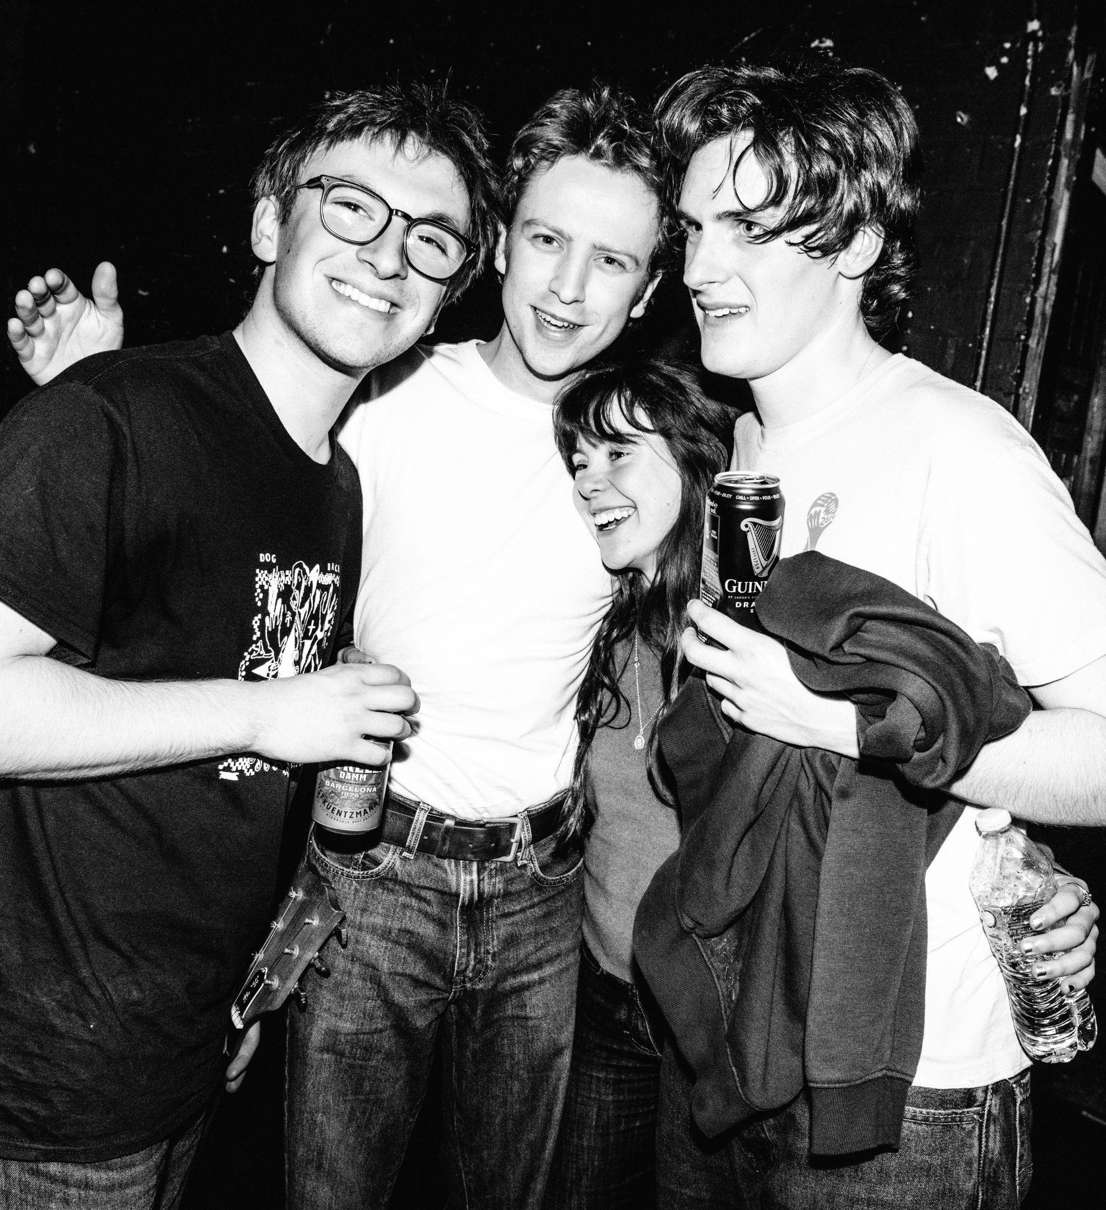

Photo Credit: Charlie Barclay Harris

FOR IMMEDIATE RELEASE - Westside Cowboy announce their biggest headline tour to date this Autumn - including shows at London’s O2 Forum Kentish Town and Manchester’s Albert Hall (full dates below).

This tour announcement follows acclaimed second EP So Much Country ‘Till We Get There - released in January via Island Records imprint Adventure Recordings.

Fresh from supporting Brooklyn icons Geese, the quartet captivated audiences with their unrelenting energy, melodies and wistful guitars. This followed a fully sold-out headline UK run in January/February, debut US dates in late 2025, and a tour with Black Country, New Road last October.
The group’s electric live shows have slingshotted them towards 1000+ cap venues before any mention of a debut album. This is establishing an immersive mythos, replete with ‘I was there’ credentials, and if-you-know-you-know moments. Last summer’s packed-out festival stages including at Glastonbury, Green Man and End of The Road are evidence of an outfit striking the core of the scene. Westside Cowboy will also appear at festivals including Green Man, Latitude, Reading and Leeds this summer.

DATES ANNOUNCED TODAY
24.11 - St Luke's, Glasgow, UK
25.11 - NUSU, Newcastle, UK
26.11 - Crookes Social Club, Sheffield, UK
27.11 - Irish Centre, Leeds, UK
29.11 - XOYO, Birmingham, UK
30.11 - 1865, Southampton, UK
01.12 - Chalk, Brighton, UK
02.12 - O2 Forum Kentish Town, London, UK
04.12 - Electric Bristol, Bristol, UK
05.12 - Albert Hall, Manchester, UK

ABOUT WESTSIDE COWBOY
Described as “thrilling” by The Guardian, “reshaping UK indie” by DAZED, and “one of the UK’s most exciting forces” in a recent NME Cover feature, their output so far showcases a band blessed with a telepathic synergy, and unafraid to take this coalescent magic outside their comfort zone.
So Much Country ‘Till We Get There was recorded in New York with producer Loren Humphrey of Cameron Winter’s acclaimed Heavy Metal LP (alongside credits for Arctic Monkeys, Lana Del Rey, Wunderhorse and more). The EPs infectious singles ‘Don’t Throw Rocks’ and ‘Can’t See’, featured on BBC 6 Music’s playlist and saw support on BBC Radio 1 from Greg James, Sian Eleri, Alyx Holcombe, and more.

Westside Cowboy is Reuben Haycocks (guitar, vocals), James (Jimmy) Bradbury (guitar, vocals), Aoife Anson O’Connell (bass guitar, vocals), Paddy Murphy (drums, vocals).

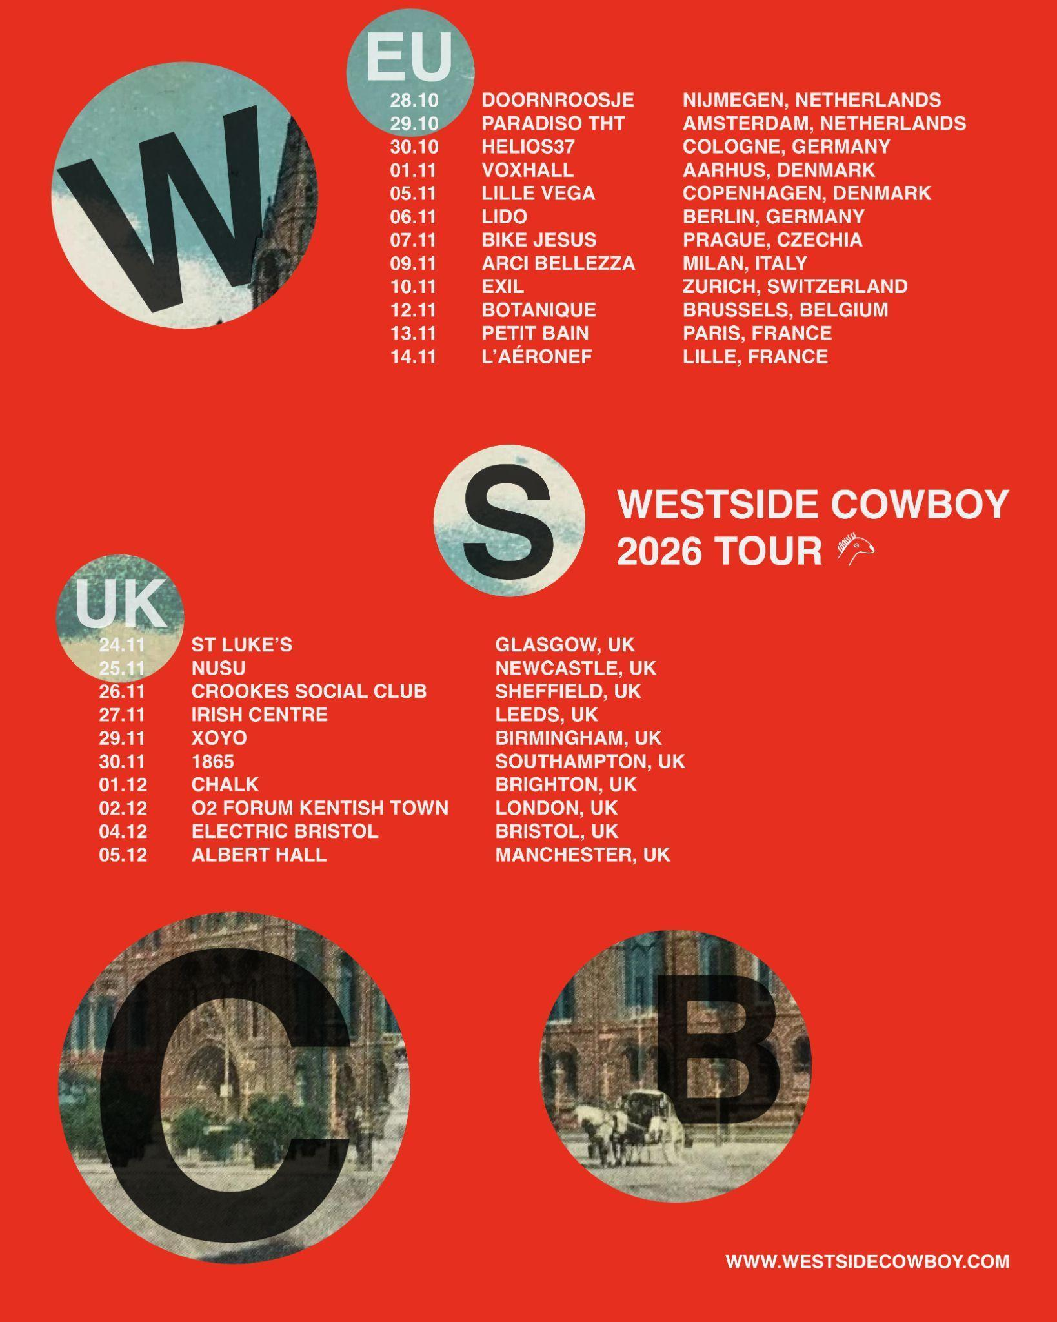

Westside Cowboy Online
Instagram / X / TikTok / YouTube / Website

SELECT ACCLAIM FOR WESTSIDE COWBOY:

“Thrilling - marked by a mood of ramshackle invention at odds with the studied, polished air of current alt-rock”
Alexis Petridis - The Guardian
"Westside Cowboy are reshaping UK indie"
DAZED
"one of Britain’s most thrilling bands"
Rolling Stone (UK)

“Come for the urgent, wistful guitars, and stay for the heart-wrenching harmonies”
Stereogum
“Rapidly climbing the rungs and notching up the wins”
DIY

“So Much Country… is an EP, but if it doesn’t set up Westside Cowboy for a very big 2026 I’ll eat my laptop”
Loud & Quiet

FULL LIVE SCHEDULE

14.05 - The Great Escape, Brighton, UK
22.05 - Bearded Theory, Walton-on-Trent, UK
24.05 - Neighbourhood, Warrington, UK
21.06 - TRNSMT, Glasgow, UK
09.07 - Ally Pally Park, London, UK (with The Maccabees)
24.07 - Tramlines, Sheffield, UK
25.07 - Latitude, Beccles, UK
26.07 - Truck, Oxfordshire, UK
21.08 - Green Man, Crickhowell, UK
28.08 - Leeds Festival, Leeds, UK
30.08 - Reading Festival, Reading, UK

24.11 - St Luke's, Glasgow, UK
25.11 - NUSU, Newcastle, UK
26.11 - Crookes Social Club, Sheffield, UK
27.11 - Irish Centre, Leeds, UK
29.11 - XOYO, Birmingham, UK
30.11 - 1865, Southampton, UK
01.12 - Chalk, Brighton, UK
02.12 - O2 Forum Kentish Town, London, UK
04.12 - Electric Bristol, Bristol, UK
05.12 - Albert Hall, Manchester, UK

For more information and press enquiries please contact

Warren Higgins
warren@chuffmedia.com

