ANNOUNCE FIRST AND ONLY ONLINE CONCERT
‘THE JOURNEY OUT OF LOCKDOWN’
17TH APRIL 2021

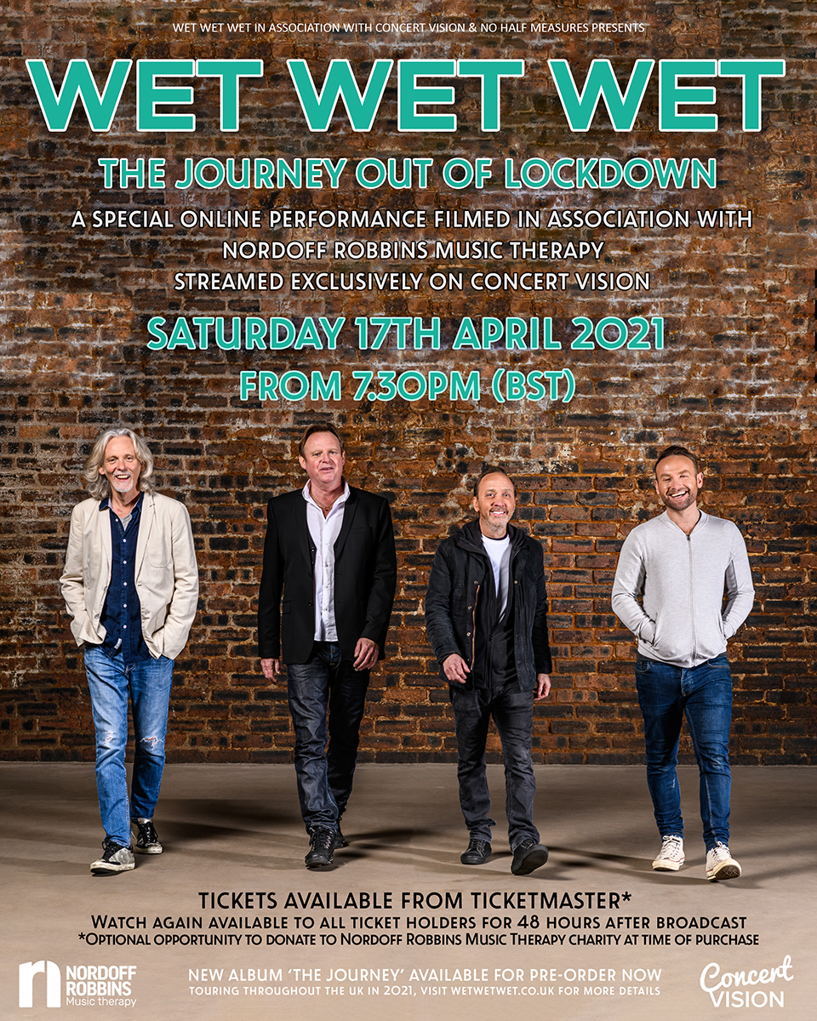

In association with the charity Nordoff Robbins Music Therapy, Wet Wet Wet will stream an exclusive one hour online show at 7.30pm on Saturday 17th April 2021.

Having spent a fair amount of time in their homes this past year, the band have been busy working on their new album entitled ‘The Journey’ whilst also finding time to entertain fans via their ‘Wet Wet Wet from Home’ sessions, rearranging original classics in videos viewed by tens of thousands. With the country still under lockdown, the band recently got together in Glasgow to record a full live band set that includes fan favourites such as Temptation, Angel Eyes, Goodnight Girl, Julia Says, Love Is All Around & so many more!

QUOTES FROM THE BAND
Tommy Cunningham: “For live musicians, COVID-19 has all but kidnapped and darkened our stages for the past year. You never realise how much you miss something until it’s not there. When the opportunity arose for Wet Wet Wet to do our only live show in lockdown, it was poignant that it was in tandem with the charity Nordoff Robbins Music Therapy. Doing the job we all love whilst trying to shine some light on them has always been important to us”.

Neil Mitchell: “Recently, we have all had other things at the forefront of our minds - life and death for some of us, and because of this charitable organisations are not necessarily a priority, so it’s important that we try our best to support these fantastic causes”.

Graeme Clark: “It hasn’t been easy to join the musical dots of being in a band during the pandemic but re-kindling our musical connection with Nordoff Robbins Music Therapy has enabled us to do just that - make music together. By playing this one off online show, we are reminded just how significant music is in our lives. We hope our music does the same for you”.

Kevin Simm: “It’s great just to be able to perform live again even without an audience present - although we would all hugely prefer to see the faces of our fans rather than just video cameras in front of us. Enjoy the stream and we’re very much hoping that the journey out of lockdown continues so we can see everybody on the road again really soon”.

Wet Wet Wet are undeniably a musical phenomenon, having made an incredible impact with their music over the last four decades, becoming one of the most successful bands in British pop history. Selling in excess of 15 million singles and albums to date, Wet Wet Wet have featured in the UK official singles and album charts for over an immense 500 weeks. With number 1 hits including ‘With A Little Help From My Friends’ and ‘Goodnight Girl’, 1994’s ‘Love Is All Around’ was the biggest selling single of the year, when it spent 15 weeks at No1, making it the longest spell at the top for any UK artist – a record that still stands.

WET WET WET – ‘THE JOURNEY’ AUTUMN TOUR 2021
Tickets on sale now from https://myticket.co.uk/artists/wet-wet-wet

Thursday 28th Oct Perth Concert Hall
Friday 29th Oct Aberdeen Music Hall
Saturday 30th Oct Edinburgh Usher Hall
Sunday 31st Oct Nottingham Theatre Royal
Tuesday 2nd Nov Halifax Victoria Theatre
Wednesday 3rd Nov Buxton Opera House
Thursday 4th Nov Bury St. Edmunds Apex Theatre
Saturday 6th Nov Eastbourne Hippodrome
Sunday 7th Nov Hastings White Rock Theatre
Monday 8th Nov Guildford G Live
Tuesday 9th Nov Portsmouth Guildhall
Thursday 11th Nov Cheltenham Town Hall
Friday 12th Nov Margate Winter Gardens
Saturday 13th Nov Stevenage Concert Hall
Sunday 14th Nov Poole Lighthouse
Tuesday 16th Nov Crawley The Hawth Theatre
Wednesday 17th Nov Weymouth Pavilion
Thursday 18th Nov Birmingham Town Hall
Saturday 20th Nov Scunthorpe Baths Hall
Sunday 21st Nov Newcastle Tyne Theatre

Please join Wet Wet Wet in supporting the amazing work done by the charity Nordoff Robbins Music Therapy and consider making (an optional) donation whilst purchasing a ticket for the band’s ‘Journey Out Of Lockdown’ online concert.

Tickets for the stream will go on sale 10am Monday 29th March 2021 from
https://www.ticketmaster.co.uk/wet-wet-wet-tickets/artist/750126

wetwetwet.co.uk / @wetwetwetuk

For more information please contact warren@chuffmedia.com

