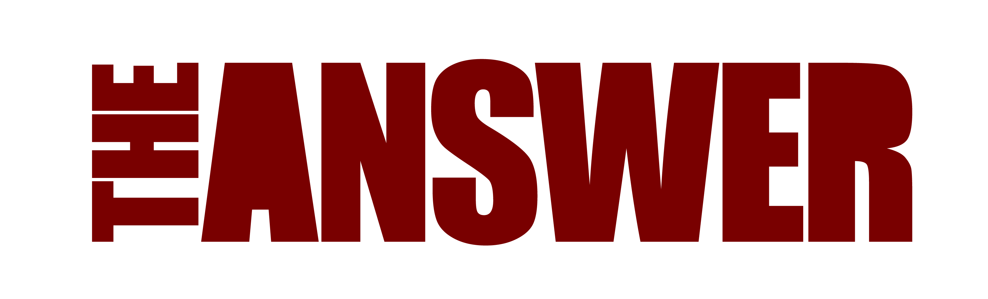
NEW TRACK
‘WANT YOU TO LOVE ME’
RELEASED JANUARY 13th, 2023
Want You To Love Me Video
Northern Irish rockers The Answer follow their storming comeback show at this year’s Planet Rock Festival with the release a second digital track on January 13th, 2023, titled Want You To Love Me. The new track is taken from their highly anticipated forthcoming album Sundowners, released on March 17th, 2023.
‘Want You To Love Me’, produced and mixed by rising British rock producer Dan Weller (Enter Shikari, Bury Tomorrow) showcases the band with a driving, grungy and raw sound, in keeping with the new direction of the album.
The band also recently announced a very special run of limited capacity UK and European album shows in March 2023 with both Belfast and London already sold out.
Says Neeson “When a friend asks me to give them a sneak peak of what this new album of ours sounds like…the first song I play them is “Want You To Love Me”. I just sit back and watch their heads start to bob up and down. This song is what we’re all about right now…dirty blues rock that hopefully makes you feel pretty damn good! The video captures the uncompromising energy of the song perfectly. I watched it 10 times when it came through to my inbox. It looks even better with a whisky in your hand too. Watch responsibly.”

The album will be released by Golden Robot Records Pty and by licensee 7Hz Productions (ADA) in the UK & Europe. It will come in several formats including a Cd Gatefold Digi sleeve, Gatefold 12” 180g black vinyl, 2 x 12” colour vinyl exclusives, a 12” fan collectible Picture Disk, Digital and various limited retail exclusive versions with HMV, Rough Trade, Crash and Assai Records.

The band’s first single of the album “Blood Brother” has received great early playlists on Planet Rock Radio UK and several German radio stations including Rock Antenne, Radio BOB!, Star FM Hamburg and Berlin, amassing over 2,000 plays in a month.

Watch video here - Blood Brother Video

Spotify: https://ada.lnk.to/WantYouToLoveMe

TOUR DATES

UK March 2023
Mar 16th Blackpool, Waterloo Bar
Mar 17th Birmingham O2 Institute.
Mar 19th Bristol Thekla
Mar 20th London 100 Club SOLD OUT
Mar 21st Leeds Key Club
Mar 23rd Belfast Limelight 2 SOLD OUT

www.myticket.co.uk
www.ticketmaster.ie

EUROPE March & April 2023
Mar 25th Haarlem, Patronaat - Holland
Mar 26th Den Bosch, Willem Twee - Holland
Mar 28th Essen, Turock - Germany
Mar 29th Hamburg, Logo - Germany
Mar 30th Berlin, Franz Club – Germany
Mar 31st Munich, Strom - Germany
Apr 1st Dornbirn, Conrad-Sohm, Austria
Apr 2nd Zurich, Plaza - Switzerland
Apr 4th Strasbourg, La Laiterie – France
Apr 5th Savigny, L’Empreinte - France
Apr 6^{th.} Vorselaar, De Dreef - Belgium

https://www.metaltix.com/the-answer-tickets-5493.html#tour1506
https://www.seaside-touring.com/tours/#answer,the

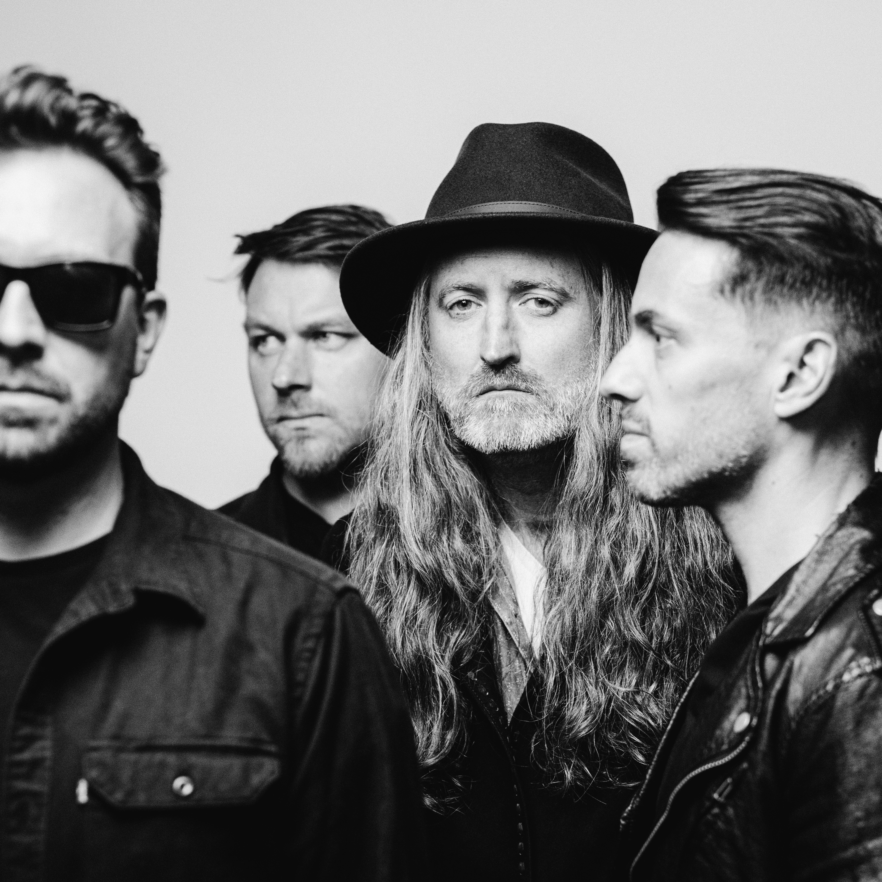

https://www.theanswerrock.com
https://www.facebook.com/theanswerrock
https://twitter.com/theanswerrocks
https://www.instagram.com/theanswerrock/?hl=en
https://open.spotify.com/artist/3STTKsLP1gSzGvOVCtNlWS?si=SYnSAgPTS3-Ji4AQvJbz4w

For more info contact warren@chuffmedia.com

