SHARES “ROOM SERVICE” VIDEO
WATCH HERE

ANNOUNCES HIGHLY ANTICIPATED DEBUT ALBUM
“PAINT MY BEDROOM BLACK”
PRE- ORDER HERE
TO BE RELEASED ON 13 OCTOBER 2023

DOUBLE A-SIDE SINGLES
“ANTICHRIST” AND “ROOM SERVICE”
OUT NOW

ANNOUNCES SEPTEMBER EU TOUR
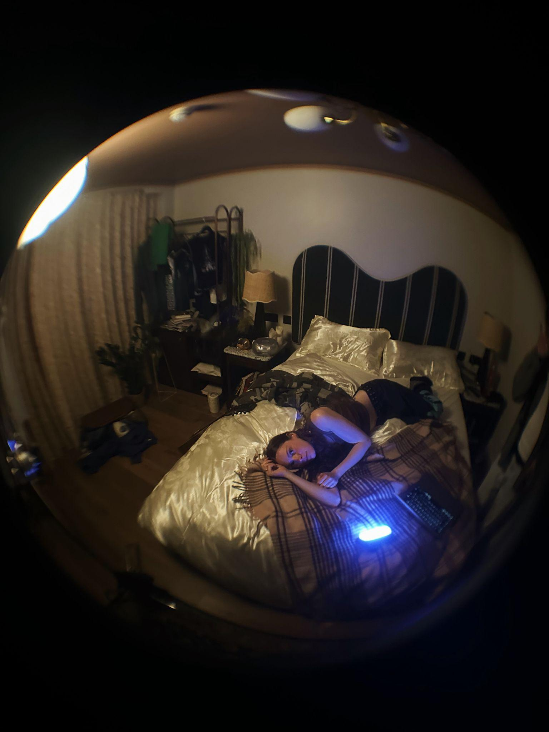

Download press pics and album artwork here Photo credit Constantine/Spence

Holly Humberstone wrote Room Service when she was touring last year, travelling from non-descript room to room and missing loved ones, feeling like she was watching their lives on phone screens. “We’ll look around to see we’ve lived another year, I’ll fill the calendar with plans for you my dear”, sings Holly over a delicate acoustic guitar. Today, the BRIT Award Winning and Ivor Novello nominated artist releases “Room Service” the video, shot in room 627 on a webcam, the same room that Holly invited 80 fans to hear songs for the first time from her highly anticipated debut album, Paint My Bedroom Black, out 13 October 2023. Inspired by early zoom calls where Holly’s world felt blurry and faraway, the video captures a day in the life of Holly on tour, trying to find normality and home in the mundane, locked away from the world in a hotel room. Part of the Grantham born singer and songwriter's double-A side single with BBC Radio 1 Hottest Record “Antichrist”, the juxtaposition of both songs, the light and dark, reflect Holly’s introspection and extraversion, two opposing artistic multitudes that inform her lyricism and sound. The introduction of these two starkly different tracks act as a revolving door into the visceral duality of Holly Humberstone.

PRE ORDER “PAINT MY BEDROOM BLACK”

LISTEN TO “ANTICHRIST”LISTEN TO “ROOM SERVICE”

"I wrote Room Service a little while ago when I’d just started touring full time. I was finding myself constantly stressed out and although I was having fun, I was really missing home and my friends. I felt like I was watching them live out their lives from a phone screen, like I was being left behind. There was this swelling feeling that I was growing apart from that world that I was missing so badly, and I just didn’t want to be forgotten. AlI I wanted to do was to get a hotel room with my best friend, lock the world out and do stupid stuff like order room service. To me, this song is a simple love song to the people I care about the most, and the seemingly basic experiences you share together that can so often be taken for granted. The busier I get, the more I treasure the precious time I get with my friends and family; the more I value them in my life." - says Holly Humberstone

With a talent for capturing and characterising moments that are both uncomfortably intimate and brutally revealing in her songwriting and creative – most of Holly’s 2022 was spent in hotel rooms, stuck between places, watching life from afar rather than being totally present in it. Lacking real connections and missing loved ones, the stirring official video for “Antichrist”, directed by Jean-Charles Chavarin, tells the story of the self-flagellation that comes with hurting someone you love, as you run away from yourself, trying to escape from room to room, until your reflection turns away from you.

WATCH “ANTICHRIST” HERE
PAINT MY BEDROOM BLACK TRACKLISTING
- Paint My Bedroom Black
- Into Your Room
- Cocoon
- Kissing In Swimming Pools
- Ghost Me
- Track 6
- Antichrist
- Lauren
- Baby Blues
- Flatlining
- Elvis Impersonators
- Girl
- Room Service

Having just headlined her first UK festival at Barn On The Farm, Holly also performed “Antichrist” to 100,000 fans at Newcastle’s St James Park earlier this month, supporting Sam Fender and reminding fans that she is one of the most compelling British live acts. When Holly first brought her intimate live shows to audiences in 2021, fans were already singing every word from her breakout debut EP, “Falling Asleep At The Wheel” released in 2020. A global tour followed, with sell-out shows across the USA including LA’s Roxy to two nights at New York’s Bowery Ballroom, which led to Holly being invited on tour with Olivia Rodrigo and Girl in Red across North America. It was on these trips through soulless hotel rooms from March to December last year that the 23-year-old began piecing her album narrative together. Striking themes of lost loves, family units, and the deep-set fears of youth and growing up intertwined with sparse and expansive sonic production, Holly’s “crazy” headspace led to the foundations of Paint My Bedroom Black. “I have had such a fun, crazy, challenging few years,” Holly says, “I wanted to put absolutely all of that into this album. An album is a much different headspace for me, but it is filled with snapshots of where I’ve been and where I’m at.”

Snapshots of Holly flit everywhere from last year’s single “Can You Afford To Lose Me”, performed on Late Night With Stephen Colbert, to playing Matty Healy co-written “Sleep Tight” for VEVO, taking festivals by storm from Coachella to her debut Glastonbury performance and Reading & Leeds. Humberstone has become one of the most loved breakthrough artists for her raw, unfiltered, confessional songwriting and distinctive, can-hear-a-pin-drop vocals, picking up fans from Olivia Rodrigo to Phoebe Bridgers, Sigrid to Glass Animals and Sam Fender, and inspiring the next generation of alternative pop acts including Tommy Lefroy, Katie Gregson-Macleod, and Matilda Mann, whilst collaborating with the likes of Jack Steadman in Bombay Bicycle Club and Griff.

Finishing 2022 on a huge high, ending her biggest UK headline tour with 5000 fans singing back favourites “Scarlett” and “Overkill” at O2 Academy Brixton, the physical manifestation of her 242.6M global streams, Holly Humberstone started 2023 with her journal in hand and creative, walled off time, as she locked herself away in Rob Milton’s studio in London, to piece together the pieces of herself she felt like she left on the road, in rooms across the world. Holly has become renowned for painting a picture of a place so viscerally, being rooted in the walls and also people that makes a city liveable, where you can “get drunk with your mates and just forget about work”. From her family home in “Haunted House” to feeling lost and isolated in her London shared flat with The Walls Are Way To Thin, Paint My Bedroom Black is Holly’s fragmented and dark love letter to friends and lovers, a hideaway from the world when her fans need one.

Live

19 Aug Japan Summer Sonic Tokyo
20 Aug Japan Summer Sonic Osaka
26 Aug UK Reading Festival
27 Aug UK Leeds Festival
3 Sep Ireland Electric Picnic
19 Sept France La Bellevilloise, Paris,
20 Sept Amsterdam Melkweg, Oude Zaal
21 Sept Berlin Gretchen

Follow Holly Humberstone:
YouTube/ Instagram / Twitter / Facebook / Spotify /
Apple/ / TikTok

For more information and press enquiries please contact

Jenny Entwistle
Jenny@chuffmedia.com

