

SHARES VIDEO FOR FORTHCOMING ALBUM TITLE-TRACK, “PEOPLE WATCHING” – WATCH HERE

FEATURES BAFTA WINNING IRISH ACTOR, ANDREW SCOTT

“PEOPLE WATCHING” LP RELEASED 21ST FEBRUARY 2025

NOMINATED FOR “ARTIST OF THE YEAR” + “BEST ALTERNATIVE/ROCK ACT” AT THE BRIT AWARDS 2025

HEADLINES RADIO 1’S BIG WEEKEND AT SEFTON PARK, LIVERPOOL IN MAY

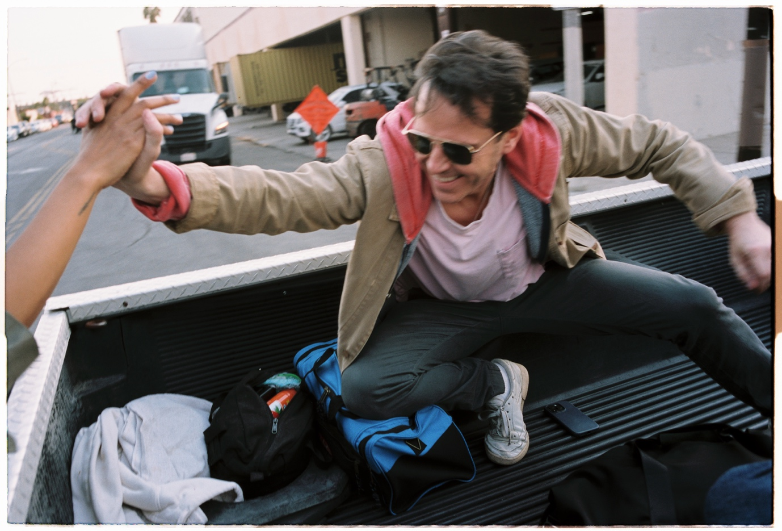

Sam Fender shares the stunning video to the title-track from his forthcoming third album, People Watching. The new record is released 21st February via Polydor Records.

Watch the People Watching video HERE

The video features the globally acclaimed, BAFTA and Laurence Olivier Award winning Irish actor, Andrew Scott. Scott is known for his award-nominated performances in the likes of the BAFTA-nominated film, All of Us Strangers; the Emmy-nominated Netflix limited series Ripley; and the stunning West End production of Chekhov’s “Uncle Vanya,” in which he brought eight characters to life. Upcoming, he will star in the newest Knives Out film: Wake Up Dead Man; and Richard Linklater’s Blue Moon which will premiere at the Berlin Film Festival in February. The Dublin born actor here puts in a heart-wrenching depiction of love and loss in the official video for Sam’s soaring anthem.

Andrew Scott on People Watching: “Sam’s masterpiece of a song has become a true friend to me. Working on it was truly cathartic, and I’ll always be grateful to Sam for his extraordinary talent, and for the other artists who made this film, and of course to my mum, who I will hold in my heart til the day I die.”

Speaking of Scott’s role in the video, Sam explains, “I’m really excited for the People Watching video to be out in the world this week. I was so buzzing when I found out Andrew wanted to be involved - I’m a huge fan of his and he was absolutely perfect for the role.”

The video was directed by Stuart McIntyre at Long Beach, California.

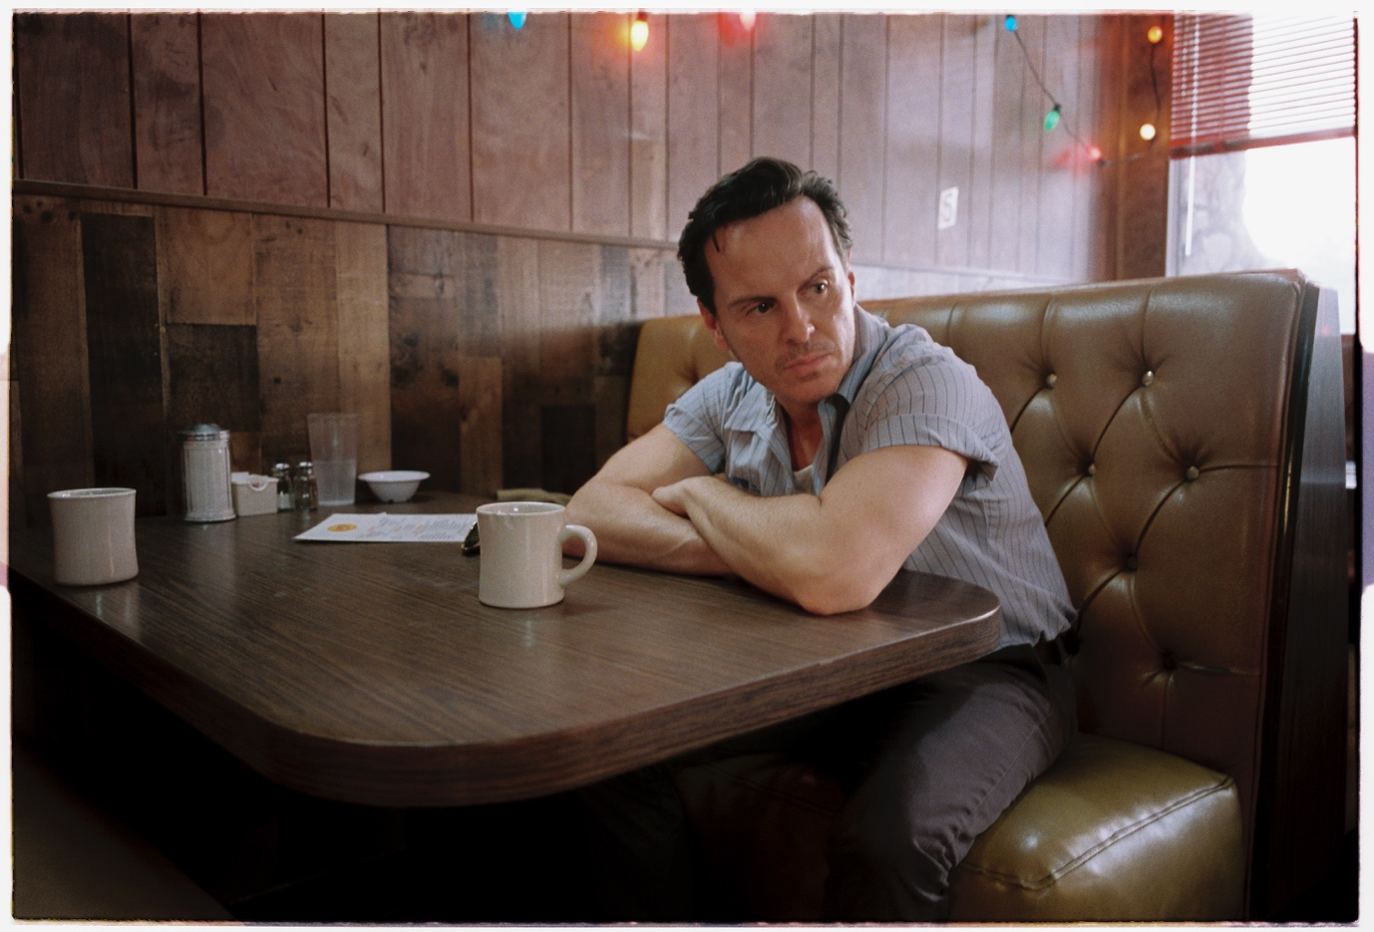

Last week, Sam shared his new single, Arm’s Length, a song that received a huge reaction from his fans on the sold-out UK/Ireland arena tour at the end of 2024, with its Fleetwood Mac inspired riff and widescreen, cinematic atmospherics.

Fender: “Arm’s Length originally came from one of those magic moments where you’re just messing around, and a song literally falls out of the sky. It’s about being avoidant and flighty. But also, just a simple pop song, which I love”

Now solidified as one of Britain’s most accomplished songwriters of his generation and the next, if Seventeen Going Under was Sam’s “coming of age” record, People Watching is his next step forward - colourful stories and observations of everyday characters living their everyday, but often extraordinary, lives.

Sam gears up for a sold-out tour of Europe in March, ahead of a Spring US tour. Back in the UK, stadium dates went on sale for next June, with three nights at Newcastle’s St. James Park selling out immediately. Fender’s biggest show to date at the London Stadium is down to its final tickets - on sale now via www.samfender.com. CMAT supports at all four shows, and The War on Drugs will play on 6th and 14th + 15th June.

£1 from every ticket sold on the Stadium run will be donated to select cultural organisations such as Youth Music and Sunday for Sammy to support the arts in the North East of England.

Pre-order the album HERE

Sam Fender Live – People Watching Tour

European Tour (support from CMAT):
4th March – Olympia, Paris SOLD OUT
5th March – 013 Poppodium, Tilburg SOLD OUT
8th March – Halle 622, Zurich SOLD OUT
10th March – Palladium, Cologne SOLD OUT
12th March – Zenith, Munich SOLD OUT
13th March – ChorusLife Arena, Bergamo SOLD OUT
16th March – Uber Eats Music Hall, Berlin SOLD OUT
18th March – Afas Live, Amsterdam SOLD OUT
19th March – Forest National, Brussels SOLD OUT

5th April - Doug Mitchell Thunderbird Sports Centre - Vancouver, BC
7th April - The Paramount Theatre - Seattle, WA
9th April - Roseland Theater - Portland, OR
11th April - Fox Theater - Oakland, CA
12th April - Coachella Festival, CA
19th April - Coachella Festival, CA
21st April - Marquee Theatre - Tempe, AZ
23rd April - The Union Event Center - Salt Lake City, UT
24th April - The Fillmore - Denver, CO

23rd-25th May – Radio 1’s Big Weekend 2025, Sefton Park, Liverpool
6th June – London Stadium (w/ The War on Drugs + CMAT)
12th June – St. James’ Park, Newcastle (w/ CMAT) SOLD OUT
14th June – St. James’ Park, Newcastle (w/ The War on Drugs + CMAT) SOLD OUT
15th June - St. James’ Park, Newcastle (w/ The War on Drugs + CMAT) SOLD OUT
21st June – Hurricane, Germany
22nd June – Southside, Germany
5th July – Rock Werchter, Belgium
6th July – Down The Rabbit Hole, Ewijk
11th July - NOS Alive, Lisbon
8th August – Syd for Solen, Copenhagen

www.samfender.com

For more information and press enquiries for SAM FENDER please contact

Jenny Entwistle
Jenny@chuffmedia.com

