A1 X J1
RELEASE THE REMIX OF ‘LATEST TRENDS’ FEATURING AITCH
OUT NOW ON EMI RECORDS

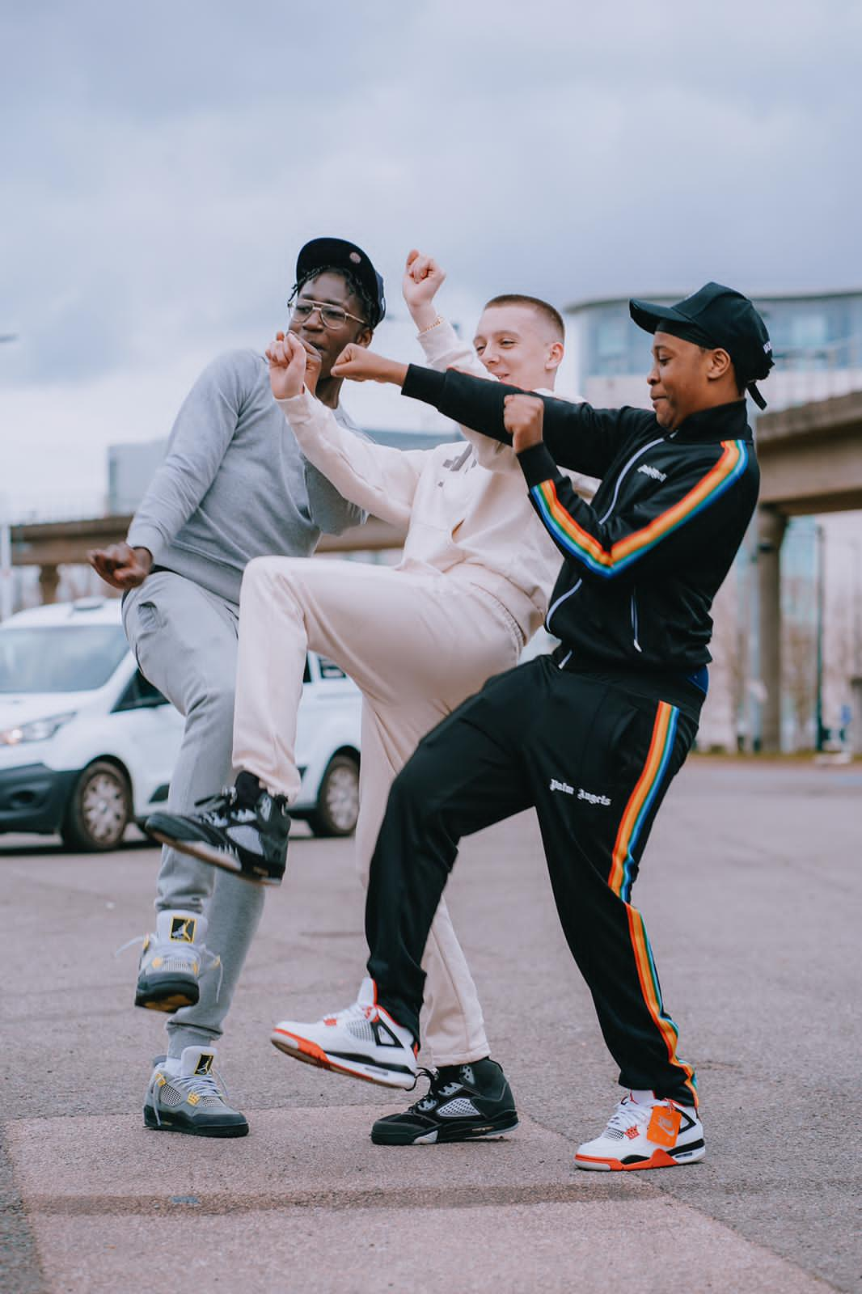

Entering the Official Charts Top 20 with their debut single “Latest Trends”, sitting in the Top 10 Spotify Chart and holding No.11 in the Global Viral Chart, A1 & J1 two of the newest rappers on the block have now released their hotly anticipated remix with one of the UK’s favourite rappers. Aitch has jumped on the remix to cement this track as an anthem throughout the upcoming summer.

Aitch put a snippet of a verse idea on Tik Tok and Twitter before surprising A1 and J1 in the studio to make the remix happen after showing his support on social media a few times. This is not the only thing new on the track. A1 has laid down a new verse for the remix, supplying fans with fire new bars. A1 bounces off of Aitch as they go back and forth in this new verse. The remix really solidifies why these 2 are the hottest UK prospects.

The love shown between the artists has been phenomenal and it has all come together naturally with mutual respect for each other, with Aitch fully backing them and wanting them to succeed.

Aitch wrote a message about A1 & J1 on his Snaphchat “I found out what studio A1 & J1 was at and I pulled up to them unexpectedly. Loved what the young G’s were doing and their story behind how they linked up and how they made the “Latest Trends” song, so wanted to meet them in the flesh and show some love. Got to the studio and was gassed to meet each other on both sides! I asked if I could jump on a remix to the song. The boys kindly said yes and we got it cracking. Done the remix there and then caught a vibe”.

“Latest Trends” has been Shamazed over 100k times in a month, has seen support from Rickie, Melvin and Charlie, Scott Mills, DJ Target & Reece Parkinson and is on the Kiss, Kiss Fresh, Kiss Dance, Capital Xtra, Radio 1 and 1Xtra playlists.

The track has been streamed 15.5 million on Spotify. It is in viral charts worldwide and Top 10 in Belgium, Iceland, Switzerland, Austria, Denmark, Sweden, Ireland, Norway, Australia, UK, Germany, Canada and Netherlands. Artists have also flooded in to support the track including JB Schofield, KSI, Darkoo, S1mba, and Deno. There is no limit to how far this track will go.

“Latest Trends” is sure to be the anthem of the Summer and this remix is going to keep fans hooked on this track.
A1 X J1 Featuring Aitch– Latest Trends (Remix)

[Watch]
https://youtu.be/7zbt4zliK4c

[Download/Stream]
https://a1xj1.lnk.to/LatestTrends

A1: TIKTOK | INSTA
J1: TIKTOK | INSTA
A1 X J1 YOUTUBE CHANNEL

For further information contact warren@chuffmedia.com

