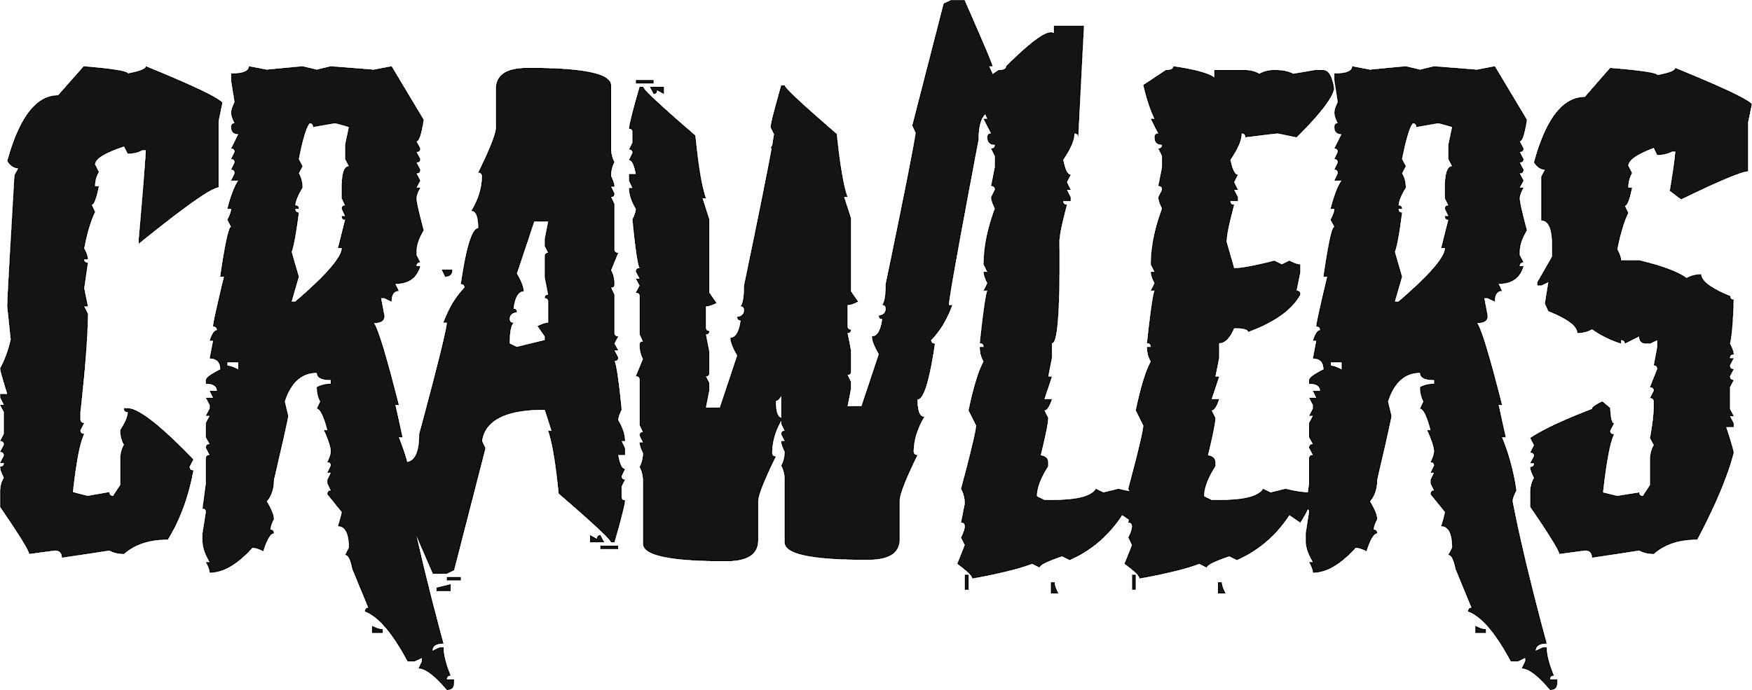

‘FUCK ME (I DIDN’T KNOW HOW TO SAY)’
MUSIC VIDEO RELEASING: 22ND JUNE 2022
WATCH HERE (LINK)

Today, Liverpool-based four-piece CRAWLERS share their stunning new video for ‘Fuck Me (I Didn’t Know How To Say)’. ‘Fuck Me’, is the band’s second release on Polydor Records, and boasts a compelling concoction of big, grungy riffs that speak sonically to the real-world dissonance between unrelenting femininity and equality. ‘Fuck Me’ sees lead singer Holly Minto pivoting the lens inwards as she examines her relationship with her own body. It’s yet another example of the bold, probing songwriting that makes CRAWLERS such an important new band and a powerful force to be reckoned with.
“I know I used to be in love,” she whispers on the song. “The kisses that led to sex were close enough.” Holly elaborates, “Fuck Me (I Didn’t Know How To Say)”’ is a song that’s very personal to us as a band. The song covers two ideas behind sex. First the trauma and disgust after sexual assault, and then the idea of how at the time of writing it I haven’t felt loved and only used for my body and for sex rather than the love I really wanted at the time.” With regards to the song's inspiration, Holly states “There’s a song that goes ‘You kiss me just to kiss me’ and I was like, ‘Damn, I’ve never been kissed just to be kissed’,” she explains. “I just sat there and had a little moment about it and was like, ‘Have I just been letting people use me so I can feel loved?’”
In line with the powerful message behind the band’s latest offering, the Ash K Halliburton directed visual cleverly plays with the idea of the tinted lens through which we see ourselves and others. As the camera’s hazy perspective hops between that of Holly’s and her oppressor’s opposing points of view - using juxtaposing color palettes to drive forward the idea of the underlying dissonance between their perspectives - we see scenes of the band performing in slow motion as they set the narrative for a visceral and affecting visual storytelling experience.

About Crawlers:
Since their inception, CRAWLERS have been putting the work in, gigging across Merseyside, working on their songwriting and steadily building an impressive following on social media. Their debut EP - released through Modern Sky/Lab Records in October – has now clocked up over XX million combined streams and landed the band their first hit with ‘Come Over (Again)’, which crashed into the Official UK Singles Chart thanks to fan power alone. To date it has racked up over 28 million streams on Spotify, 1.5 million views on YouTube and was a Radio 1 Tune of the Week. Since releasing ‘Fuck Me (I Didn’t Know How To Say) on May 19th, the single has racked over 73k streams across all DSP’s, as well as holding in the UK daily streams this week at 6k on Spotify. ‘F*ck Me (I Didn't Know How To Say)’ has also received six plays at Radio 1 to date, having been featured on Clara Amfo, Jack Saunders and BBC introducing.
After signing to Polydor Records in January, the band released new single ‘I Can’t Drive’ which was Jack Saunders Tune of the Week on Radio 1 and garnered support from the likes of NME, Kerrang, Clash, DIY, Dork and Sunday Times Culture. With a sold out debut UK tour under their belts, the band announced a nationwide autumn tour with 10 headline shows including London’s Scala on November 2nd. Prior to this, CRAWLERS will play a month-long headline tour of North America in June and perform at Lollapalooza, as well as fulfilling a childhood dream when they support My Chemical Romance in Warrington on May 27th.
CRAWLERS are: Holly Minto (she/they), Amy Woodall (she/her), Liv Kettle (she/they) and Harry Breen (he/him).

Connect with CRAWLERS:
INSTAGRAM
TWITTER
FACEBOOK

For more information and press enquiries please contact
Jenny Entwistle
Jenny@chuffmedia.com

