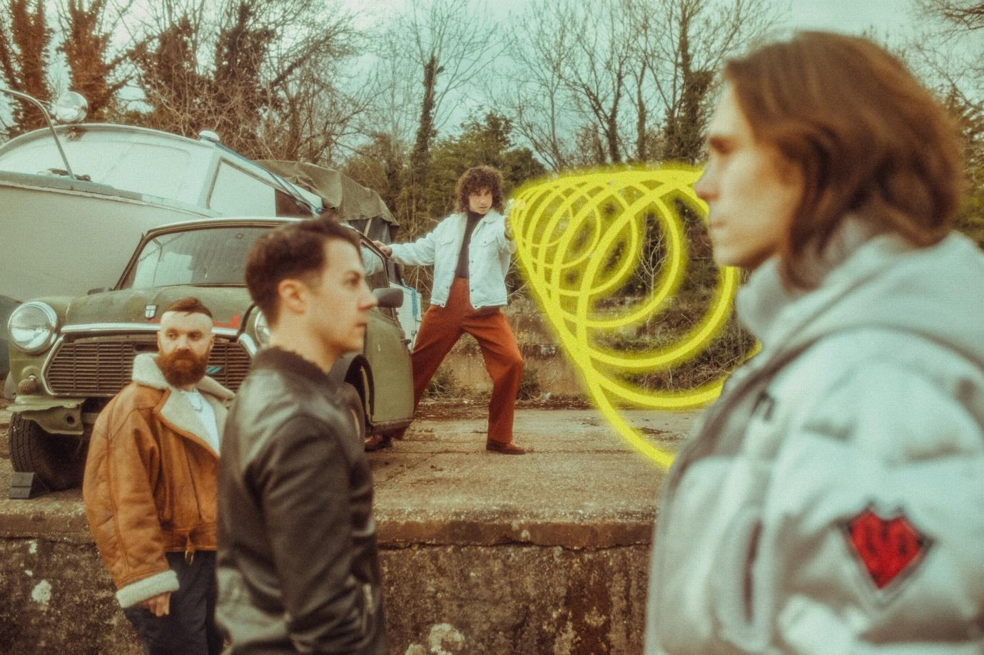
Photo credit: Fraser Taylor

‘ENDORPHINS’
BRAND NEW SINGLE
WATCH HERE / LISTEN HERE

BRAND NEW ALBUM
AMAZING THINGS
DIGITALLY RELEASED OCTOBER 22ND
*NEW PHYSICAL RELEASE DATE OF JAN 28TH*
VIA SHARPTONE RECORDS
PRE-ORDER HERE

‘ONE TRUE PRINCE’
ORCHESTRAL PERFORMANCE
LIVE FROM ABBEY ROAD STUDIOS
WATCH HERE

UK HEADLINE TOUR
OCTOBER / NOVEMBER 2021
TICKETS AVAILABLE HERE

Don Broco have released their new single ‘Endorphins’ alongside a brand new video. The track is the latest to be taken from their forthcoming new album Amazing Things, which will be digitally released on October 22nd via Sharptone Records. Watch ‘Endorphins’ here.

‘Endorphins’ is an unmistakable slice of Don Broco’s power, delivering yet another pulsating and infectious anthem. Overflowing with monstrous riffs, jagged synths, pummelling drums and a towering irresistible chorus, the track sees them blend their light and dark sides together.

The video is another brilliant addition to Don Broco’s catalogue of supremely inventive, creative and funny short films, with the band posing as shape-shifting super heroes battling masked villains in a martial arts, lazer-gun battle for supremacy… along with some awesome performance footage of them blasting out the track.

“Power Rangers was without doubt my favourite show when I was a kid,” vocalist Rob Damiani shared. “When my parents actually went through with a long threatened punishment of taking away the TV (I think because me and my brothers were fighting too much), it was the one programme I was still allowed to watch on a Saturday morning, albeit on the black and white TV in my Dad’s garden shed. After an ENTIRE YEAR of this (still can’t believe my parents actually went through with it - pure evil) for Christmas not only did they bring the TV back, I also got the Green Ranger’s Dragon Dagger for my present!”

“While writing Endorphins as soon as the line ‘mighty morphin into a piece of shit’ materialised I knew I wanted to live my childhood fantasy in the video and luckily the boys were up for it! Huge thanks to Harry Lindley and Elaina Mensing for all their hard work and talent making it happen, as well as letting me use my original Dragon Dagger in the fight against Scorpion King Beckham! We hope you guys all love the vid as much as we do.”

The band also recently unveiled a stunning live orchestral version of ‘One True Prince’, filmed in partnership with Amazon Music at the revered Abbey Road Studios in London. The epic track is rocketed into the stratosphere with backing from the London Metropolitan Orchestra, enhancing all of its most enchanting moments to create a spine-tingling, mesmerising rendition. Watch the performance here.

Always unique, and forever pushing boundaries, Don Broco are never ones to follow the trend and the new album Amazing Things is very aptly named. It’s yet another genre-bending masterpiece with electro, rock, pop, metal and more all wrapped up in their own unique blend, bringing to mind the likes of Deftones, Beastie Boys and Linkin Park amongst others… but simultaneously sounding like nobody else on earth.

Fans have been wildly enthusiastic about the singles released through the summer, with ‘Manchester Super Reds No.1 Fan’, ‘Gumshield’ and ‘One True Prince’ and ‘Uber’ all being accompanied by spectacular videos that are as unique as Don Broco themselves.

Amazing Things is the band’s fourth album, and follows the release of 2018’s Technology, which was was a Top 5 album in the UK charts and has had over 100 million streams to date, and also 2015’s Automatic, which provided the band with their first Top 10 album in the UK. Unfortunately due to the ongoing supply and manufacturing issues currently affecting many artists, the physical release of Amazing Things has sadly had to be delayed until January 28th 2022. For full details on that, the band have issued a statement HERE.

A ferociously good live band, acclaimed for their relentless high-octane performances, Don Broco have previously sold-out arena shows across the UK, headlining Wembley Arena after selling out Alexandra Palace as well as festival performances around the world including Vans Warped Tour, Download, Reading & Leeds, Slam Dunk & more. They set out on a major headlining tour of the UK later this month which includes multiple nights in UK cities, featuring two shows at London’s Brixton Academy and ending with a special sold out hometown show in Bedford.

Tickets for all of the upcoming shows are available here.

DON BROCO 2021 TOUR DATES
Oct 25th – O2 Academy, Newcastle
Oct 27th – Barrowlands, Glasgow
Oct 28th – Manchester Academy, Manchester
Oct 29th – Mancester Academy, Manchester SOLD OUT
Oct 31st – Guildhall, Portsmouth
Nov 1st – Rock City, Nottingham SOLD OUT
Nov 2nd – Rock City, Nottingham
Nov 4th – UEA, Norwich
Nov 5th – O2 Academy Brixton, London
Nov 6th – O2 Academy Brixton, London SOLD OUT
Nov 8th – O2 Academy, Oxford
Nov 9th – O2 Academy, Bristol
Nov 10th – Esquires, Bedford SOLD OUT

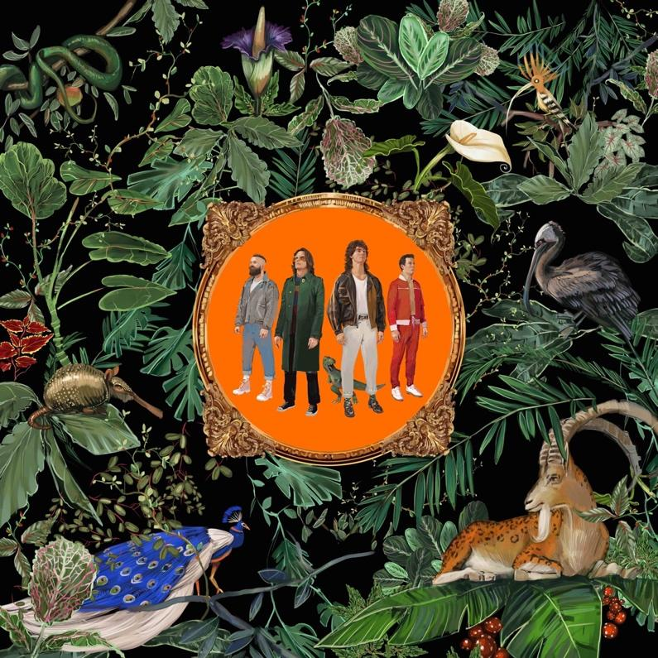

WEBSITE
INSTAGRAM
FACEBOOK
YOUTUBE
TWITTER

For more information and press enquiries please contact
Jenny Entwistle
Jenny@chuffmedia.com

