BREAKOUT PRODUCER NAVOS RELEASES
RAVE REHAB VIDEO FOR VIRAL SINGLE ‘BELIEVE ME’

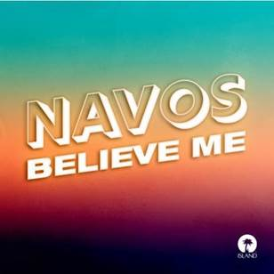

Watch the official ‘Believe Me’ video HERE
Listen to ‘Believe Me’ HERE
Press Assets HERE

Are you worried that you’ve been isolated for so long you can’t remember how to party? Are you desperately craving a rave? If so look no further, as rising dance producer NAVOS has released a video for his huge single ‘Believe Me’, to teach us how to rave again.

Following a chance discovery on Tik-Tok after being in born in his girlfriends bedroom during lockdown, ‘Believe Me’ instantly went viral and has since taken the internet by storm. The single is fast approaching the Top 20 Official Charts, landed a place in Capital’s A List and Radio 1’s B List, received over 150k Shazams and has hit over 8+ million plays on Spotify, proving the songs impact is humongous.

After being in lockdown for so long, partying has been put on hold and we’ve become boring versions of ourselves, sat at computer screens and living monotonous lives. Shot in a convention centre, the video is based on a ‘Rave Rehabilitation Centre’ where music lovers are taught how to party again post-lockdown. The opening scene focuses on ex partygoers discussing the mourning of day raves and UK nightlife in a tongue and cheek therapy session. As the energy of the video picks up, the patients are taught how to dance and let loose with the help of VR headsets, congregating on a rooftop for a long awaited rave in the final scene.

Only a short few months ago, NAVOS was working in a furniture shop in Liverpool and making his way through his last year at university. Now the ordinary 21-year-old lad is on the cusp of breakout success and ‘Believe Me’ is fast becoming the party anthem of 2021.

When dance-floor lovers are finally reunited, this club-tinged banger will embody a feeling of freedom and togetherness that we’ve all been waiting for. Speaking to MistaJam during his Capital Dance show NAVOS said, “Thanks to all this time indoors I’ve been able to put more time into my music and it’s one of the many positives that’s come out of a negative situation.”

If you miss the thumping bass, festival wristbands stronger than your last relationship and the feeling of leaving a rave when the birds are chirping, then check yourself into NAVOS rehab centre to make sure you’re rave ready for summer 2021.

FOLLOW NAVOS ON SOCIAL MEDIA:

Instagram | Twitter | Tik Tok

For more contact warren@chuffmedia.com

