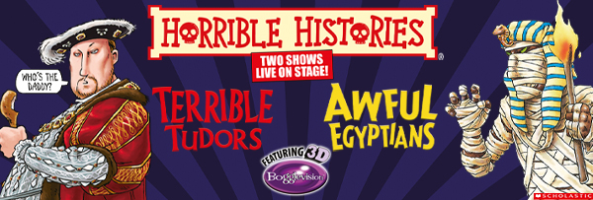

HORRIBLE HISTORIES LIVE ON STAGE
BRINGS TWO FUN-PACKED SHOWS TO YOUR LOCAL THEATRE

Families in are in for a historical treat as Horrible Histories Live on Stage arrives in town with Terrible Tudors and Awful Egyptians! These two horrible productions will take audiences on a wildly entertaining journey through history, packed with outrageous facts, larger-than-life characters and featuring spectacular eye-popping 3D special effects that will leave the whole family spellbound.

Terrible Tudors and Awful Egyptians are two separate, must-see shows that bring history to life in all its gruesome glory. Families can choose to experience one or double the fun by seeing both!

Terrible Tudors – From the horrible Henries to the evil Elizabeth, this show unveils the legends (and the lies!) of the torturing Tudors. Discover the fate of Henry VIII’s unlucky (and headless!) wives, witness his punch up with the Pope, and meet Bloody Mary. Plus, prepare to duck as the Spanish Armada sails straight into the audience!

Awful Egyptians – From the fascinating Pharaohs to the power of the pyramids travel back to Ancient Egypt and uncover the foul facts of death, decay, and those menacing mummies! Are you ready to rumble with Ramesses the Great? Will you dare to pass through the Gates of the Afterlife? This is Egyptian history with all the nasty bits left in!

Whether families choose Terrible Tudors, Awful Egyptians, or both, they’re guaranteed a laugh-out-loud, eye-popping adventure through time!

Don’t miss out on the ultimate history lesson, Horrible Histories shows are recommended for ages 5 to 105 (106 year olds may not like them!).

Horrible Histories – Terrible Tudors & Awful Egyptians are written by Terry Deary, Neal Foster and JP Cherrington based on Terry Deary’s bestselling books. Terry is the world's bestselling non-fiction author for children and one of the most popular children’s authors in the country. He has written 200 books which have been translated into 42 different languages. His 50 Horrible Histories titles have sold over 35 million copies worldwide from China to Brazil!

Both shows are directed by Neal Foster, designed by Jackie Trousdale, lighting by Jason Taylor, sound by Nick Sagar, music by Matthew Scott and choreography by Kenn Oldfield.

Birmingham Stage Company is one of the world’s top theatre companies for families. They have produced all the Horrible Histories live stage shows since 2005. The BSC also created the smash-hit productions of David Walliams’ Awful Auntie, Gangsta Granny and Demon Dentist and adaptations of Roald Dahl stories like George’s Marvellous Medicine.

20th – 22nd March Sunderland, Empire
27th – 30th March Darlington, Hippodrome
4th – 6th April Chelmsford, Theatre
10th – 12th April Birmingham, The Alexandra Theatre
16th – 19th April Northampton, Royal & Derngate
24th – 26th April Belfast, Grand Opera House
8th – 11th May Richmond, Theatre
15th – 17th May Leeds, Playhouse
22nd – 25th May Truro, Hall For Cornwall
29th May – 1st June Exeter, Northcott Theatre
5th – 7th June Grimsby, Auditorium
12th – 14th June Cardiff, New Theatre
18th – 22nd June Dublin, 3Olympia Theatre
26th – 29th June High Wycombe, Swan
10th – 12th July Glasgow, Theatre Royal

For all media enquiries contact Warren Higgins at Chuff Media
warren@chuffmedia.com / 07762 130510

