SAM FENDER SHARES NEW TRACK, THE DYING LIGHT

UK ARENA DATES SET FOR SPRING 2022

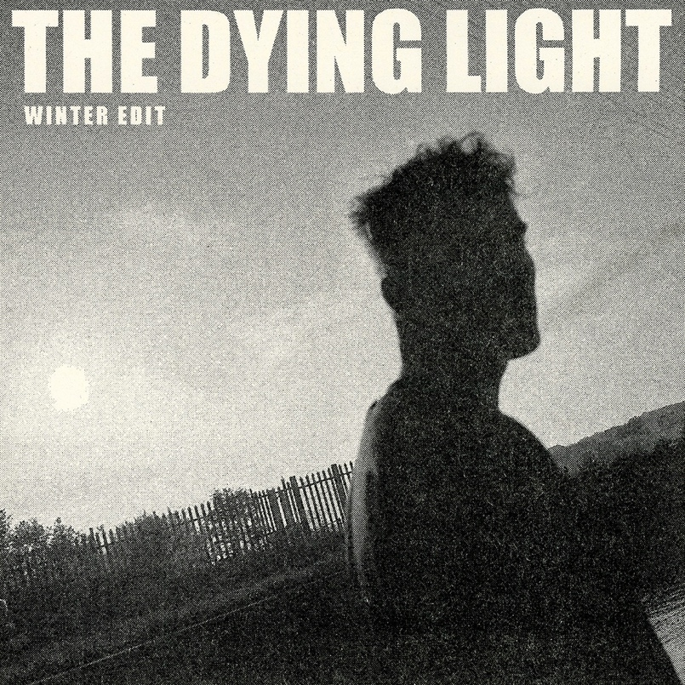

“urgent, incisive and brave” ***** - The Guardian
“this is very special indeed” ***** - DORK
“Stunning” **** - Rolling Stone UK
“One of the year’s best” **** - NME
“It feels good to have a popular artist whose songs not only fill your heart and twitch your hips, but also say things worth hearing” ***** - The I
“an album shot through with the adrenalin of youth” **** - The Telegraph
“An album of the year contender” **** - Daily Star
“A towering piece of work… one of this generation’s truly great songwriters” 8/10 – The Line of Best Fit
“lyrics worthy of a real listen” 8/10 - Clash
“A once in a generation artist delivers a stunning second album” 10/10 - Gigwise
**** - The Independent
**** - The Times

﻿Sam Fender is pleased to share “The Dying Light”, the latest track to be lifted from his chart topping, critically acclaimed second album, Seventeen Going Under.

Watch the animation for The Dying Light by Amitay Leopold HERE
It’s been a year to remember for Newcastle’s latest, greatest son, Sam Fender. He welcomed it in whilst putting the finishing touches to a bruisingly open, honest and personal second record, and he now concludes it as an unlikely Tik Tok viral success story, the creator of one of the most successful British albums of the year, all whilst looking ahead to his biggest arena tour to date next Spring,

Sam: “This is the closing track on the standard version of Seventeen Going Under. I wrote it at a time when we’d sadly lost a good friend to mental health. It was a confusing and painful time for our town, I found myself in a bit of a bad way, and The Dying Light is what came from that time. It became a sort of sequel to Dead Boys off the first album, but where Dead Boys was about male suicide in itself, The Dying Light was about conquering that moment, and surviving for your friends and family. It’s a triumph over the dark, and a celebration of life and love.
The Dying Light is a multi-layered, sky-scraping anthem that shoots for the stars and touches them all. The ever-present electric guitar is momentarily replaced by piano, as Sam sings from a swelling chest and straight from the heart. It’s the proverbial light at the end of the tunnel, referencing lyrics from Sam’s 2019 breakthrough single, Dead Boys. The song explodes in a shower of musical fireworks. A set closer if ever you heard one, it’s a celebration of life and a respectful nod to those that were unable to find their way through the darkness. An extraordinary song by a generational talent.
Sam Fender Live 2022:

20th March – Motorpoint Arena, Nottingham
21st March – M&S Bank Arena, Liverpool
24th March - 3Arena, Dublin
26th March – SSE Hydro Arena, Glasgow SOLD OUT
27th March – Utilita Arena, Birmingham
30th March - Brighton Centre SOLD OUT
1st April – SSE Arena Wembley, London SOLD OUT
2nd April - SSE Arena Wembley, London *NEW DATE*
5th April – Utilita Arena, Newcastle SOLD OUT
6th April - Utilita Arena, Newcastle SOLD OUT
3rd June – Emirates Stadium, London (w/ The Killers)
4th June – Emirates Stadium, London (w/ The Killers)
14th June – Malahide Castle, Dublin (w/ The Killers)
15th June – Malahide Castle, Dublin (w/ The Killers)
6th July – Castlefield Bowl, Manchester SOLD OUT

For more information and press enquiries please contact

Jenny Entwistle
Jenny@chuffmedia.com

