BILLIE MARTEN SHARES NEW SINGLE, “LEAP YEAR” – LISTEN HERE
THE BRITISH FOLK ARTIST’S FIFTH LP, “DOG EARED”, OUT FRIDAY 18TH JULY VIA FICTION RECORDS
+ SET FOR THE ACOUSTIC STAGE AT GLASTONBURY ON FRIDAY 27TH JUNE
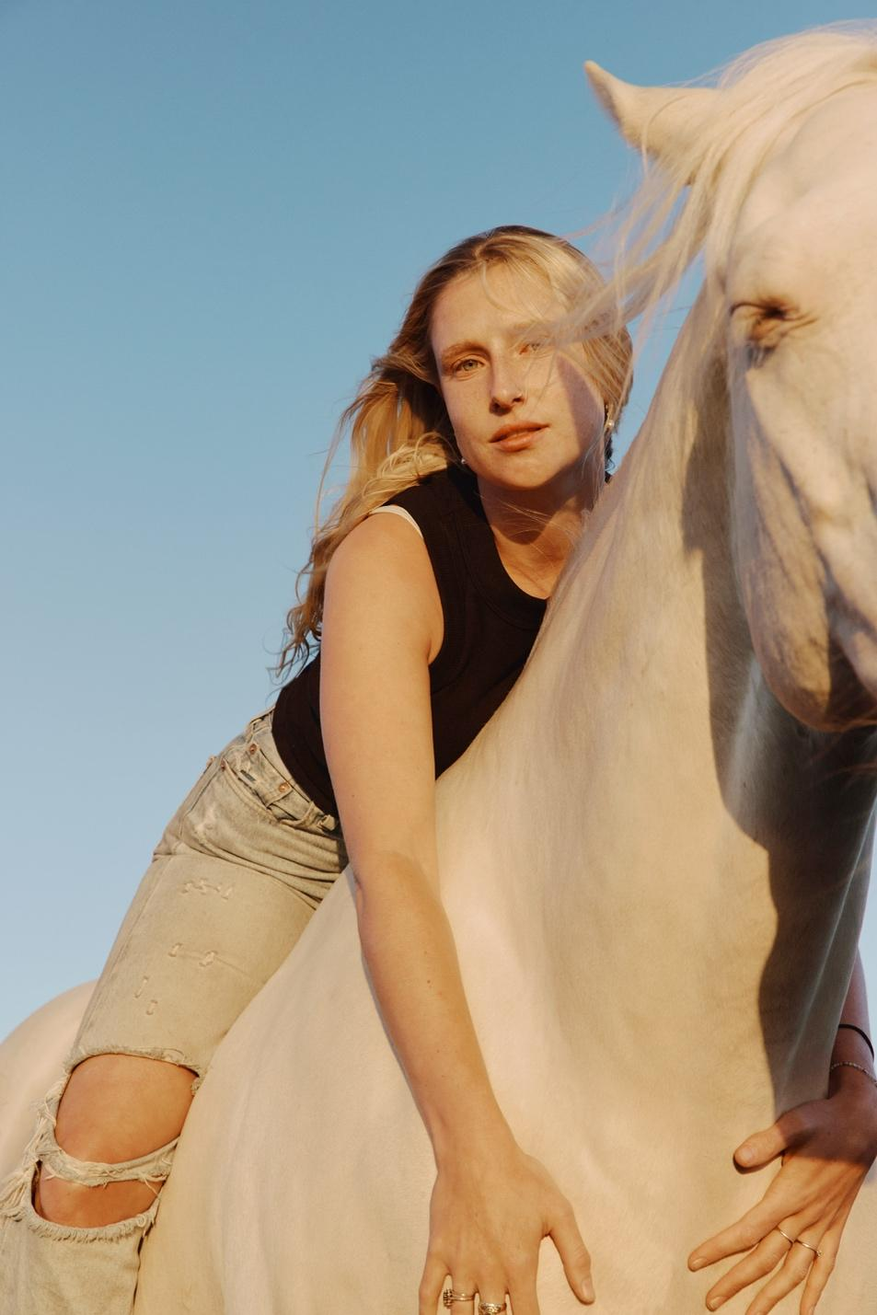
Photo Credit: Frances Carter

Billie Marten is pleased to share a third track from her forthcoming album, Dog Eared.
“Leap Year” is the latest single from her forthcoming album, Dog Eared, out 18th July via Fiction Records. Following “Crown” and “Feeling,” the irrepressible “Leap Year” was written on Leap Day in 2024 while Marten wrestled with winter malaise in bed.

Billie’s first non-autobiographical song considers a couple who can only rendezvous every four years, on our astronomical makeup day. They long for the future but cling to the moments they have. The song is the centrepiece of Dog Eared, with Sam Evian’s epochal guitar solo perfectly framing a couple trying to feel their way forward while knowing they are destined to fail.
Recalling the track’s genesis, Billie says: “I picked up this app which is a digital version of an Optigan that you can get on your phone. It has pre-stored sample sounds that you can play chord by chord. I stitched some buttons together and it became this song. It was written in a Leap Year, 29th February 2024, which is where I got the title and premise from. It’s about two people who can only be reunited every leap year; they have one day every four years. It’s a song about fleeting love and the pain that can bring.”

Leap Year is streaming now. Listen HERE and watch the video HERE.
Dog Eared is released on Friday 18th July via Fiction Records. Pre-order the record HERE.

A lengthy tour of North America, the UK, Ireland and Europe kicks off next month, winding up with Billie’s biggest headline show to date, at London’s O2 Forum Kentish Town in November. A full list of shows can be found below, with ticket details at billiemarten.com.

Billie plays The Acoustic Stage at the Glastonbury Festival on Friday 27th June.

The making of Dog Eared…

Billie headed to New York in the summer of 2024 to record with producer Phil Weinrobe (Adrianne Lenker, Buck Meek, Laura Veirs) at his Sugar Mountain studio, alongside an all-star cast of musicians. The likes of Catalan singer-songwriter/guitarist Núria Graham, bassist Josh Crumbly, virtuosic guitarist Mike Haldeman, multi-instrumentalist Shahzad Ismaily, revered indie-rock musician Sam Evian, former Dirty Projectors vocalist/folk musician Maia Friedman, Brazilian percussionist Mauro Refosco, drummer/multi-instrumentalist Vishal Nayak, keys/synth player Michael Coleman, and acclaimed folk musician Sam Amidon sprinkle their gold dust over Dog Eared. A band packed with talent and cumulative credits across records by Cassandra Jenkins, Kamasi Washington, Moses Sumney, Robert Glasper, Tune-Yards, Empress Of, Nick Hakim, David Byrne, Atoms for Peace, Feist, Bonnie “Prince” Billy, and now Billie Marten.

Since the release of Billie’s fourth LP, 2023’s Drop Cherries, she’s largely spent her time on the road, honing her craft as a deeply instinctual artist and songwriter. Living and learning. Playing and writing. Collaborating with gifted strangers. Exploring questions of identity and self. All the while, sending demos and voice-notes across the Atlantic to Weinrobe and watching those embryonic songs come to life and flourish fully-realised in the studio.

Dog Eared is a warm, rich and textured record that bristles with confidence and self-belief, with Billie already approaching the prolificacy of a “lifer” with so much life left to live. It’s a left turn from her previous recordings, albeit a subtle one, taken with a deftness of touch. A musician embracing change, while staying true to her core self. There’s a certain strength of conviction here that finds its voice more prominently in the extensive pool of her acclaimed American contemporaries, of which she now surely stands shoulder to shoulder with. With Dog Eared, Billie calmly posits herself at the top of the tree of not just British contemporary folk artists, but with British songwriters at large.

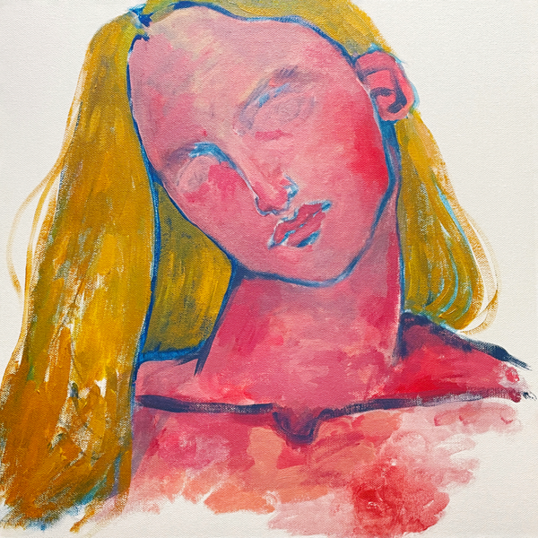

- Feeling
- Crown
- Clover
- No Sudden Changes
- The Glass
- Leap Year
- Goodnight Moon
- Planets
- You and I Both
- Swing

Billie Marten Live - UK:

13th June - Cardiff Castle, Cardiff (w/ Elbow)
18th June - Warwick Arts Centre, Coventry (w/ Elbow)
19th June - Westonbirt Arboretum, Gloucestershire (w/ Elbow)
27th June – Glastonbury Festival (Acoustic Stage)
3rd July - York Museum Gardens, York

7th November - SWG3 TV Studio, Glasgow
8th November - Newcastle University Student Union, Newcastle
10th November - Rescue Rooms, Nottingham
11th November - SWX, Bristol
13th November - Academy 2, Manchester
14th November - Irish Centre, Leeds
15th November - O2 Forum Kentish Town, London

Tickets at billiemarten.com

FOLLOW BILLIE MARTEN
Website | Instagram | YouTube | TikTok | Facebook | X | Spotify | Apple Music | Soundcloud

For more information and press enquiries please contact

Jenny Entwistle
Jenny@chuffmedia.com

