A1 X J1
VIRAL TRACK ‘LATEST TRENDS’
OUT NOW ON EMI RECORDS

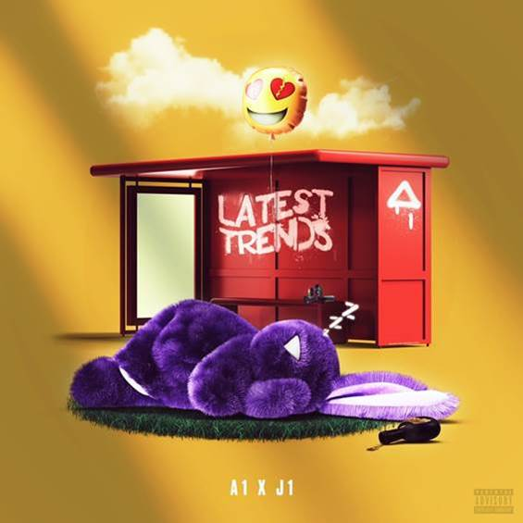

If something good was to come from the pandemic, it is A1 and J1. Meeting on the App Houseparty in 2020, 15-year-old A1 from Coventry and 17-year-old J1 from Kent started their rapping aspirations together remotely, showcasing a zeitgeist movement from the repercussions of this year.

The track launched as just a 15 second tease, going viral on Tik Tok, with social media comments begging for the song to be released in full. All organically and from 2 young, brand new artists the track now titled ‘Latest Trends’ has grown and grown on social media and is ready for its official release.

Both A1 and J1 bring unique flows throughout the track. J1 with strong standout bars and A1 who brings the idyllic catchy chorus. Rap and R&B vibes are in full flow with the UK stamp placed on the track. Resonating the UK Rap scene, the instrumental is easy to take to and very well sculpted. With guitar taking the lead of the beat the simplicity of the loop along with the tasteful production surrounding, establishes a great platform for the boys to showcase their talent. Melodically the track is warming for all who listen, you cannot help but find these two likeable.

Before they had thought about making a full-length track, the snippet was receiving 2000 organic video creations a day on Tik Tok. In a short space of time the boys had over 100k combined social following. The first week saw 250k views across all platforms. Rippling across media the snippet has taken off, now talking in the millions. With support from the likes of KSI, Deno, Darkoo, and JB Scofield there is no limit to how far this track will go.

It's an extremely current and wholesome energy to bring to these times. The people have spoken, and the record is here! This is only the first chapter of their story; the potential is limitless!

A1: TIKTOK | INSTA
J1: TIKTOK | INSTA
A1 X J1 YOUTUBE CHANNEL
For further information contact warren@chuffmedia.com

