Shares new song ‘King’
Watch/Listen HERE

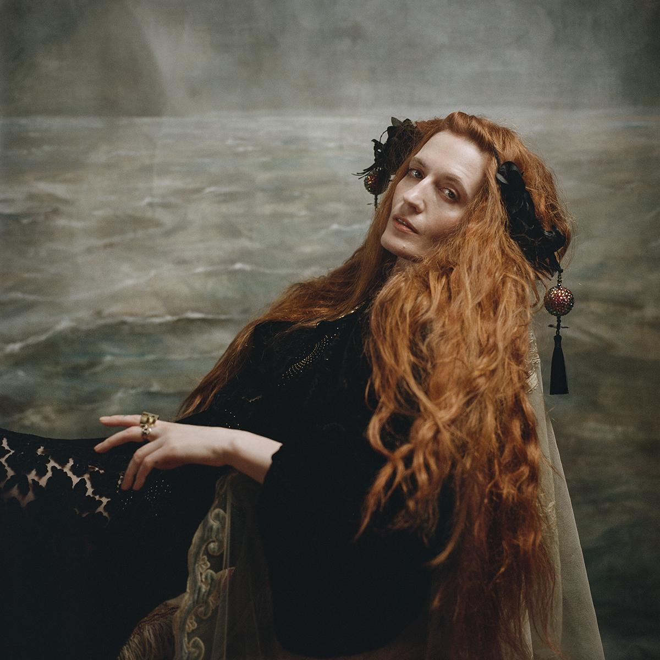
(Credit: Autumn de Wilde)

Florence + the Machine surprise drops new track ‘King’. A meditation on womanhood, family, femininity and the subverting of expectations that makes a personal manifesto in transcending gender-defined roles into a cast-iron, crowd-searing festival-uniting call to arms in which she declares: “I am no mother, I am no bride - I am king”.

Being a woman artist, and one who performs provides its own conflict as to how to thrive and continue along the same path that male artists whose stars keep ascending, whose path to success is unimpeded by biology. In her mid-30s, these are the contradictions Florence is grappling with.

“As an artist, I never actually thought about my gender that much. I just got on with it. I was as good as the men and I just went out there and matched them every time. But now, thinking about being a woman in my 30s and the future… I suddenly feel this tearing of my identity and my desires. That to be a performer, but also to want a family might not be as simple for me as it is for my male counterparts. I had modelled myself almost exclusively on male performers, and for the first time I felt a wall come down between me and my idols as I have to make decisions they did not.”

Watch the new video, directed by Autumn de Wilde, HERE.

Follow Florence + the Machine HERE

For more information and press enquiries please contact
Jenny Entwistle / Jenny@chuffmedia.com

