BILLIE MARTEN SHARES NEW TRACK, “CLOVER” – LISTEN HERE

THE BRITISH FOLK ARTIST’S FIFTH LP, DOG EARED, OUT FRIDAY 18TH JULY VIA FICTION RECORDS

NEW NORTH AMERICAN DATES ANNOUNCED FOR NOVEMBER

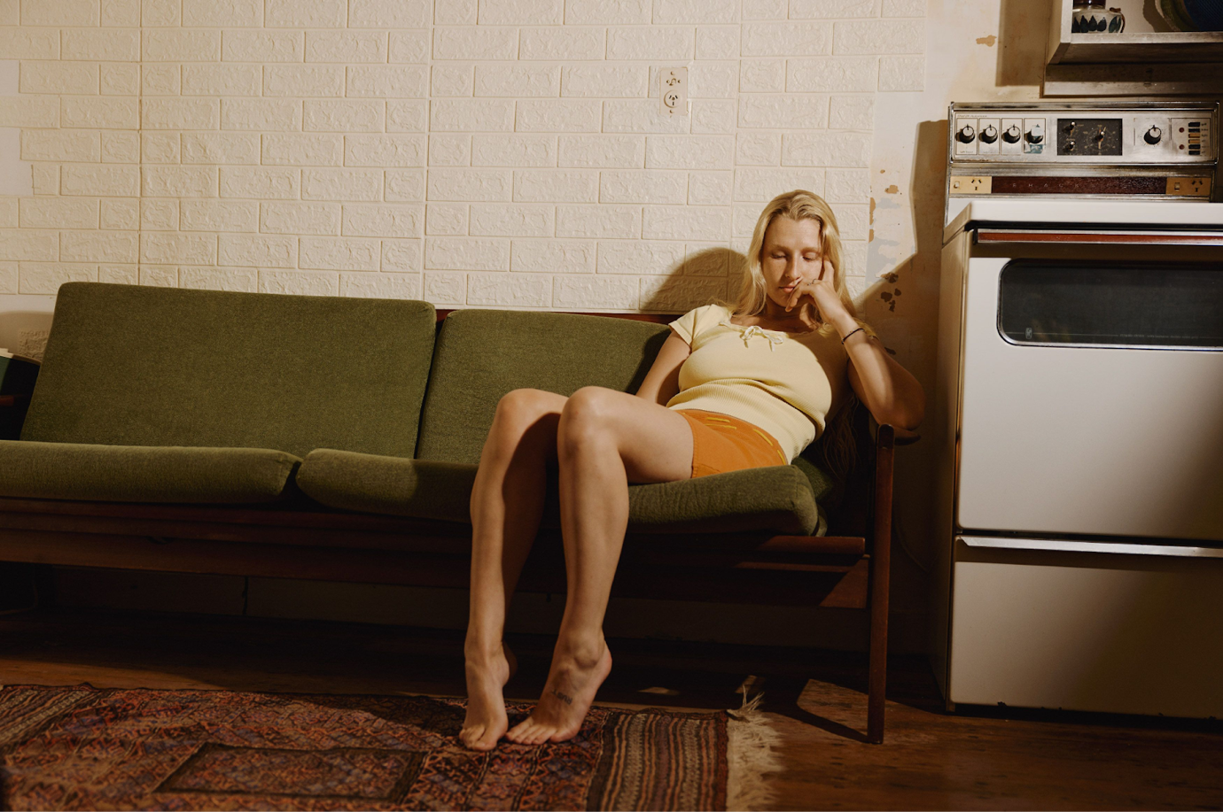
Photo Credit: Frances Carter

Billie Marten is pleased to share a fifth track from her forthcoming album, Dog Eared.

“Clover” is the latest single from her forthcoming album, Dog Eared, out 18th July via Fiction Records. Following “Swing”, “Crown”, “Feeling,” and “Leap Year”, “Clover” is a beautifully crafted, playful tune “built of contradictions and oxymorons”. It’s another telling example of Billie’s prowess to step left of centre from the box marked ‘folk’ and into somewhere more lucid, where the likes of Feist or Lucy Dacus currently operate.

Of the track, Billie says: “A song about feeling small but needing to appear big. It’s a note on power and inequality. Most of this record talks about age and experience and relevance, something that’s clogged my mind since I began music. I carry a lot of premature worry with me, and that’s something that comes from starting an adult life as a teenager I suppose.

“I gained the human affliction of inventing things before they happen. I’m a multitude of anxieties.”

“Clover” is streaming now. Listen HERE and watch the visualiser HERE

Dog Eared is released on Friday 18th July via Fiction Records. Pre-order the record HERE.

Following a lengthy run of shows in support of Tennis across North America, Billie will return to the US and Canada in September for a headline stint and is pleased to announce another 10-date headline run in November. Núria Graham will support on select North American dates. Full details are listed below.

Billie heads back to the UK for three outdoor shows in support of Elbow, a headline solo show at Warwick Arts Centre in Coventry and a slot on Glastonbury’s Acoustic Stage on 27th June. Billie’s European headline tour kicks off in early October, followed by a UK headline tour in November that includes her biggest headline show to date at the O2 Kentish Town Forum on 15th November. Le Ren will support on all dates.

All ticket details are found at billiemarten.com.

The making of Dog Eared…

The Yorkshire born, London based Billie Marten headed to New York in the summer of 2024 to record with producer Phil Weinrobe (Adrianne Lenker, Buck Meek, Laura Veirs) at his Sugar Mountain studio, alongside an all-star cast of musicians. The likes of Catalan singer-songwriter/guitarist Núria Graham, bassist Josh Crumbly, virtuosic guitarist Mike Haldeman, multi-instrumentalist Shahzad Ismaily, revered indie-rock musician Sam Evian, former Dirty Projectors vocalist/folk musician Maia Friedman, Brazilian percussionist Mauro Refosco, drummer/multi-instrumentalist Vishal Nayak, keys/synth player Michael Coleman, and acclaimed folk musician Sam Amidon sprinkle their gold dust over Dog Eared. A band packed with talent and cumulative credits across records by Cassandra Jenkins, Kamasi Washington, Moses Sumney, Robert Glasper, Tune-Yards, Empress Of, Nick Hakim, David Byrne, Atoms for Peace, Feist, Bonnie “Prince” Billy, and now Billie Marten.

Since the release of Billie’s fourth LP, 2023’s Drop Cherries, she’s largely spent her time on the road, honing her craft as a deeply instinctual artist and songwriter. Living and learning. Playing and writing. Collaborating with gifted strangers. Exploring questions of identity and self. All the while, sending demos and voice-notes across the Atlantic to Weinrobe and watching those embryonic songs come to life and flourish fully-realised in the studio.

Dog Eared is a warm, rich and textured record that bristles with confidence and self-belief, with Billie already approaching the prolificacy of a “lifer” with so much life left to live. It’s a left turn from her previous recordings, albeit a subtle one, taken with a deftness of touch. A musician embracing change, while staying true to her core self. There’s a certain strength of conviction here that finds its voice more prominently in the extensive pool of her acclaimed American contemporaries, of which she now surely stands shoulder to shoulder with. With Dog Eared, Billie calmly posits herself at the top of the tree of not just British contemporary folk artists, but with British songwriters at large.

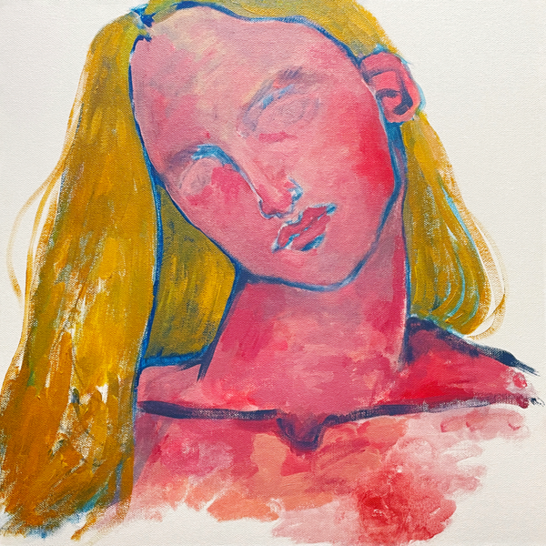
Dog Eared Artwork

- Feeling
- Crown
- Clover
- No Sudden Changes
- The Glass
- Leap Year
- Goodnight Moon
- Planets
- You and I Both
- Swing

Billie Marten Live:
18th June - Warwick Arts Centre, Coventry
19th June - Westonbirt Arboretum, Gloucestershire #
27th June - Glastonbury Festival (Acoustic Stage)
3rd July - York Museum Gardens, York #
5th July - VIDA FESTIVAL 2025, Vilanova i la Geltrú
30th August - Golden Leaves Festival, Darmstadt
8th September - Bluebird Theater, Denver, CO
10th September - Lou Lou's, San Diego, CA *
11th September - El Rey Theatre, Los Angeles, CA *
12th September - Ojai Valley Woman's Club, Ojai, CA *NEW DATE*
13th September - The Independent, San Francisco, CA
15th September - Aladdin Theater, Portland, OR
16th September - The Crocodile, Seattle, WA
17th September - Hollywood Theatre, Vancouver, BC
9th October - Le Grand Mix, Tourcoing ^
10th October - Botanique, Brussels ^
11th October - Le Trabendo, Paris ^
12th October - L'Epicerie Moderne, Feyzin ^
15th October - Teatro Lara, Madrid ^
17th October - Bogen F, Zurich ^
18th October - Strom, Munich ^
19th October - Flucc Wanne, Vienna ^
21st October - Hybrydy, Warsaw ^
23rd October - Frannz Club, Berlin ^
25th October- Vega Small Hall, Copenhagen ^
26th October - Nalen Klubb, Stockholm ^
28th October - Parkteatret, Oslo ^
31st October - Nochtspeicher, Hamburg ^
1st November - Melkweg Max, Amsterdam ^
2nd November - Luxor, Cologne ^
5th November - Vicar Street, Dublin
6th November - Empire Music Hall, Belfast ^
7th November - SWG3 TV Studio, Glasgow ^
8th November - Newcastle University Student Union, Newcastle ^
10th November - Rescue Rooms, Nottingham ^
11th November - SWX, Bristol ^
13th November - Academy 2, Manchester ^
14th November - Irish Centre, Leeds ^
15th November - O2 Forum Kentish Town, London ^
28th November – The Mod Club, Toronto, ON * *NEW DATE*
29th November – Théâtre Fairmount, Montreal, QC * *NEW DATE*
30th November – Grizzly Fuzz, Quebec City, QC * *NEW DATE*
2nd December – The Sinclair, Boston, MA * *NEW DATE*
4th December – Music Hall of Williamsburg, Brooklyn, NY * *NEW DATE*
6th December – The Atlantis, Washington, D.C. * *NEW DATE*
7th December – The Andy Warhol Museum, Pittsburgh, PA * *NEW DATE*
9th December – The Basement East, Nashville, TN * *NEW DATE*
11th December – Fine Line, Minneapolis, MN * *NEW DATE*
12th December – High Noon Saloon, Madison, WI * *NEW DATE*
13th December – Thalia Hall, Chicago, IL * *NEW DATE*
# w/ Elbow
* w/ Núria Graham
^ w/ Le Ren

Tickets at billiemarten.com

FOLLOW BILLIE MARTEN
Website | Instagram | YouTube | TikTok | Facebook | X | Bluesky | Spotify | Apple Music | Soundcloud

For more information and press enquiries please contact

Jenny Entwistle
Jenny@chuffmedia.com

