SAM FENDER RELEASES NEW TRACK, ALRIGHT, AHEAD OF HUGE LONDON FINSBURY PARK HEADLINE SHOW

THE SONG ORIGINATES FROM ORIGINAL SEVENTEEN GOING UNDER STUDIO SESSIONS

ARRIVES AHEAD OF US DATES AND US SUPPORT TOUR WITH FLORENCE & THE MACHINE

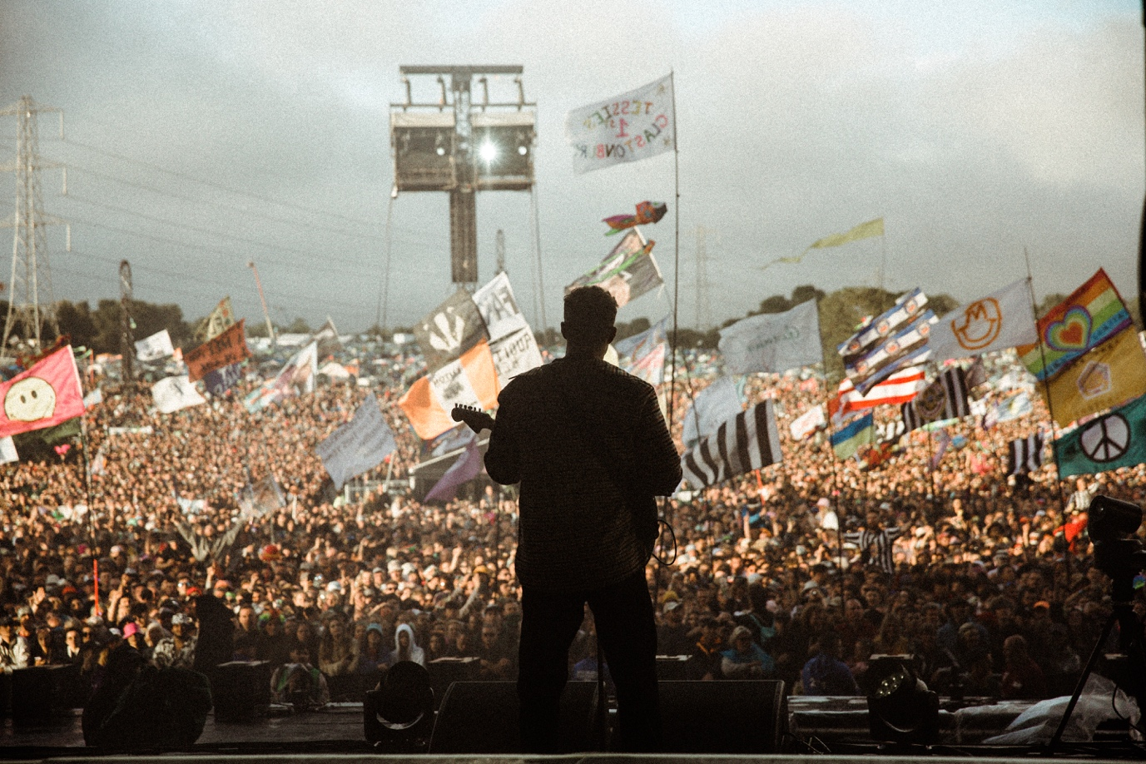

Praise for Sam Fender at Glastonbury 2022..
“Fender is cemented as a major British star with a performance of huge anger and emotional release” ***** - The Guardian
“this is nothing short of the stuff of dreams…the indie master finally has his moment” ***** - NME
“He set the field afire… One of the day’s most emotional moments” ***** - The Times
“Welcome to the summer of Sam… Careers are made from such things” ***** - The Telegraph
“More than the star power to back up the hype” ***** - The I
“taking Friday’s Pyramid sunset slot and demonstrating that one more great album could make him a headliner” – Evening Standard
“Geordie hero proves he’s a future headliner.” - Rolling Stone UK

Sam Fender is pleased to share new track, Alright. The track was recorded during the initial recording sessions for Sam’s number 1 charting second album Seventeen Going Under, and lands now during a triumphant Summer of festival performances, and ahead of Sam’s first US live dates since 2019.

Of the back of one of the most-talked about, show-stealing of performances at Glastonbury, and ahead of Sam’s own 40,000+ sold-out headline date in London’s Finsbury Park, Sam is pleased to unearth Alright from the original Seventeen Going Under studio sessions in Newcastle.

Listen to Alright HERE

Sam Fender: “Alright is one of the first tracks from the Seventeen Going Under era. It was always a favourite of mine, and somehow didn’t make the record. It’s about growing up and the theme of cheating death.”

Following the huge London Finsbury Park date, Sam headlines Sheffield’s Tramlines Festival and the Truck Festival in Oxfordshire later this month, before heading out to the States for a string of festival and headline dates before returning to Europe for more festival slots. He then heads back out to the US in support of Florence & The Machine throughout September, including a night at Madison Square Garden in New York, before concluding the US run with three more headline shows.

Sam Fender Live (UK/Europe):
15th July – Finsbury Park, London SOLD OUT
22nd July - Tramlines, Sheffield
23rd July – Truck Festival, Oxfordshire
15th August – Sziget, Budapest
19th August – Lowlands Festival, Biddinghauzen
28th August – Victorious Festival, Portsmouth

For more information & media enquiries, please contact Jenny Entwistle jenny@chuffmedia.com

