JESSIE REYEZ ANNOUNCES
UK TOUR IN JANUARY 2023

NEW ALBUM YESSIE OUT SEPTEMBER 16th

THE YESSIE TOUR UK TICKETS GO ON SALE
SEPTEMBER 23RD

On the eve of the release of her new album YESSIE, Grammy-nominated singer-songwriter Jessie Reyez has announced she will play three headline shows in the UK in January 2023. The shows in Birmingham, Manchester and London form part of the European leg of The YESSIE Tour, revealed in full today. Jessie Reyez’s sophomore album, YESSIE, was released on September 16th via FMLY / Polydor Records.

YESSIE picks up where her 2020 debut studio album Before Love Came To Kill Us left off - a highly anticipated release from a now unforgettable era. Her writing on the new album captures the human experience in a way that is at once unique and relatable. After releasing two critically acclaimed EPs, Kiddo & Being Human In Public, Jessie released Before Love Came To Kill Us in March of 2020. Against unenviable odds, the album charted Top 5 on Billboard’s R&B Album Chart, amassed over 1.2B global streams, and earned the title of Top Female Debut Album and Top R&B Album of 2020 - cementing Reyez as a worldwide phenomenon. She made live appearances at 2021 Lollapalooza, 2022 Coachella and opened on Billie Eilish’s Happier Than Ever World Tour.

Jessie Reyez has played sold out shows and festivals across the world, impressing all with her exceptional live show and The YESSIE Tour marks the beginning of an all-new era.

YESSIE UK TOUR DATES

Sat 28 Jan - Birmingham, UK - O2 Institute 1
Sun 29 Jan - Manchester, UK - Manchester Academy
Tue Jan 31 - London, UK - O2 Shepherd's Bush Empire

jessiereyezofficial.com
PHOTO CREDIT: Philip Harris

FOLLOW JESSIE REYEZ
TIKTOK
INSTAGRAM
TWITTER
FACEBOOK
YOUTUBE
WEBSITE

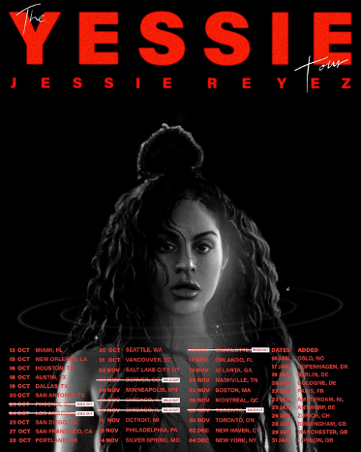
For more information and press enquiries please contact

Warren Higgins
Warren@chuffmedia.com

