WYATT FLORES SUPPORTING 49 WINCHESTER ON UK TOUR
TICKETS ARE ONSALE NOW



Starting on the 4th of October, Wyatt begins his tour on this side of pond supporting Virginian band 49 Winchester. This tour will take Wyatt throughout the UK and Europe.

Wyatt’s supporting tour dates can be found below:
4th of October – Olympia Theatre, Dublin
5th of October – The Telegraph Building, Belfast
7th of October – O2 Academy, Glasgow
8th of October – Manchester Academy, Manchester
10th of October – Stylus, Leeds
11th of October – O2 Institute, Birmingham
14th of October – Roundhouse, London
16th of October – O2 Academy, Bristol

Born and raised in Oklahoma, the Mexican-American artist has established himself as one of country music’s most vital voices with his debut album Welcome to the Plains, which was released in October last year. Receiving widespread critical attention.

Flores has been recognized as one of Rolling Stone’s 25 “Future of Music” artists, received a nomination for Emerging Act of the Year at the 2024 Americana Honors & Awards, was selected as Amazon’s Breakthrough Artist of the Year, included in Spotify’s Hot Country Class of 2024 and CMT’s Listen Up class, and made his Grand Ole Opry debut. Additionally, Flores has garnered over 575 million streams to date, saw his 2022 breakout single, “Please Don’t Go,” scale the Billboard Hot Country Songs Chart and had his song “Before I Do” with Jake Kohn featured on the soundtrack for the new Twisters movie.

Critical acclaim for Welcome To The Plains:
“it just speaks to his power as this young songwriter in the country lane, doing what I think is some of the most powerful music I’ve heard in a very long time.”—NPR
“Welcome to the Plains...is full of enough musical and lyrical range to be the defining album of the 23-year-old Flores’ career”—Rolling Stone
“His latest pulses with the raw energy of a full-band sound, thrashing percussion and churning guitars”—Billboard
“a vivid, emotional portrait of life”—Nashville Scene
“Wyatt Flores is a superstar in the making…the torchbearer for Oklahoma’s red dirt music tradition”—Whiskey Riff
“one of the most exciting breakout stars in country music today”—All Country News
“Flores’s music has a fresh and modern sound while keeping the traditional roots of his Oklahoman upbringing”—Country Central
“Wyatt Flores is the face of the new generation of country”—Country Chord

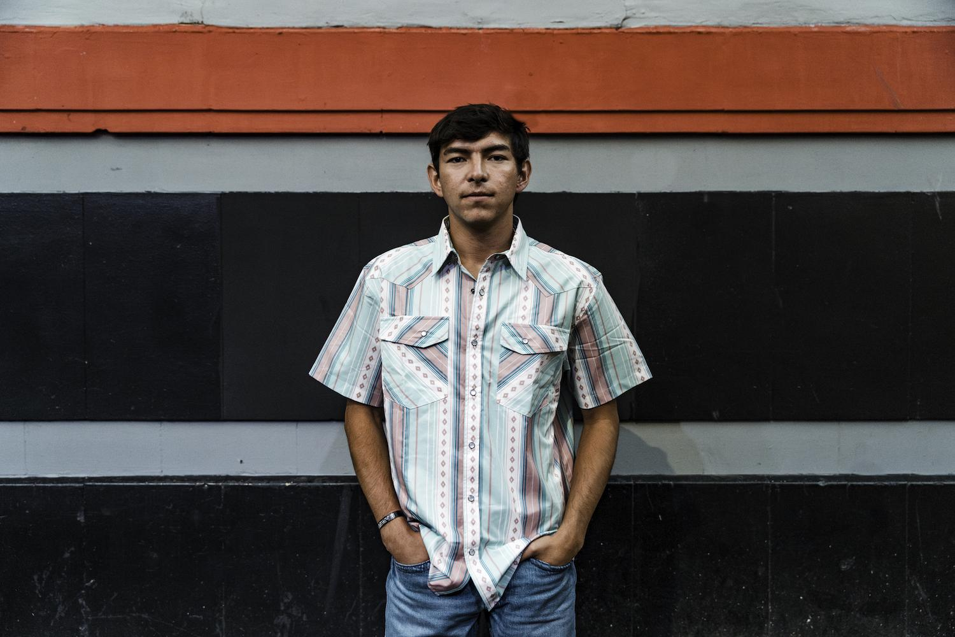
photo credit: Natalie Rhea

FOLLOW WYATT FLORES
Instagram | Facebook | Twitter | TikTok | YouTube

For more information contact Warren & Harry @chuffmedia.com

