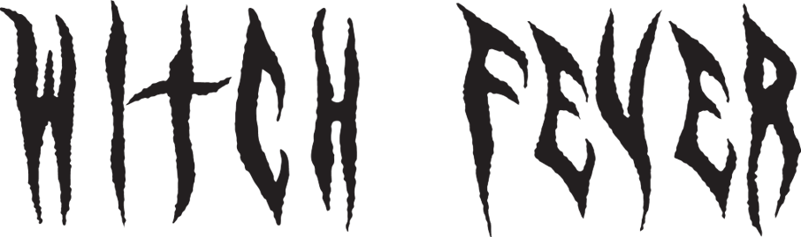

Music Venue Trust United By Music
Headline Tour August & September

Supporting Hot Milk November 2023

Refusing to be confined by gender or genre, Witch Fever have always defied expectations as individuals in society. Now, they’re defying expectations as a band. Their debut album Congregation is the sound of punk without boundaries of any kind, and with it they are ushering in a new era of heavy music that’s accessible, confrontational and, most importantly of all, a huge pressure release.
Lyrically, Congregation draws largely on Walpole’s experience of growing up in a Charismatic Church – a form of Christianity that emphasises the work of the Holy Spirit, spiritual gifts, and modern-day miracles. She left the church when she was 16, and her parents followed suit two years later. Guitarist Alisha Yarwood also grew up in a church, though not to the same extent as Walpole, and all members agree that the themes of the album – control, abuse of power and patriarchal violence – resonate beyond a religious framework.
Listen to Congregation HERE
While the subject matter of their songs is often heavy, Witch Fever’s attitude certainly isn't. Their videos have always been vivid and playful, showing the band having as much of a laugh on set as they do at their shows or in the studio, plus a wardrobe that’s very London Fashion Week meets Berlin club night.
“We always try to have a sense of humour in everything that we do,” says Thompson. “As heavy as everything is, we all love what we do, and the essence is positive and productive.”

Since their formation in 2017, meeting through Manchester’s close-knit alternative music scene, Witch Fever – Amy Walpole (vocals), Alex Thompson (bass), Alisha Yarwood (guitar) and Annabelle Joyce (drums) – have spent six years making gains within an industry that still skews overwhelmingly male when it comes to punk. Their raucous on stage presence, followed by last year’s Reincarnate EP has seen their sound develop in intensity as well as scope.
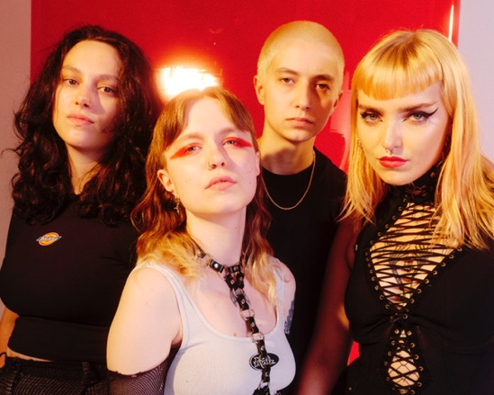
CATCH WITCH FEVER LIVE AT THE FOLLOWING DATES:
8-Jul-23 Cheltenham 2000 Trees Festival

Music Venue Trust United By Music Tour

16-Aug-23 Milton Keynes The Craufurd Arms
17-Aug-23 Ramsgate Music Hall
18-Aug-23 Colchester Three Wise Monkeys
19-Aug-23 Derby Dubrek Studios
30-Aug-23 Newport Le Pub
31-Aug-23 Reading The Facebar
1-Sep-23 Bridgwater The Cobblestones
2-Sep-23 Brighton Bad Pond Festival
6-Sep-23 Darlington The Forum Music Centre
7-Sep-23 Edinburgh Sneaky Pete's
8-Sep-23 Darwen Sunbird Records
9-Sep-23 Leicester The Soundhouse
13-Sep-23 Huddersfield The Parish

Supporting Hot Milk

18-Nov-23 Glasgow SWG3 Warehouse
19-Nov-23 Nottingham Rescue Rooms
21-Nov-23 Bristol The Trinity Centre
22-Nov-23 London O2 Forum Kentish Town
24-Nov-23 Birmingham O2 Institute 2
25-Nov-23 Manchester Manchester Academy
——
WITCHFEVER.COM
FACEBOOK | TWITTER | INSTAGRAM | YOUTUBE | SPOTIFY | APPLE MUSIC

For more information please contact
Warren Higgins warren@chuffmedia.com

