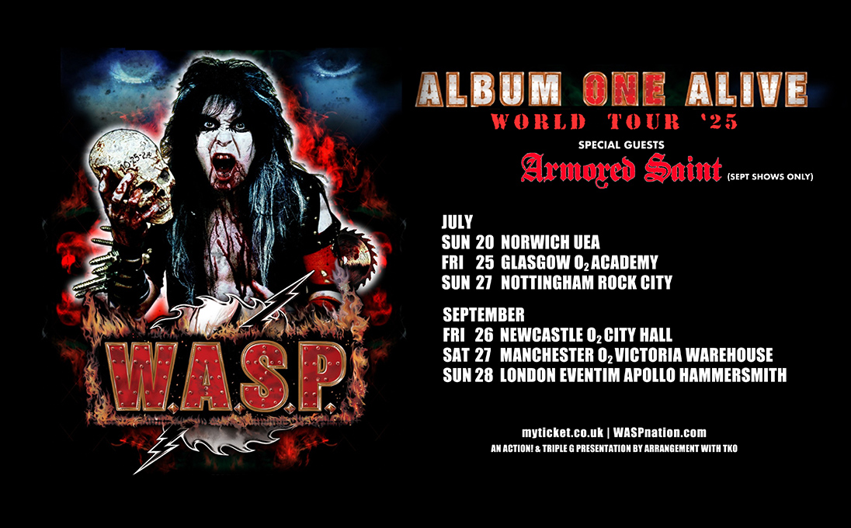

W.A.S.P.
RETURN TO THE UK FOR
'ALBUM ONE ALIVE' & THE CLASSICS TOUR
CELEBRATING THE 40TH ANNIVERSARY
OF THE BAND'S FIRST ALBUM

Los Angeles metal pioneers W.A.S.P. return to the UK later this year for a very special celebratory tour.
‘Album ONE Alive!’ marks the 40th anniversary of the release of W.A.S.P.’s first album. To celebrate this classic metal album, W.A.S.P. will, for the first time in 40 years, play the entire album in full, from start to finish plus classics from the band's catalogue.
Formed in 1982, W.A.S.P. is set to bring this universally acclaimed “classic” album to life. Lead vocalist Blackie Lawless says, “This is the tour that showcases the album that started the long, long undying bond between the band and to all the fans in your countries where all our international success first began 40 years ago. It was an angry record made by an angry band. It was a record that not only reflected the attitude of the band members who made it, but also a record that reflected its time.”
He continues, “This tour showcases for the first time, that landmark first album, played in its entirety, from top to bottom, most likely never to be repeated ever again. So be there and see these Winged Assassins, and witness this once in a lifetime event.”
The record became a central piece of the 80s metal scene and remains one of the best metal debut albums of all time.
Along with bassist Mike Duda and lead guitarist Doug Blair, whose tenures in the band are 29 and 26 years respectively, W.A.S.P. is joined by long time drummer extraordinaire Aquiles Priester.
Lawless and company will deliver the ultimate incredible spectacle, bringing W.A.S.P.’s
most colourful history to life by performing this revered album in its entirety... ONE more time... ONE last time... Album ONE Alive!
JULY 2025 | W.A.S.P. - ALBUM ONE ALIVE
20/07 - UEA, Norwich
25/07 - O2 Academy, Glasgow
27/07 - Rock City, Nottingham
SEPTEMBER 2025 | W.A.S.P. - ALBUM ONE ALIVE
+ Armored Saint
26/09 - Newcastle O2 City Hall
27/09 - O2 Victoria Warehouse, Manchester
28/09 - Eventim Apollo Hammersmith, London
Tickets on sale via https://myticket.co.uk/artists/wasp
https://www.waspnation.com/

Assets available here.

For more on info contact warren@chuffmedia.com

