boygenius
announce debut UK shows
with MUNA, Ethel Cain & more special guests TBA

Gunnersbury Park, London on August 20th & The Piece Hall, Halifax on August 22nd
Debut album - the record - released March 31st on Polydor/Interscope Records

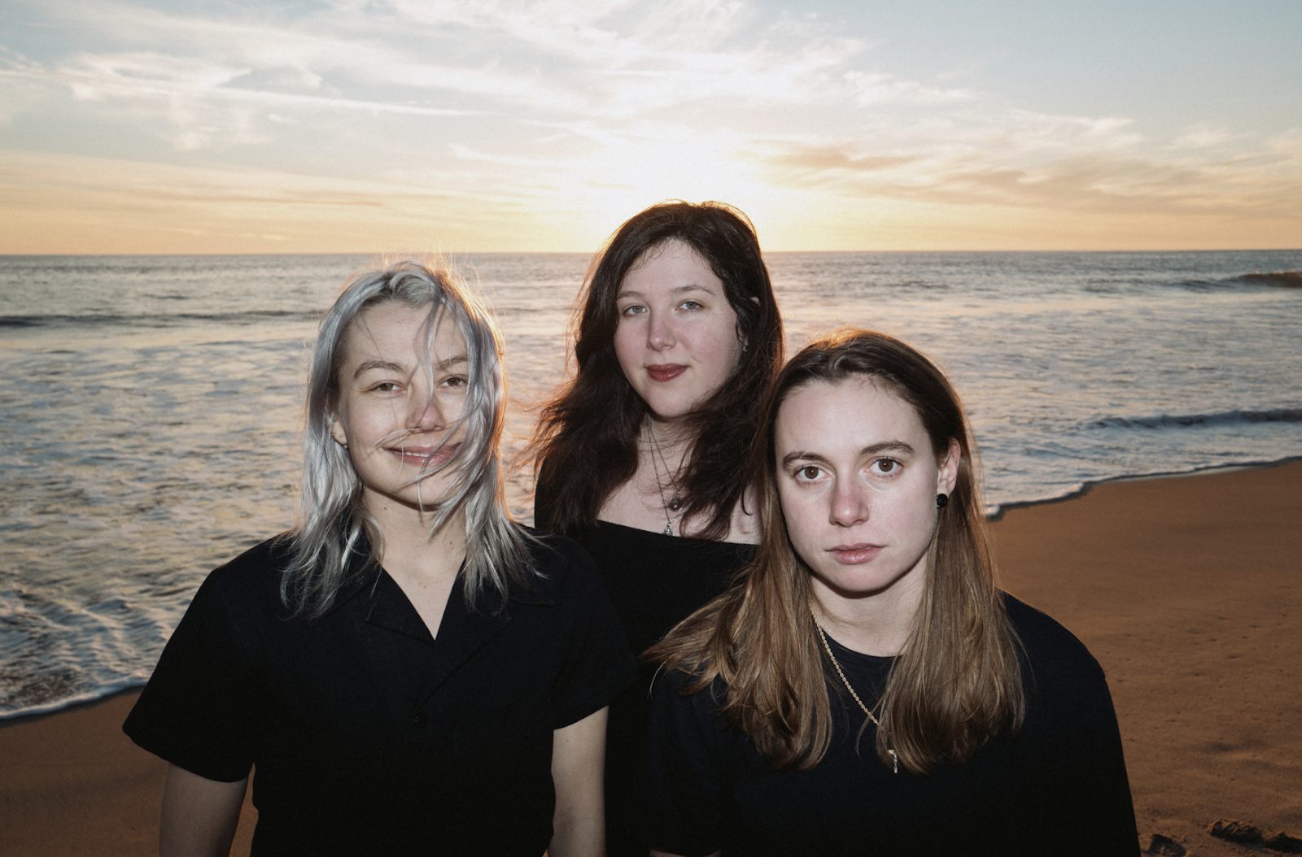
L-R: Phoebe Bridgers, Lucy Dacus & Julien Baker
(Photo credit: Harrison Whitford)
“One-of-a-kind” – Rolling Stone
“The band instantly became the “Infinity War” of female-led indie-rock outfits…it’s not your average vision of feminist empowerment via extreme independence” – Vogue
“The sizable talent and personalities of Julien Baker, Phoebe Bridgers, and Lucy Dacus come together for a harmonious, confrontational, and all too brief EP” – Pitchfork
“An astonishing record” – NME

boygenius have today announced details of their first ever UK headline shows, with two huge outdoor dates confirmed at London’s Gunnersbury Park on August 20th and Halifax’s The Piece Hall on August 22nd. Album pre-order registration is open now, ahead of general release on March 3rd at 10AM GMT via https://shopuk.xboygeniusx.com.

With more special guests for both shows to be announced soon, Ethel Cain and MUNA have today been confirmed to open for boygenius at their landmark London show at Gunnersbury Park, with Ethel Cain also joining boygenius for the later show at Halifax’s historic The Piece Hall.

boygenius recently announced their long-awaited return with the release of three singles from their upcoming album, the record: ‘$20’, ‘Emily I’m Sorry’, and ‘True Blue’. It’s the first full-length project from the band - comprised of Julien Baker, Phoebe Bridgers and Lucy Dacus - to follow their self-produced, self-titled EP back in 2018. the record was produced and written by boygenius, and recorded at Shangri-la Studios in Malibu, California. The band discussed the album for the first time recently in their immediately iconic Rolling Stone cover story, with more to come ahead of its release on March 31st.
MUNA is comprised of Katie Gavin (she/they), Naomi McPherson (they/them), and Josette Maskin (she/they). Previous singles like ​'​Silk Chiffon​',​ ​'​Home By Now​' ​and ​'​Anything But Me​'​ and single ​'​What I Want​'​ have fans ready for the next new, exciting chapter. The band sold out shows all over the world last year and set to continue in 2023, readying sold out headline dates all over the US, Coachella and a stadium tour with Taylor Swift.
Raised a backwoods churchgoer in the deep south, Ethel Cain’s “sound defies definition [straddling] a line between alternative rock, folk, pop, and even country” (Billboard). After writing, producing and mixing her EP Inbred from the basement of a church in Indiana, it was released last year to critical acclaim, receiving overwhelming support from Pitchfork, Paper Magazine, VICE, Zane Lowe, YouTube, SoundCloud, and Tidal. Recently, Spotify selected Ethel as their first ever transgender EQUAL Ambassador for March 2022, a distinction shared with Billie Eilish, Mickey Guyton, and STAYC.
Grab general sale tickets for boygenius’ UK shows at 10AM GMT on March 3rd via https://www.ticketmaster.co.uk
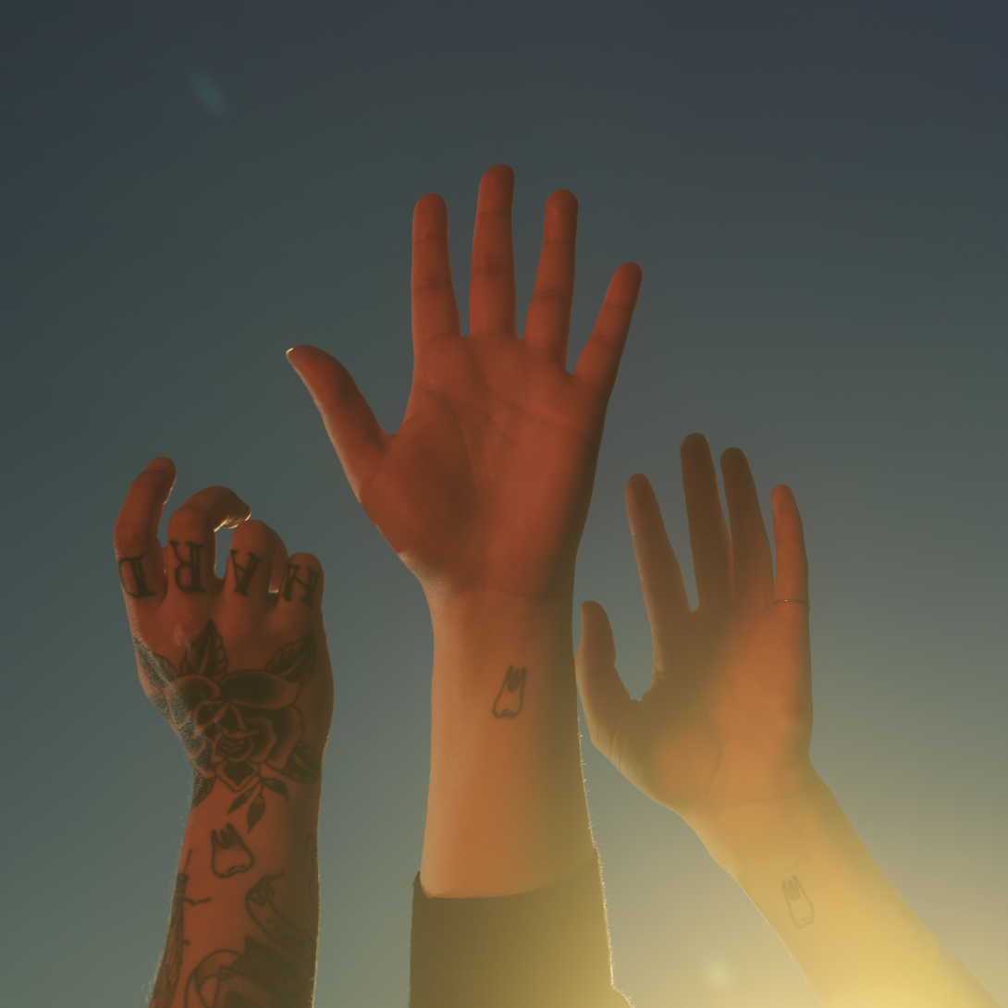
(the record album art. Photo credit: Matt Grubb. Download High Res HERE)
Track listing for the record below:

- ‘Without You Without Them’
- ‘$20’
- ‘Emily I’m Sorry’
- ‘True Blue’
- ‘Cool About It’
- ‘Not Strong Enough’
- ‘Revolution 0’
- ‘Leonard Cohen’
- ‘Satanist’
- ‘We’re In Love’
- ‘Anti-Curse’
- ‘Letter To An Old Poet’

KEEP UP WITH BOYGENIUS:
Web / Instagram / Twitter

For more information and press enquiries please contact

Jenny Entwistle
Jenny@chuffmedia.com

