BROOKE COMBE

UK HEADLINE TOUR JUST ANNOUNCED

BEST FEMALE BREAKTHROUGH WINNER AT THE SCOTTISH MUSIC AWARDS

HUGE RUN OF SUMMER FESTIVALS ANNOUNCED INCLUDING TRNSMT, NBHD FESTIVAL & MORE

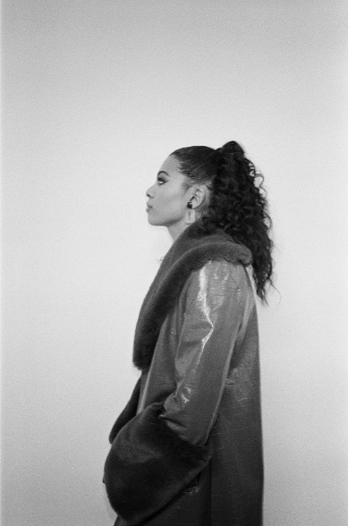

Photo credit: Island Records (hi-res HERE)

“One to keep an eye on” - Dork

“It epitomises her tranquil intimacy, and her glorious promise” - CLASH

“Scottish indie star-in-waiting already mingling with the greats” - NME

BUY TICKETS HERE
Soulful Edinburgh-born newcomer Brooke Combe has announced details of a brand-new headline tour for October 2022. Tickets on sale now.

The 21 year old - now based in East and Midlothian - enjoyed a remarkable breakthrough year in 2021, which culminated in winning the Breakthrough Female prize at the Scottish Music Awards. Combe’s 2022 kicked off in similarly scintillating fashion with her debut single ‘Are You With Me?’ topping the Official Vinyl Singles chart upon its release on 7”.

The rising soul star has been adopted by indie royalty such as The Courteeners and The Snuts, who Combe supported last year; now she joins a clutch of hotly-tipped female artists making waves on the live circuit like Wet Leg in playing a run of UK festivals - including Liverpool Sound City, Warrington's Neighbourhood Weekender and a slot at Glasgow's TRNSMT. Brooke Combe will also perform at Neighbourhood Festival in Manchester on Saturday 1st October.

Brooke Combe discovered a love for music aged just 5 years old, after getting her first toy drum kit. Eventually she added playing saxophone, trombone, guitar, bass and piano to her repertoire while at secondary school and began to find her own uniquely powerful voice along the way. Combe, influenced by the ‘90s R&B played in her mum and dad's house, as well as the Motown her grandparents would play her, developed a love of great songwriting and vocalists and lyricists with their own idiosyncrasies - such as Amy Winehouse and Fleetwood Mac - before beginning to work on her own material.

Now, with ‘Miss Me Now, her stunning fourth statement out in the world, Brooke Combe has confirmed herself as a genuine artist to watch in 2022 and provides another tantalising window into the world of a singularly talented and hugely exciting young artist.

***

See Brooke Combe live in 2022:

21 Jul | Truck Festival, Abingdon
22 Jul | Tramlines, Sheffield
29 Jul | Deer Shed Festival, North Yorkshire
30 Jul | Kendal Calling, Cumbria
31 Jul | Y Not Festival, Derbyshire
14 Aug | 110 Above Festival, Leicester
29 Sep | Jimmy’s, Liverpool
30 Sep | Headrow House, Leeds
01 Oct | Neighbourhood Festival, Manchester
03 Oct | The Louisiana, Bristol
04 Oct | Rough Trade, Nottingham
06 Oct | Courtyard Theatre, London
07 Oct | The Garage, Glasgow

For more information & media enquiries, please contact Warren
warren@chuffmedia.com

