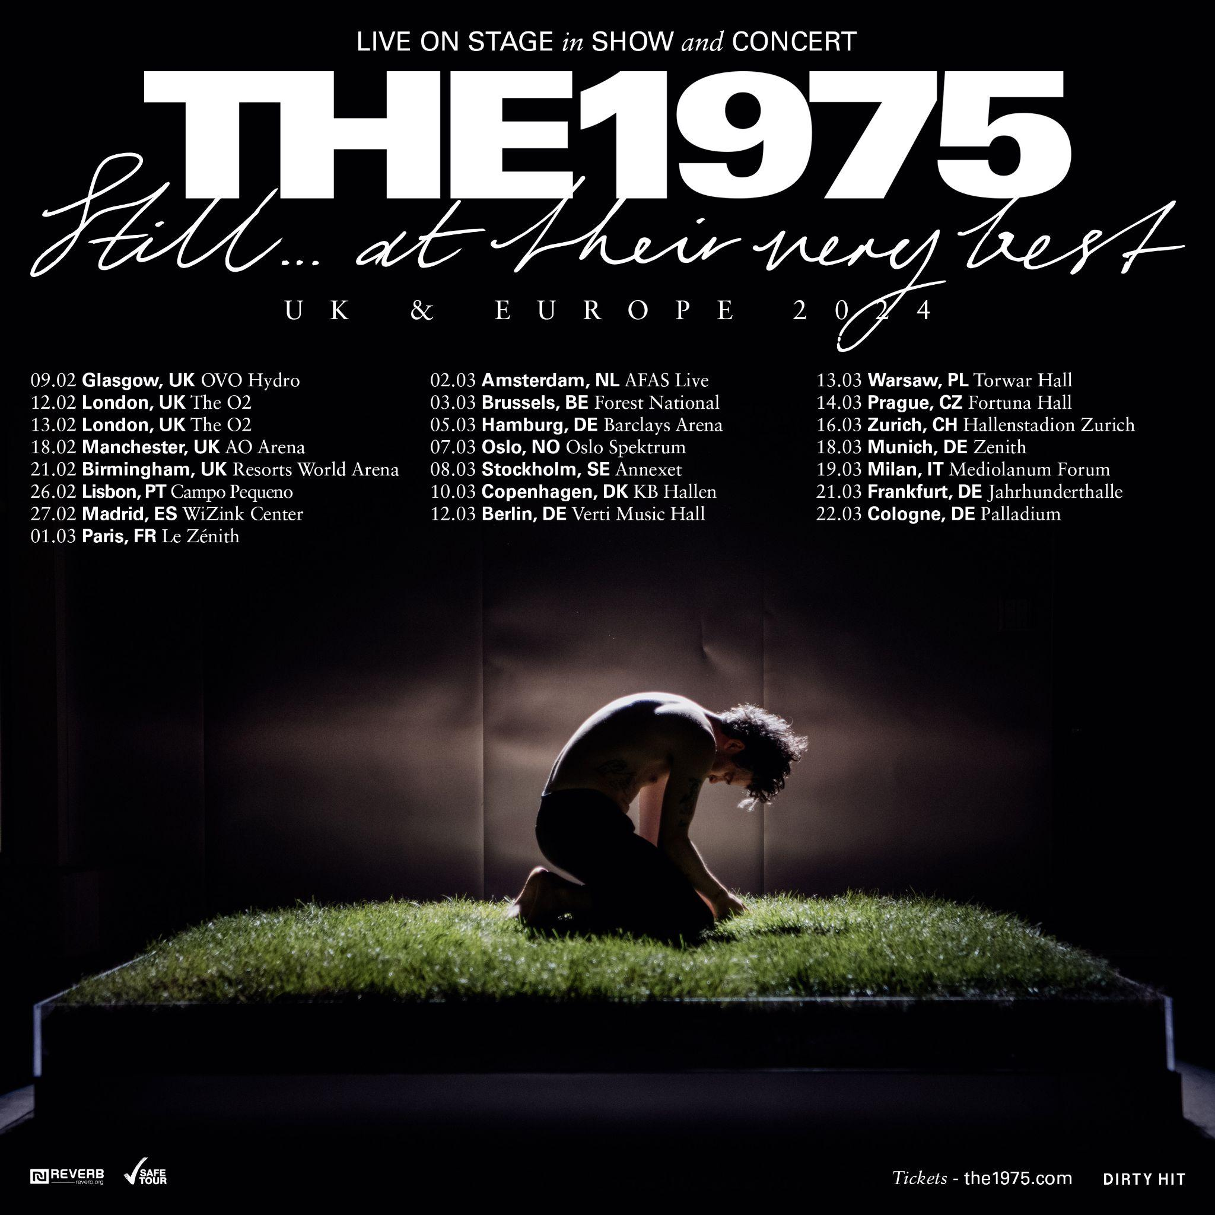

[Thursday 31st August 2023, London]

The 1975 today announce details of the UK and Europe leg of their ‘Still… At Their Very Best’ tour in February and March 2024.

The newly announced dates, including two nights at London’s The O2, represent the band’s biggest ever shows in Europe and will be the final shows of the ‘Being Funny In A Foreign Language’ campaign.

Tickets for the UK and Europe tour will be available via Exclusive Fan Presale on Wednesday 6th September at 10am local time, with tickets then on general sale on Friday 8th September at 10am local time. You can sign up for the Exclusive Fan Presale HERE.

The 1975’s new ‘Still… At Their Very Best’ tour will see the band play arenas across North America and Canada throughout the Autumn, including sold out shows at The Hollywood Bowl in Los Angeles and, for the first time ever, two back-back sold out nights at New York’s iconic Madison Square Garden, before arriving in the UK and Europe for these newly announced shows in 2024.

The band’s previous ‘At Their Very Best’ tour took in arenas across USA, Canada, UK & Europe, Australia, New Zealand, and Asia across the last nine months with an impressive 500k+ tickets sold. Between the impressive staging, high concept performance art and surprise appearances from friends, the tour has been lauded as a band truly in their prime; a claim backed up by the plethora of five-star reviews from critics. The 1975 ‘Still… At Their Very Best’ will set the bar even higher, featuring newly expanded production.

The 1975 also recently announced a number of new limited edition formats of their debut album ‘The 1975’ to celebrate the 10th anniversary of the record. This includes a 4LP deluxe vinyl release containing 'The 1975' plus ‘Facedown' EP, ‘Sex' EP, 'Music For Cars' EP & ‘IV’ EP, plus a solid white vinyl release in gatefold sleeve, a limited edition white cassette and 2CD set containing the album plus live recording of 'The 1975' played in full live at Gorilla, Manchester earlier this year. New and classic era merchandise will also be available from The 1975’s webstore - available from tomorrow (Friday 1st September), the original release date for the album back in 2013.

Over the last decade, The 1975 have firmly established themselves the defining band of their generation with their distinctive aesthetic, passionate fanbase and unique sonic approach.

Released last October, the band’s fifth studio album ‘Being Funny In A Foreign Language’ was met with lavish praise, with The FACE labeling it “an album of massive tunes, pristine production and sincere romanticism” and Rolling Stone vowing the album saw the band “reassert themselves at the forefront of 2020s pop-rock”. It outsold the rest of the Top 5 combined to land the band their fifth Official UK Number 1 album in a row. The band were also crowned ‘Best Rock/Alternative Act’ at the 2023 BRIT Awards.

The 1975 ‘Still… At Their Very Best’ UK & Europe 2024 Tour Dates:

Fri 09/02/24 - Glasgow, UK - OVO Hydro
Mon 12/02/24 - London, UK - The O2
Tue 13/02/24 - London, UK - The O2
Sun 18/02/24 - Manchester, UK - AO Arena
Wed 21/02/24 - Birmingham, UK - Resorts World Arena
Mon 26/02/24 - Lisbon, PT - Campo Pequeno
Tue 27/02/24 - Madrid, ES - WiZink Center

Fri 01/03/24 - Paris, FR - Le Zénith
Sat 02/03/24 - Amsterdam, NL - AFAS Live
Sun 03/03/24 - Brussels, BE - Forest National
Tue 05/03/24 - Hamburg, DE - Barclays Arena
Thu 07/03/24 - Oslo, NO - Oslo Spektrum
Fri 08/03/24 - Stockholm, SE - Annexet
Sun 10/03/24 - Copenhagen, DK - KB Hallen
Tue 12/03/24 - Berlin, DE - Verti Music Hall
Wed 13/03/24 - Warsaw, PL - Torwar Hall
Thu 14/03/24 - Prague, CZ - Fortuna Hall
Sat 16/03/24 - Zürich, CH - Hallenstadion Zurich
Mon 18/03/24 - Munich, DE - Zenith
Tue 19/03/24 - Milan, IT - Mediolanum Forum
Thu 21/03/24 - Frankfurt, DE - Jahrhunderthalle
Fri 22/03/24 - Cologne, DE - Palladium

The 1975 ‘Still… At Their Very Best’ North America & Canada 2023 Tour Dates:

Sat 09/16/23 - Atlanta, GA - Music Midtown
Fri 09/22/23 - 09/24/23 - Las Vegas, NV - Life Is Beautiful Festival
Tue 09/26/23 - Sacramento, CA - Golden 1 Center
Thu 09/28/23 - San Jose, CA - SAP Center
Sat 09/30/23 - San Diego, CA - Pechanga Arena San Diego - Sold Out

Mon 10/02/23 - Los Angeles, CA - Hollywood Bowl - Sold Out
Thu 10/05/23 - Glendale, AZ - Desert Diamond Arena
Sat 10/07/23 - Greenwood Village, CO - Fiddler’s Green Amphitheatre
Mon 10/09/23 - Fort Worth, TX - Dickies Arena
Thu 10/12/23 - New Orleans, LA - Smoothie King Center
Tue 10/17/23 - Miami, FL - Kaseya Center
Wed 10/18/23 - Tampa, FL - Amalie Arena
Fri 10/20/23 - Charlotte, NC - Spectrum Center
Sun 10/22/23 - Nashville, TN - Bridgestone Arena - Sold Out
Mon 10/23/23 - St. Louis, MO - Enterprise Arena
Wed 10/25/23 - Kansas City, MO - T-Mobile Center
Thu 10/26/23 - Minneapolis, MN - Target Center
Sat 10/28/23 - Milwaukee, WI - Fiserv Forum
Sun 10./29/23 - Chicago, IL - Allstate Arena
Tue 10/31/23 - Detroit, MI - Little Caesars Arena

Thu 11/02/23 - Indianapolis, IN - Gainbridge Fieldhouse
Fri 11/03/23 - Columbus, OH - Nationwide Arena
Sun 11/05/23 - Pittsburgh, PA - PPG Paints Arena
Tue 11/07/23 - Newark, NJ - Prudential Center
Wed 11/08/23 - Baltimore, MD - CFG Bank Arena
Fri 11/10/23 - Philadelphia, PA - Well Fargo Arena - Sold Out
Sun 11/12/23 - Boston, MA - TD Garden - Sold Out
Tue 11/14/23 - New York, NY - Madison Square Garden - Sold Out
Wed 11/15/23 - New York, NY - Madison Square Garden - Sold Out
Fri 11/17/23 - Montreal, QC - Bell Centre
Sat 11/18/23 - Toronto, ON - Scotiabank Arena - Sold Out
Mon 11/20/23 - London, ON - Budweiser Gardens
Wed 11/22/23 - Grand Rapids, MI - Van Andel Arena
Sun 11/26/23 - Salt Lake City, UT - Delta Center
Mon 11/27/23 - Boise, ID - ExtraMile Arena
Wed 11/29/23 - Vancouver, BC - Rogers Arena

Fri 12/01/23 - Portland, OR - Moda Center
Sat 12/02/23 - Seattle, WA - Climate Pledge Arena

Being Funny In A Foreign Language Artwork [Photo credit: Samuel Bradley]

##

https://the1975.com/
https://twitter.com/the1975
https://www.instagram.com/the1975
https://www.tiktok.com/@the1975

www.instagram.com/trumanblack
https://www.instagram.com/bedforddanes75
https://www.instagram.com/1975adam
https://www.instagram.com/rass1975

##

For more on info contact warren@chuffmedia.com

