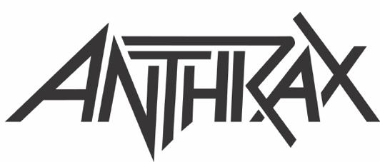

ANTHRAX EXTENDS ITS 40TH ANNIVERSARY CELEBRATION
WITH 28-DATE EUROPEAN HEADLINE TOUR SET FOR 2022
Speed Metal Punks Municipal Waste Will Be Main Support
Check out the Tour Video Trailer HERE

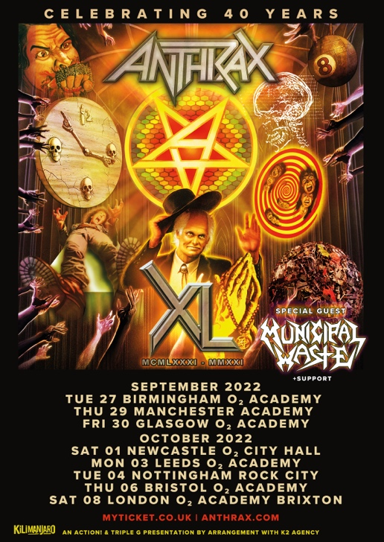

Celebrating its 40-year tenure as one of music's premier thrash metal bands, Anthrax announces its first European tour since the summer of 2019. Kicking off on September 27, 2022 in Birmingham. Crossover thrash band Municipal Waste will support on all dates. Tickets go on sale this Friday, August 20 at 10AM; go to www.anthrax.com for all purchasing information.

"It sure has been a long time since we rock’n’rolled in the UK and Europe,” said Anthrax’s Charlie Benante, "but we’re coming back soon to bring the noise to all of you guys. Being that we can’t get over there until 2022, we’re going to make sure that every show will be an eventful one. We won’t just be playing four decades of songs to celebrate our ongoing 40th anniversary - hey, we’ll be giving YOU some history! - but we just might have some brand new ones for you as well. Can’t wait to see all your happy, smiling faces!!!"

On this tour, fans can expect Anthrax - Joey Belladonna/vocals, Scott Ian/rhythm guitar, Frank Bello/bass, Charlie Benante/drums, and Jon Donais/guitar - to draw from all four decades - fan favorite and deep cuts - for their nightly setlist.

"There's just something special about Europe," said Belladonna. "Our fans there have always had a full-fledged excitement about our shows, and I enjoy performing more than anyone can imagine, so we're really looking forward to this tour."

Dates for the UK leg of Anthrax’s 2022 European tour are as follows:

SEPTEMBER
27 O2 Academy, Birmingham
29 Academy, Manchester
30 O2 Academy, Glasgow

OCTOBER
1 O2 City Hall, Newcastle
3 O2 Academy, Leeds
4 Rock City, Nottingham
6 O2 Academy, Bristol
8 O2 Academy Brixton, London

ABOUT ANTHRAX: July 18, 2021 marked Anthrax's 40th anniversary, during which time the band released 11 studio albums, was awarded multiple Gold and Platinum certifications, received six GRAMMY nominations, and a host of other accolades from the media, the music industry, and fans. In 1991, the band helped break down race and genre barriers when they collaborated with Public Enemy on the track "Bring The Noise," and was the first metal band to have its music heard on Mars when NASA played "Got The Time" to wake up the Mars Rover in 2012. Along with Metallica, Slayer, and Megadeth, Anthrax is a card-carrying member of The Big Four, the four bands that defined the speed/thrash/metal genre. Anthrax has also introduced a series of now sold-out signature whiskeys and bourbons and partnered with the Stockholm-based NEZUMI Studios for a high-end, limited-edition Baleine dive watch. Twenty-twenty-one also saw the release of Z2 Comics' "Among the Living" graphic novel with a track-by-track storyline inspired by Anthrax's iconic 1987 album, Among The Living. The book pulls together a "who's who" of names from the worlds of comics and music who created "bubble dialogue" and original artwork to express what the songs meant to them. Taking advantage of COVID-19's prohibition of concert touring, the band has been hard at work writing the next Anthrax album.

For Anthrax, 2022 is already off to a great start, but their 40th anniversary isn't quite in the band's rear-view mirror. Unable to launch a planned 40th anniversary world tour due to COVID, the band will launch that World Tour this year. The celebrations start with an headline trek in the UK in Fall.

Anthrax is: Scott Ian/guitars, Frank Bello/bass, Charlie Benante/drums, Joey Belladonna/vocals, Jonathan Donias/guitars.

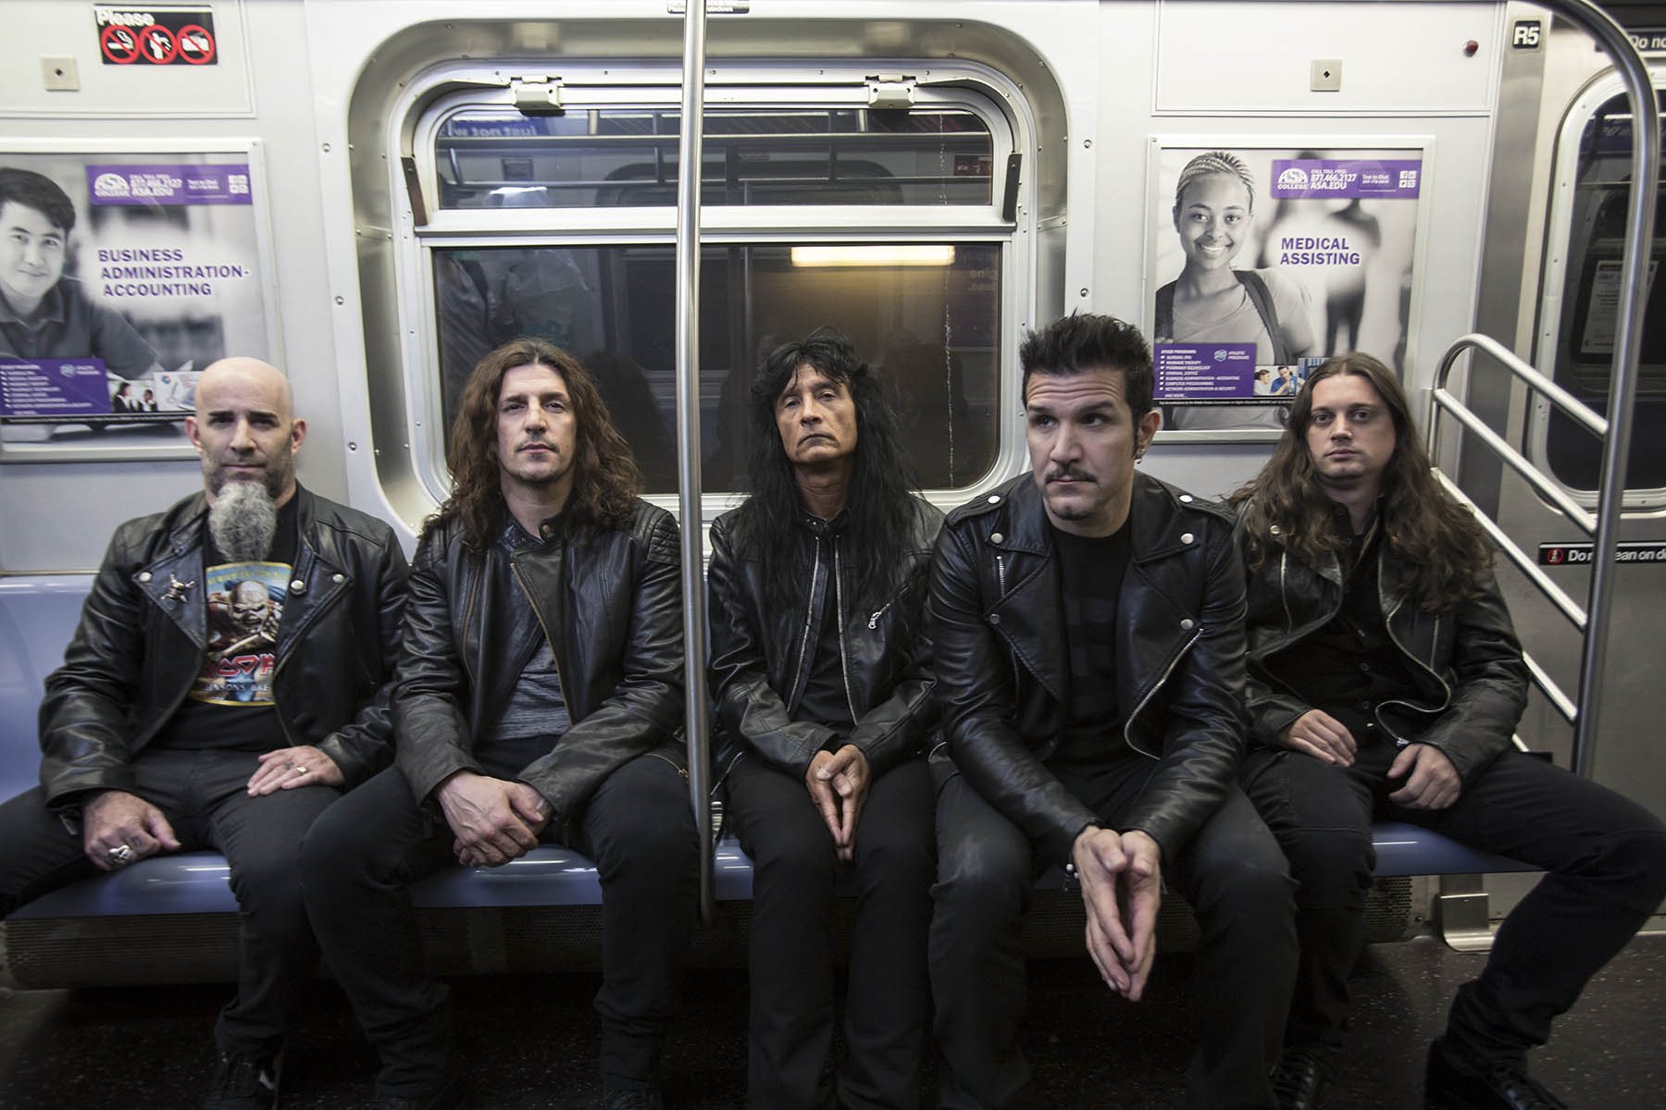

For more on info contact warren@chuffmedia.com

