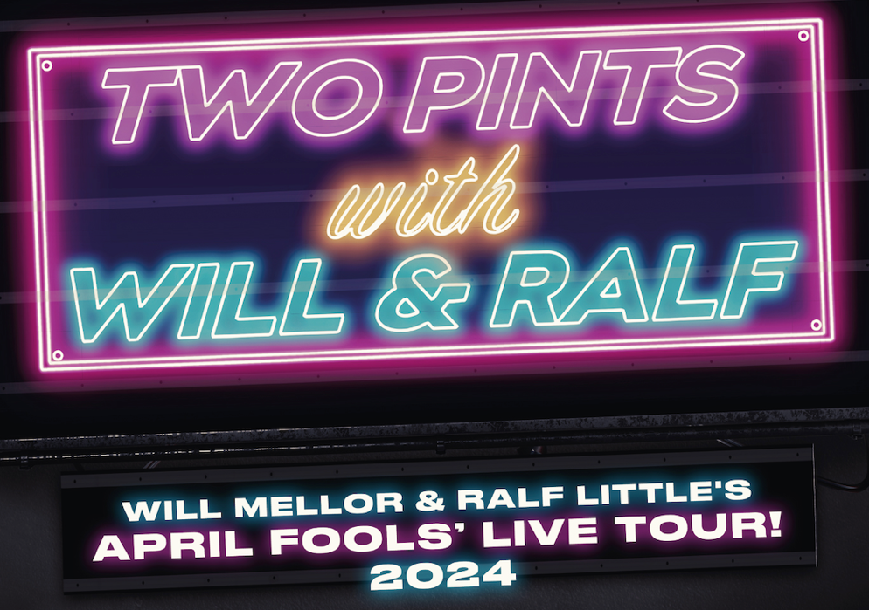

ON SALE – 10AM FRI 15TH DEC
TICKETS ON SALE VIA TWOPINTSPODCAST.COM

After the sold-out success of their 17-date Two Pints Podcast, LIVE! Tour in 2022, WILL MELLOR and RALF LITTLE are heading back on the road with their brand-new, hilarious April Fools’ Live Tour! 2024. Starting in Leeds on the 4th April, the tour visits 7 cities across the UK, culminating at Sheffield’s City Hall on 28th April.

Never mind the dancing and filming in paradise, the boys are excited to bring their side hustle to fans in real life. In true Two Pints style, every night of the tour will be uproarious – combining the infectious camaraderie of Will & Ralf with raw audience participation.

Ralf says, "Going out on tour again is very exciting! We had such a blast last time, can't wait to meet everyone again and see all your lovely faces."

Agreeing with Ralf, Will says “I loved the buzz of being on tour last time so can’t wait to have loads of banter with everyone again!!! Might even get some of my strictly moves out!!”

Tickets are on general sale 10am Friday 15th December, with a presale available on Wednesday 13th December. Visit twopintspodcast.com to secure your spot!

4-Apr-24 Leeds City Varieties
5-Apr-24 Manchester Albert Hall
6-Apr-24 Newcastle O2 City Hall
19-Apr-24 Birmingham O2 Academy
26-Apr-24 Nottingham Royal Concert Hall
27-Apr-24 Wolverhampton The Wulfrun at The Halls
28-Apr-24 Sheffield City Hall

Follow Two Pints Pod:
Twitter / Instagram / Facebook

For all media enquiries contact Warren@chuffmedia.com on 07762 130510

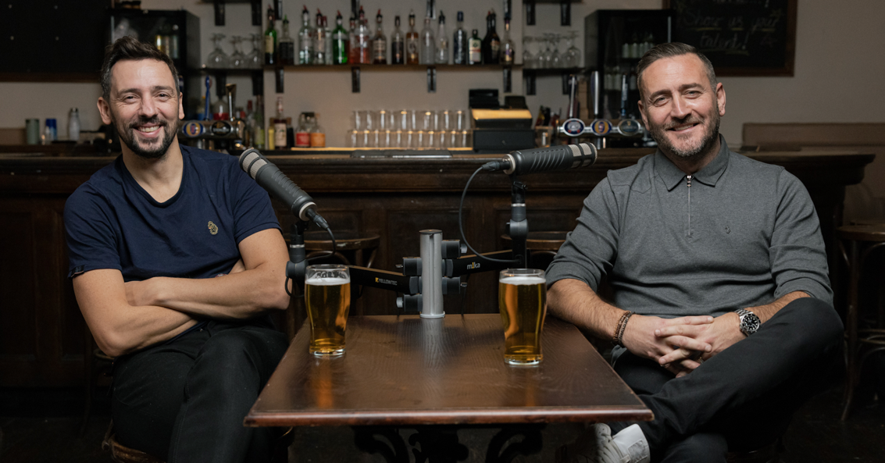

For nearly 10 years, Will Mellor and Ralf Little were the voice of a generation – notorious for pushing the boundaries of acceptable humour on British TV. After multiple failed attempts to reunite them, the boys began their Two Pints with Will & Ralf podcast in 2020. The duo are now back with the latest fourth series of the hit podcast.

Enjoying the kind of banter that only true friends can have, Will and Ralf chat sh*t to each other, to fellow celebs and to guests with fascinating stories to tell...all over two pints and a hearty helping of bar snacks.

(For legal purposes our lovely lawyers want us to point out this podcast is in no way related to a former BBC TV show of a similar name.)

