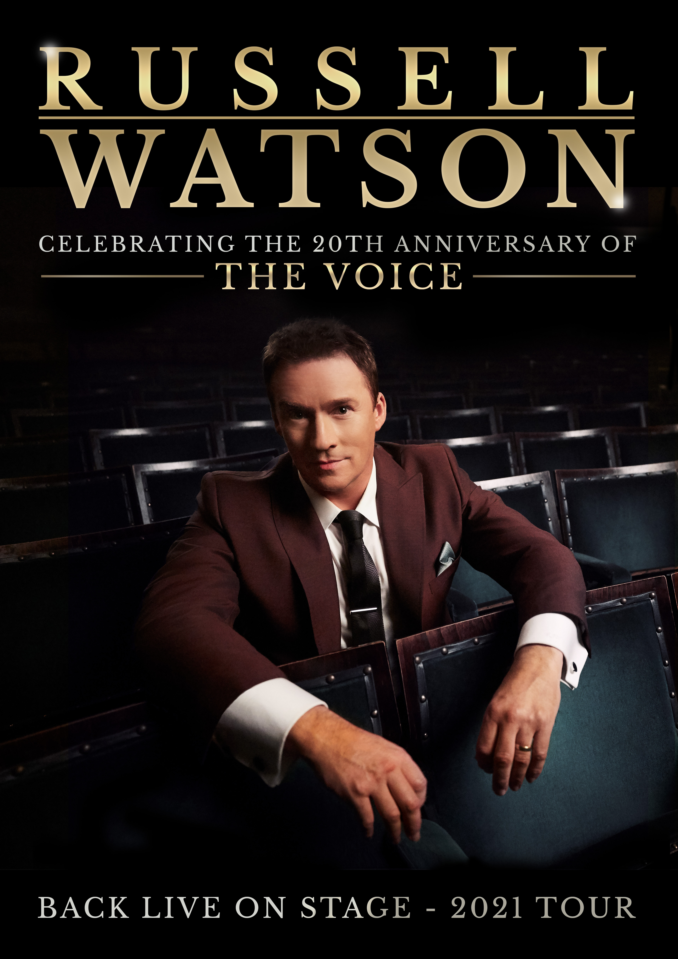

Singing sensation Russell Watson will be on tour in Autumn 2021, celebrating over 20 years since his debut album ‘The Voice’ was released.

‘The Voice’ entered the Official Classical Artist Album Chart at No 1, becoming the biggest selling classical album of 2000 and establishing the tenor as one of the Britain’s most popular classical stars. In a very special concert, Russell will perform some of his most loved songs and career highlights from the past two decades.

Commenting on the tour, Russell Watson said “I can’t believe that next year will be over 21 years since my debut album The Voice reached Number 1! All of you made this & everything that followed possible and I am thankful to be able to celebrate with you on my Autumn 2021 tour!”

Russell’s rise is the stuff of fairytale, a movie script in-the-making that saw the former bolt-cutter and working mens’ club act top charts both at home and abroad, perform for Popes and Presidents and open global sporting events from Champions League and Rugby Cup Finals to the Commonwealth Games. Single-handedly, the People’s Tenor, as he was dubbed, created classical-pop crossover, a genre that hasn’t stopped snowballing since.
Favourite pieces to be performed include:
Caruso
O Sole Mio
Il Gladiatore
You Are So Beautiful
Someone to remember me
Where My Heart Will Take Me

Tour dates
19-Sep-21 Woking New Victoria Theatre
22-Sep-21 Milton Keynes Milton Keynes Theatre
20-Oct-21 Aylesbury Waterside Theatre
22-Oct-21 Shrewsbury Severn Theatre
24-Oct-21 Leicester De Monfort Hall
28-Oct-21 Cheltenham Town Hall
29-Oct-21 Cardiff St David's Hall
31-Oct-21 Buxton Opera House
2-Nov-21 Harrogate Royal Hall
5-Nov-21 Basingstoke Anvil
7-Nov-21 York Barbican
14-Nov-21 Birmingham Symphony Hall
17-Nov-21 Hull Bonus Arena
21-Nov-21 Crewe Lyceum
25-Nov-21 Nottingham Royal Concert Hall
26-Nov-21 Manchester Bridgewater Hall
28-Nov-21 Southend Cliffs Pavilion
30-Nov-21 High Wycombe Swan Theatre
14-Jan-22 Wolverhampton Grand Theatre

Booking link: http://www.raymondgubbay.co.uk/whats-on/russell-watson-1

Please note that Laura Wright will be performing in Cardiff, York, Birmingham, Hull, Nottingham. Manchester and Southend.
Emily Haig will be joining Russell in Wolverhampton, Woking, Shrewsbury, Leicester, Cheltenham, Buxton, Harrogate, Basingstoke, Crewe, High Wycombe, Aylesbury and Milton Keynes

For more information please contact warren@chuffmedia.com on 07762 130510

