THE BLUE STONES
announce highly awaited UK & European Tour
MARCH & APRIL 2022

Download
TICKETS
WATCH: “Grim” (Video)

Today, alternative-rock duo The Blue Stones, known for their blistering live shows announce their highly anticipated UK & European 2022 Tour, their first journey over the Atlantic since 2019s sold out run.
“It’s been far too long since we’ve seen the stage,” says frontman Tarek Jafar, “We plan on hitting these European shows with every last drop of pent up energy we’ve had this year.”

The Blue Stones released their sophomore album, Hidden Gems, via Entertainment One (eOne) on March 19th. On Hidden Gems, the band worked with famed producer Paul Meany (Mutemath, Twenty One Pilots, LANY), who helped the band to not only explore and create music in a new way, but discover themselves throughout the writing process. The critically acclaimed Hidden Gems gained new fans with such key tastemakers as BBC Radio 1’s Annie Mac & Jack Saunders, Kerrang! Radio & Upset Magazine plus TVs BBC Sport & the Formula 1 all supporting the band.

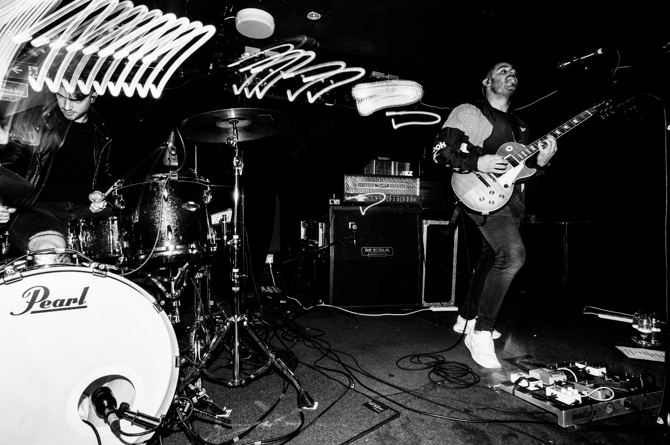
Photo Credit: Nick Sayers | Download

TOUR DATES
General on sale: Wednesday 16 June 9 AM
Mon 14th Mar: Thekla, Bristol
Tue 15th Mar: Fulford Arms, York
Wed 16th Mar: King Tuts, Glasgow
Fri 18th Mar: St. Dom’s, Newcastle
Sat 19th Mar: Academy 3, Manchester
Sunday 20th Mar: The Grand Social, Dublin
Tue 22nd Mar: Institute 2, Birmingham
Wed 23rd Mar: Lafayette, London
Thu 24th Mar: Patterns, Brighton
Sat 26th Mar: Les Etoiles, Paris, FR
Sun 27th Mar: Rotonde, Brussels, BE
Wed 30th Mar: Stengade, Copenhagen, DK
Thu 31st Mar: Knust, Hamburg, DE
Fri 1st Apr: Privatclub, Berlin, DE
Sat 2nd Apr: Hydrozagadka, Warsaw, PL
Mon 4th Apr: Café V Lese, Prague, CZ
Tue 5th Apr: Strom, Munich, DE
Wed 6th Apr: B 72, Vienna, AT
Fri 8th Apr: Magnolia, Milan, IT
Sat 9th Apr: Exil, Zurich, CH
Sun 10th Apr: Luxor, Cologne, DE
Mon 11th Apr: Paradiso, Amsterdam, NL

More from The Blue Stones
Website | Instagram | Twitter | Facebook | YouTube | Spotify

For more information please contact warren@chuffmedia.com on 07762 130510

