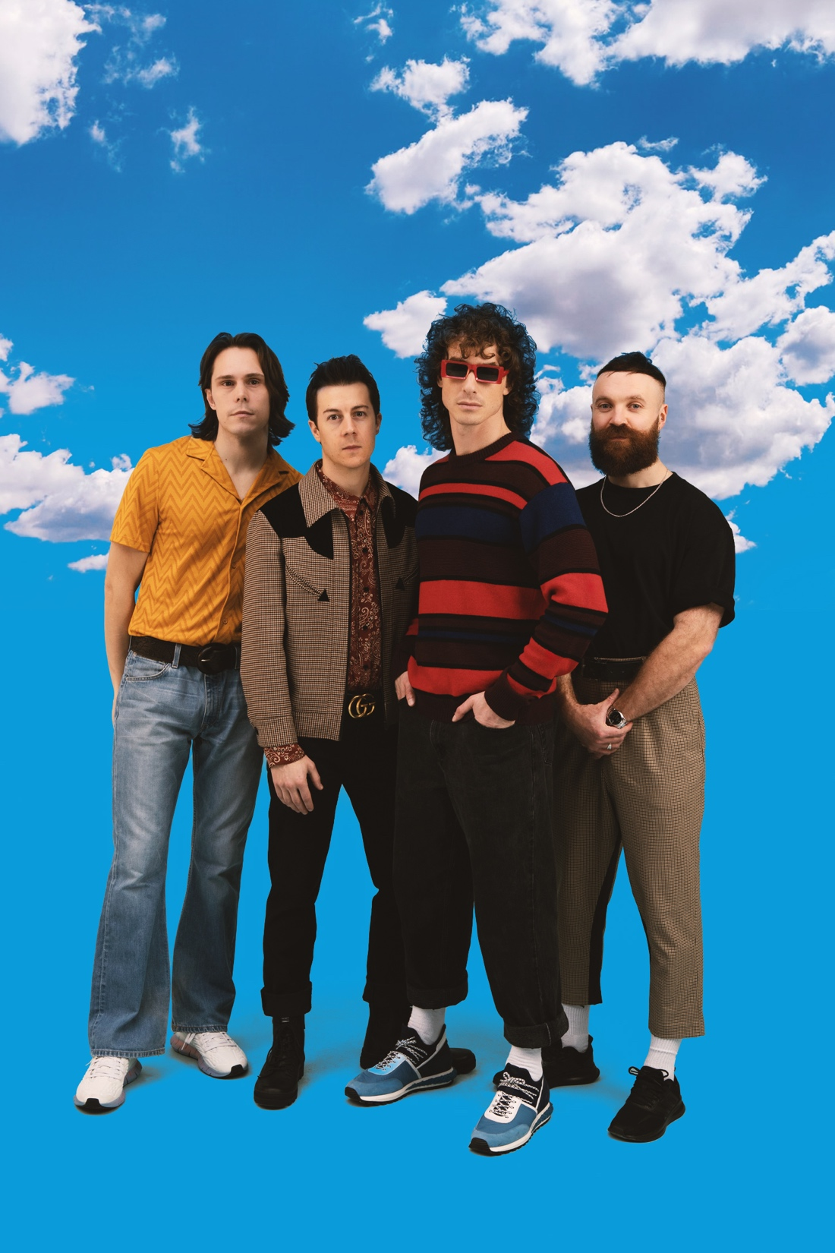

Photo credit Riya Hollings: Download hi-res photo here
THE BIRTHDAY PARTY TOUR
UK CLUB SHOWS IN NOV & DEC 2023
TICKETS ON SALE TODAY FROM https://myticket.co.uk/artists/don-broco

‘BIRTHDAY PARTY’
BRAND NEW SINGLE RELEASED SEPT 15TH
PRE-SAVE HERE

Following their incredible main stage performances at Reading & Leeds Festivals last weekend, DON BROCO hit the road again in the UK this autumn. Having blown audiences away in March when they headlined huge venues including the likes of Alexandra Palace and Cardiff Motorpoint Arena, DON BROCO will be taking to the stages of some of the smallest venues they’ve played in years.

Vocalist Rob Damiani reveals, “We’re buzzing to be heading out on The Birthday Party Tour in November and December, hitting up some of our favourite spots in the UK that we haven’t been to in a little while and some future faves we’ve never been to before! BROCO at KOKO the first time around was a huge night for us and can’t wait to be back for round 2!”

To celebrate the news, the band will be releasing a brand new single on September 15th. ‘Birthday Party’ is yet another left-turn from the Bedfordshire four-piece, who continually evolve and surprise with new musical directions. A skittery, genre-bending electro-blast of crunching beats and distorted guitars, it’s topped off with Rob Damiani’s ennui-drenched vocals, full of disappointment and dismay.

As he explains, “Birthdays can be the absolute worst. You get all hyped up for what you think is a guaranteed top day, but when that doesn’t work out you can’t help but feel EXTRA bad. I don’t really like birthdays because of this, but one year tried throwing a last min shindig and in classic form it was not well attended, haha. I can’t say I took it well but my only option was having a party for one and this song is the story of that night.”

The 15-date Birthday Party Tour will be a much more celebratory affair, with DON BROCO playing a hits-packed set and getting up, close and personal with their exuberant fan-base. Making the shows even more special will be the fact that anyone with a ticket who is celebrating their birthday on the day of each gig will be treated to their own mini-birthday party by being invited to an exclusive meet-and-greet with the band before the show. Full details will be revealed on the band’s website in due course.

THE BIRTHDAY PARTY TOUR
NOVEMBER 2023
29 – Reading, Hexagon
30 – Southend, Cliffs Pavilion

DECEMBER 2023
1 – Margate, Dreamland
2 – Norwich, UEA
4 – Bristol, O2 Academy
5 – Brighton Dome
7 – Sheffield, O2 Academy
8 – Cambridge, Corn Exchange
9 – Leicester, O2 Academy
11 – York, Barbican
12 – Newcastle, O2 City Hall
13 – Manchester, O2 Victoria Warehouse
15 – Wolverhampton, KK’s Steel Mill
16 – Bournemouth, O2 Academy
17 – London, KOKO

Tickets for the tour go on sale today via https://myticket.co.uk/artists/don-broco

For more information and press enquiries please contact
Jenny Entwistle
Jenny@chuffmedia.com

