

ADDS THIRD AND FINAL NIGHT AT NEWCASTLE’S ST. JAMES PARK FOR JUNE 2025

NOW PLAYS HOMETOWN STADIUM ON SUNDAY 15TH JUNE IN ADDITION TO PREVIOUSLY ANNOUNCED 12TH AND 14TH JUNE DUE TO PHENOMENAL DEMAND

+ PLAYS LONDON STADIUM ON FRIDAY 6TH JUNE – HIS BIGGEST HEADLINE SHOW TO DATE

TICKETS ON GENERAL SALE FROM FRIDAY 29TH NOVEMBER @ 9:30AM

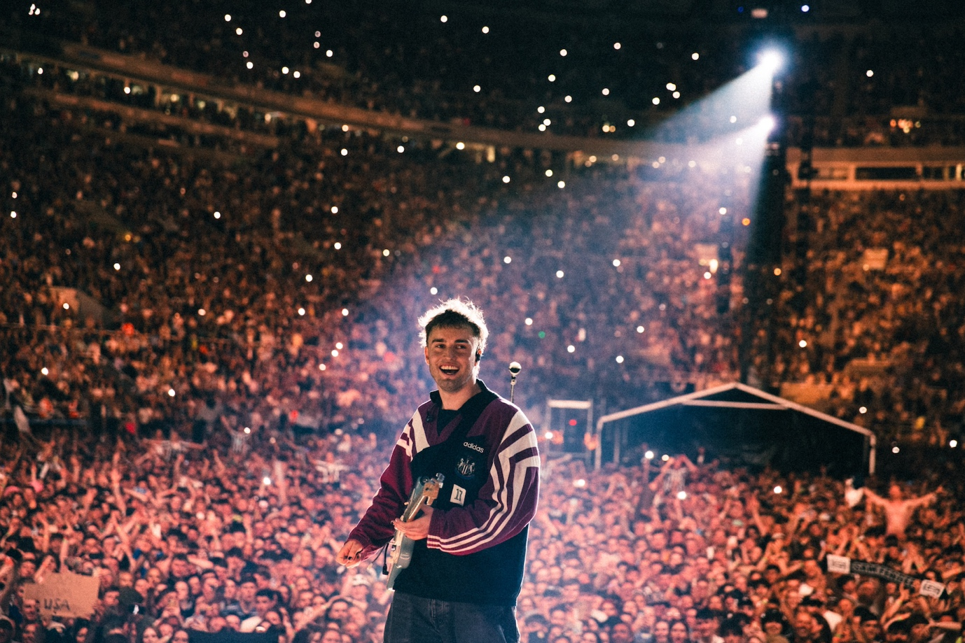
Credit: Niall Lea

SUPPORT FROM THE WAR ON DRUGS (6TH, 14TH + 15TH JUNE ONLY) + CMAT (ALL DATES)

Sam Fender is very pleased to announce a third and final night at Newcastle’s St. James’ Park for next Summer.

Sam will now play his hometown stadium on 12th, 14th and 15th June.

As previously announced, Sam also plays the 75,000 capacity London Stadium on Friday 6th June, which becomes his biggest headline show to date

The stadium run comes in support of his forthcoming third album, People Watching, out 21st February 2025.

CMAT supports at all four shows, and The War on Drugs will play on 6th and 14th + 15th June.

All remaining tickets go on general sale from 9:30am on Friday 29th November via www.samfender.com

£1 from every ticket sold will be donated to select cultural organisations such as Youth Music and Sunday For Sammy to support the arts in the North East of England.

Listen to People Watching HERE and pre-order the album HERE

As previously announced, next month Sam heads out on the first leg of the People Watching Tour across the UK/Ireland, with all the arena dates long since sold out. He then heads to Europe for the second leg of the tour in March 2025. Sam is also confirmed to headline next year’s Rock Werchter festival in July.

Full supporting line ups will be announced in the coming weeks.

In February 2025, Sam Fender releases his third album, People Watching. Now solidified as one of Britain’s most accomplished songwriters of his generation and the next, if Seventeen Going Under was Sam’s “coming of age” record, People Watching is his next step forward - colourful stories and observations of everyday characters living their everyday, but often extraordinary, lives

Sam Fender Live – People Watching Tour

2024 (support from Wunderhorse):
2nd December – 3Arena, Dublin (SOLD OUT)
4th December – First Direct Arena, Leeds (SOLD OUT)
6th December – Co-Op Live, Manchester (SOLD OUT)
7th December – Co-Op Live, Manchester (SOLD OUT)
10th December – The O2, London (SOLD OUT)
12th December – The O2, London (SOLD OUT)
13th December – Utilita Arena, Birmingham (SOLD OUT)
16th December – OVO Hydro, Glasgow (SOLD OUT)
17th December – OVO Hydro, Glasgow (SOLD OUT)
20th December – Utilita Arena, Newcastle (SOLD OUT)

2025 (support from CMAT):
4th March – Olympia, Paris (SOLD OUT)
5th March – 013 Poppodium, Tilburg (SOLD OUT)
8th March – Halle 622, Zurich (SOLD OUT)
10th March – Palladium, Cologne (SOLD OUT)
12th March – Zenith, Munich (SOLD OUT)
13th March – ChorusLife Arena, Bergamo
16th March – Uber Eats Music Hall, Berlin (SOLD OUT)
18th March – Afas Live, Amsterdam (SOLD OUT)
19th March – Forest National, Brussels (SOLD OUT)

6th June – London Stadium (w/ The War on Drugs + CMAT)
12th June – St. James’ Park, Newcastle (w/ CMAT)
14th June – St. James’ Park, Newcastle (w/ The War on Drugs + CMAT)
15th June - St. James’ Park, Newcastle *NEW DATE* (w/ The War on Drugs + CMAT)

21st June – Hurricane, Germany
22nd June – Southside, Germany
5th July – Rock Werchter, Belgium

www.samfender.com

For more information and press enquiries for SAM FENDER please contact

Jenny Entwistle
Jenny@chuffmedia.com

