STEREO MC’S

ANNOUNCE 2025 “TRUE TO LIFE”

UK & IRELAND TOUR

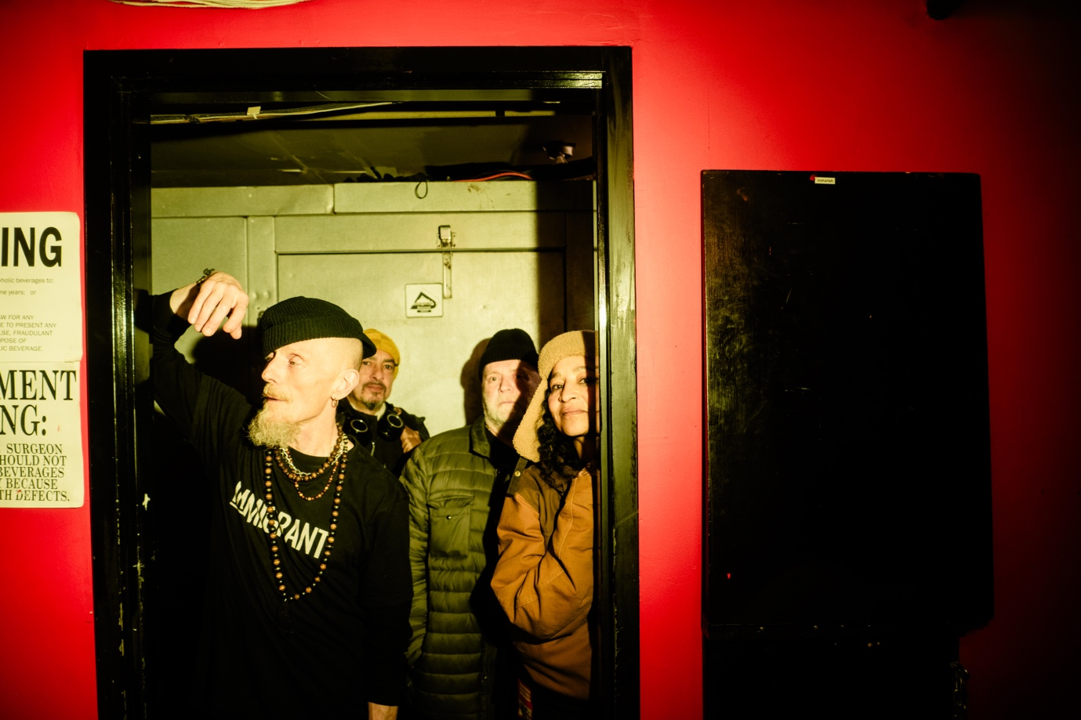

Pioneers of UK hip-hop and electronic dance, Stereo MC’s are gearing up for a major return to the road in 2025, announcing a brand-new run of UK and Ireland tour dates that will see them reconnect with fans across the country and beyond.

Momentum has been building steadily for the Brit Award-winning outfit. Following their appearance on The Tonight Show Starring Jimmy Fallon earlier this year where they performed their timeless hit “Connected”, the group revealed a full run of US shows, their first coast-to-coast tour Stateside since 2001, culminating in a slot at the Cruel World Festival on 17 May.

Now, they’re setting their sights closer to home. The ‘True To Life’ UK / IE Tour will launch at Glasgow’s St Luke’s on 27 November 2025, kicking off an 11-date trek that includes stops in Leeds, Liverpool, Bristol, Manchester, Birmingham, and more. The run wraps with a two-night residency at Dublin’s Button Factory on 30–31 January 2026, marking the band’s first full European tour since 2014.

The core lineup features founding members Rob Birch (Rob B), Nick Hallam, and Cath Coffey, joined by drummer and percussionist Tansay Omar — a reunion that promises to deliver the unmistakable groove and live chemistry that has long defined Stereo MC’s.

Fans can look forward to a deep dive through the group’s catalogue spanning seven acclaimed studio albums with classics such as “Connected,” “Step It Up,” “Elevate My Mind,” and “Lost In Music” all expected to feature.

Speaking about the upcoming tour, Rob Birch says:
“There are so many influences shaping what we’re doing right now. We’ve always drawn from the past while responding to the present — mixing old-school methods with new technology. The more diverse the sound becomes, the better it feels.”

Nick Hallam adds:
“We’ve got a lot of new material — some club-focused, some more in the Stereo MC’s tradition. When those worlds collide, that’s where the magic happens.”

STEREO MC’S – TRUE TO LIFE UK / IE TOUR

NOVEMBER 2025
27 – GLASGOW, St Luke’s
28 – LEEDS, Brudenell Social Club
29 – LIVERPOOL, Arts Club

DECEMBER 2025
4 – BRISTOL, Trinity
6 – MARGATE, Dreamland
7 – NORWICH, Epic Studios
12 – LONDON, Shepherd’s Bush Empire
13 – MANCHESTER, O2 Ritz
14 – BIRMINGHAM, O2 Academy 2

JANUARY 2026
30 – DUBLIN, Button Factory
31 – DUBLIN, Button Factory

Tickets for all shows are on sale now via www.stereomcs.com.

ABOUT STEREO MC’S

Emerging from London’s underground scene in the mid-80s, Stereo MC’s were founded by childhood friends Rob Birchand Nick Hallam, united by a love of early hip-hop, funk, and the evolving world of electronic sound.

Their 1992 breakthrough album ‘Connected’ was a landmark release — reaching #2 on the UK Albums Chart and spawning international hits including “Connected,” “Step It Up,” “Creation,” and “Ground Level.” The record earned the band two Brit Awards (Best Group and Best Album, 1994) and positioned them as one of the UK’s most influential crossover acts.

After forming their own label Gee Street Records, Stereo MC’s became trailblazers for live dance music, touring with acts such as De La Soul, Living Colour, and A Certain Ratio. Their early albums ‘33-45-78’ and ‘Supernatural’cemented their reputation on both sides of the Atlantic, and by the early 90s, they were remixing for artists as varied as U2, Madonna, Tricky, and RZA.

The band’s 2001 release ‘Deep Down & Dirty’ continued their run of hit singles and extensive global touring, while their later ventures saw them return to the club scene through their label connected, launched in 2015. The imprint has become a fixture in the Afro House movement, featuring collaborations with Adam Port, Keinemusik, Anja Schneider, Fred Everything, and more.

Now, more than three decades since first emerging from the UK’s hip-hop underground, Stereo MC’s remain a vital creative force — evolving, experimenting, and staying true to life.

For more info contact Warren warren@chuffmedia.com / 07762 130510

