DECLAN MCKENNA ANNOUNCES UK/IRELAND 2024 SPRING TOUR DETAILS

14 DATE HEADLINE RUN INCLUDES LONDON’S ALEXANDRA PALACE IN APRIL

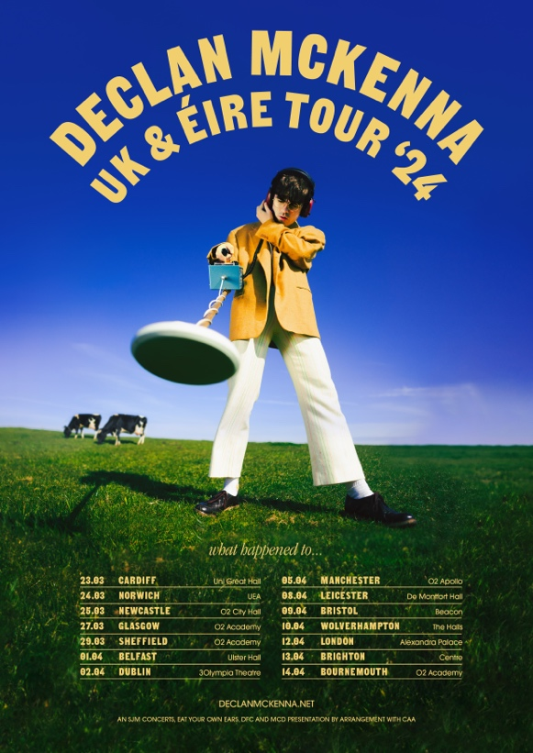

PRE-ORDER NEW ALBUM, WHAT HAPPENED TO THE BEACH? FOR EARLY ACCESS TO TICKETS

ALBUM RELEASED 9TH FEBRUARY 2024

Declan McKenna is excited to announce details of a UK headline tour for 2024 in support of his forthcoming album, What Happened To The Beach?

The new dates kick off on 23rd March at Cardiff University, concluding on 14th April at Bournemouth’s O2 Academy. The 14-date run also stops at London’s Alexandra Palace, Declan’s biggest headline show to date.

A fan pre-sale goes on sale from 9am on Wednesday 11th October, and on general sale from 9am on Friday 13th October. Fans pre-ordering the album via Declan’s own website will receive early access to UK tour tickets.

The tour announcement follows news of Declan McKenna’s forthcoming third album, set for release on 9th February through Columbia Records, which was shared last month with a new single, “Nothing Works”. The album was produced alongside Gianluca Buccellati in Los Angeles.

Listen to Nothing Works HERE / Watch the lyric video HERE

What Happened To The Beach? Is the follow up to Declan’s acclaimed second album, Zeros, which debut in the UK album chart at number 2.

Declan is currently out on a full headline tour of the US.

23rd March – Great Hall, Cardiff University
24th March – UEA, Norwich
25th March – O2 City Hall, Newcastle
27th March – O2 Academy, Glasgow
29th March – O2 Academy, Sheffield
1st April – Ulster Hall, Belfast
2nd April – 3Olympia Theatre, Dublin
5th April – O2 Apollo, Manchester
8th April – De Montfort Hall, Leicester
9th April – Beacon, Bristol
10th April – The Halls, Wolverhampton
12th April – Alexandra Palace, London
13th April – Brighton Centre, Brighton
14th April – O2 Academy, Bournemouth

www.declanmckenna.net

What Happened To The Beach? Artwork

For more information and press enquiries please contact

Jenny Entwistle
Jenny@chuffmedia.com

