ANNOUNCE TWO UK HEADLINE SHOWS IN MAY 2023
BIGGEST UK HEADLINE SHOWS TO DATE AT LONDON BRIXTON ACADEMY & MANCHESTER VICTORIA WAREHOUSE

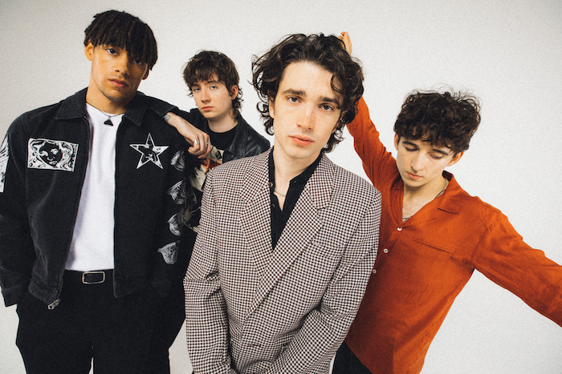

INHALER today (Nov 14th) announce their biggest UK headline shows to date. The Dublin four-piece will play Manchester’s O2 Victoria Warehouse on 19th May and London’s O2 Academy Brixton on 20th May. Tickets go on-sale at 9am on Friday 18th November.

The dates are the latest to be added to INHALER’s world tour in support of their new eagerly awaited second album ‘Cuts & Bruises’ which is released on February 17th via Polydor.
Following a run of festival dates this year, including their first Glastonbury performance, a gig at Dublin’s Fairview Park and a tour of Europe supporting Arctic Monkeys, INHALER recently played a sold out run of four UK dates including a triumphant show at The Roundhouse in London. They will tour the UK again in February before embarking on a month-long tour of the US in March.
In addition to their support slots next year with Harry Styles at Slane Castle and Sam Fender at St James Park, INHALER have just been announced as special guests of Arctic Monkeys on their 2023 European tour.
The full list of UK new dates:

FEB 2023

16th Leeds O2 Academy
17th Newcastle NX
18th Liverpool Uni The Mountford Hall
20th Norwich The Nick Rayns LCR, UEA
21st Cardiff University Great Hall
23rd Nottingham Rock City
24th Birmingham O2 Academy 1
25th Bristol O2 Academy 1

MAY 2023

19th Manchester O2 Victoria Warehouse
20th London O2 Academy Brixton

JUNE 2023

9th Newcastle St James Park (with Sam Fender)

For more information and press enquiries please contact

Jenny Entwistle
Jenny@chuffmedia.com

