TROYE SIVAN ANNOUNCES
‘SOMETHING TO GIVE EACH OTHER TOUR’

THE FIRST LEG BEGINS IN UK & EUROPE IN MAY 2024

Includes First Ever European Arena Performances

General Onsale Begins on Friday, 8th December at 9am Local on troyesivan.com

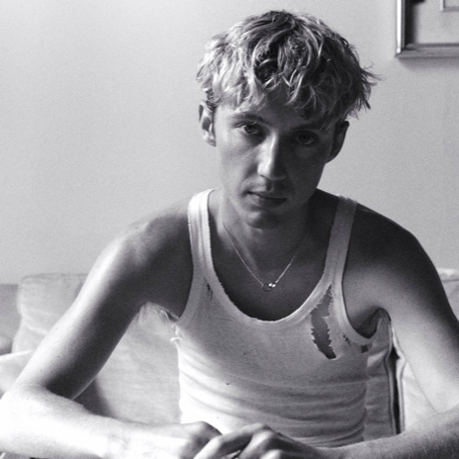
For hi-res tour art, please download HERE.

THURSDAY, 30th November 2023 – Troye Sivan has announced his biggest European headline tour to date for May and June 2024, in support of the critically acclaimed album Something to Give Each Other (October 13, EMI Australia / Capitol Records). The 17-date run, with headline shows produced by Live Nation, will kick off in Portugal on 29th May 2024 at Lisbon’s Coliseu dos Recreios, continuing with shows and festivals in Spain, Sweden, Denmark, Czech Republic, Germany, Switzerland, Netherlands, Scotland, Ireland before wrapping in the UK at the iconic OVO Arena Wembley and Birmingham’s Utilita Arena.

Sivan’s debut single from the album, “Rush”, garnered two Grammy nominations and he walked away with 4 ARIA Awards this past month – including Best Solo Artist and Song of the Year (“Rush”). Hailed by The Guardian as “one of this year’s best and most distinctive pop albums” and celebrated by Rolling Stone as “a pristine slice of pop heaven,” the Something to Give Each Other Tour is destined to be Sivan’s biggest, boldest and brightest tour. The album was accompanied by three captivating music videos that garnered viral social media traction and adoration. GQ went as far to say that “Troye Sivan shows how we might bring [music videos] back to life”. “Something to Give Each Other”, which has amassed 650 Million album streams since its release, debuted at #3 in the Netherlands, #4 in the UK and #9 in Germany – marking some of Sivan’s highest album debuts of his career.

More tour dates to be announced soon.

Tickets go on general on sale beginning Friday, 8th December at 9am local time at troyesivan.com.

VIP: The Something to Give Each Other Tour will also offer VIP packages and experiences for fans to take their concert experience to the next level. For more information, visit vipnation.eu

Troye Sivan 2024 European Tour Dates
Wednesday 29th May | Lisbon, Portugal | Coliseu dos Recreios
Friday 31st May | Barcelona, Spain | Primavera Sound*
Wednesday 5th June | Stockholm, Sweden | Hovet
Thursday 6th – Saturday 8th June | Aarhus, Denmark | NorthSide Festival*
Sunday 9th June | Prague, Czech Republic | Sportovní hala Fortuna
Tuesday 11th June | Berlin, Germany | Velodrom
Wednesday 12th June | Hamburg, Germany | Sporthalle
Friday 14th June | Munich, Germany | Zenith
Saturday 15th June | Zurich, Switzerland | The Hall
Monday 17th June | Frankfurt, Germany | myticket Jahrhunderthalle
Tuesday 18th June | Dusseldorf, Germany | Mitsubishi Electric Halle
Thursday 20th June | Amsterdam, Netherlands | AFAS Live
Saturday 22nd June | Manchester, UK | AO Arena
Sunday 23rd June | Glasgow, UK | OVO Hydro
Tuesday 25th June | Dublin, Ireland | 3Arena
Thursday 27th June | London, UK | OVO Arena Wembley
Friday 28th June | Birmingham, UK | Utilita Arena

*Festival appearance
Connect with Troye Sivan:
Instagram | Twitter | Facebook | YouTube | Website | TikTok

About Troye Sivan
Troye Sivan is a GRAMMY nominated Australian singer, songwriter and actor who has firmly established himself as a global icon in the worlds of pop music, fashion and LGBTQIA+ representation. Twenty-six billion streams and 10 million adjusted albums sold worldwide are milestones only a few artists can claim. Doing it by age 28 is another thing entirely. Throw in a range of standout roles in Hollywood features, high fashion collabs, runway appearances and a combined social audience of over 30 million and the list really boils down to one person – Troye Sivan. Raised in Perth, Australia, Sivan set the world on fire with a pair of EPs – 2014’s TRXYE and 2015’s Wild. With his debut album Blue Neighbourhood, sophomore album Bloom, the 2020 EP In A Dream, and most recently his third studio album, Something To Give Each Other, as well as a slew of singles and collaborations in between, Sivan has cemented himself in the music industry with 10 years of experience under his belt. Hailed as “the perfect pop star” by TIME, Sivan’s recent hit single “Rush” earned global accolades and praise, including two GRAMMY nominations. His career has been further celebrated as the recipient of six ARIA Awards, a Billboard Music Award, three MTV Europe Music awards and two GLAAD Media wins. “Revelation,” his collaboration with Jónsi for BOY ERASED, was nominated for a Golden Globe for Best Original Song – Motion Picture and shortlisted for an Oscar. Sivan has recently been featured in campaigns for Cartier, YSL Beauty, Calvin Klein, Valentino, Savage Fenty, and Beyoncé’s Ivy Park, and appeared in The Weeknd & Sam Levinson’s “The Idol” for MAX, alongside Lily-Rose Depp, Blackpink’s Jennie and Abel himself. He also launched Tsu Lange Yor, an independent luxury lifestyle collection of fragrances and art-driven objects. Sivan continues to be represented by Good World Management, CAA and imPRint.

For more information and press enquiries please contact

Jenny Entwistle
Jenny@chuffmedia.com

