BILLIE MARTEN
SHARES NEW SINGLE & VIDEO ‘CREATURE OF MINE’ - ANNIE MAC’S HOTTEST RECORD IN THE WORLD ON BBC RADIO 1

ANNOUNCES 2021 UK TOUR
NEW ALBUM FLORA FAUNA - OUT 21 MAY ON FICTION RECORDS

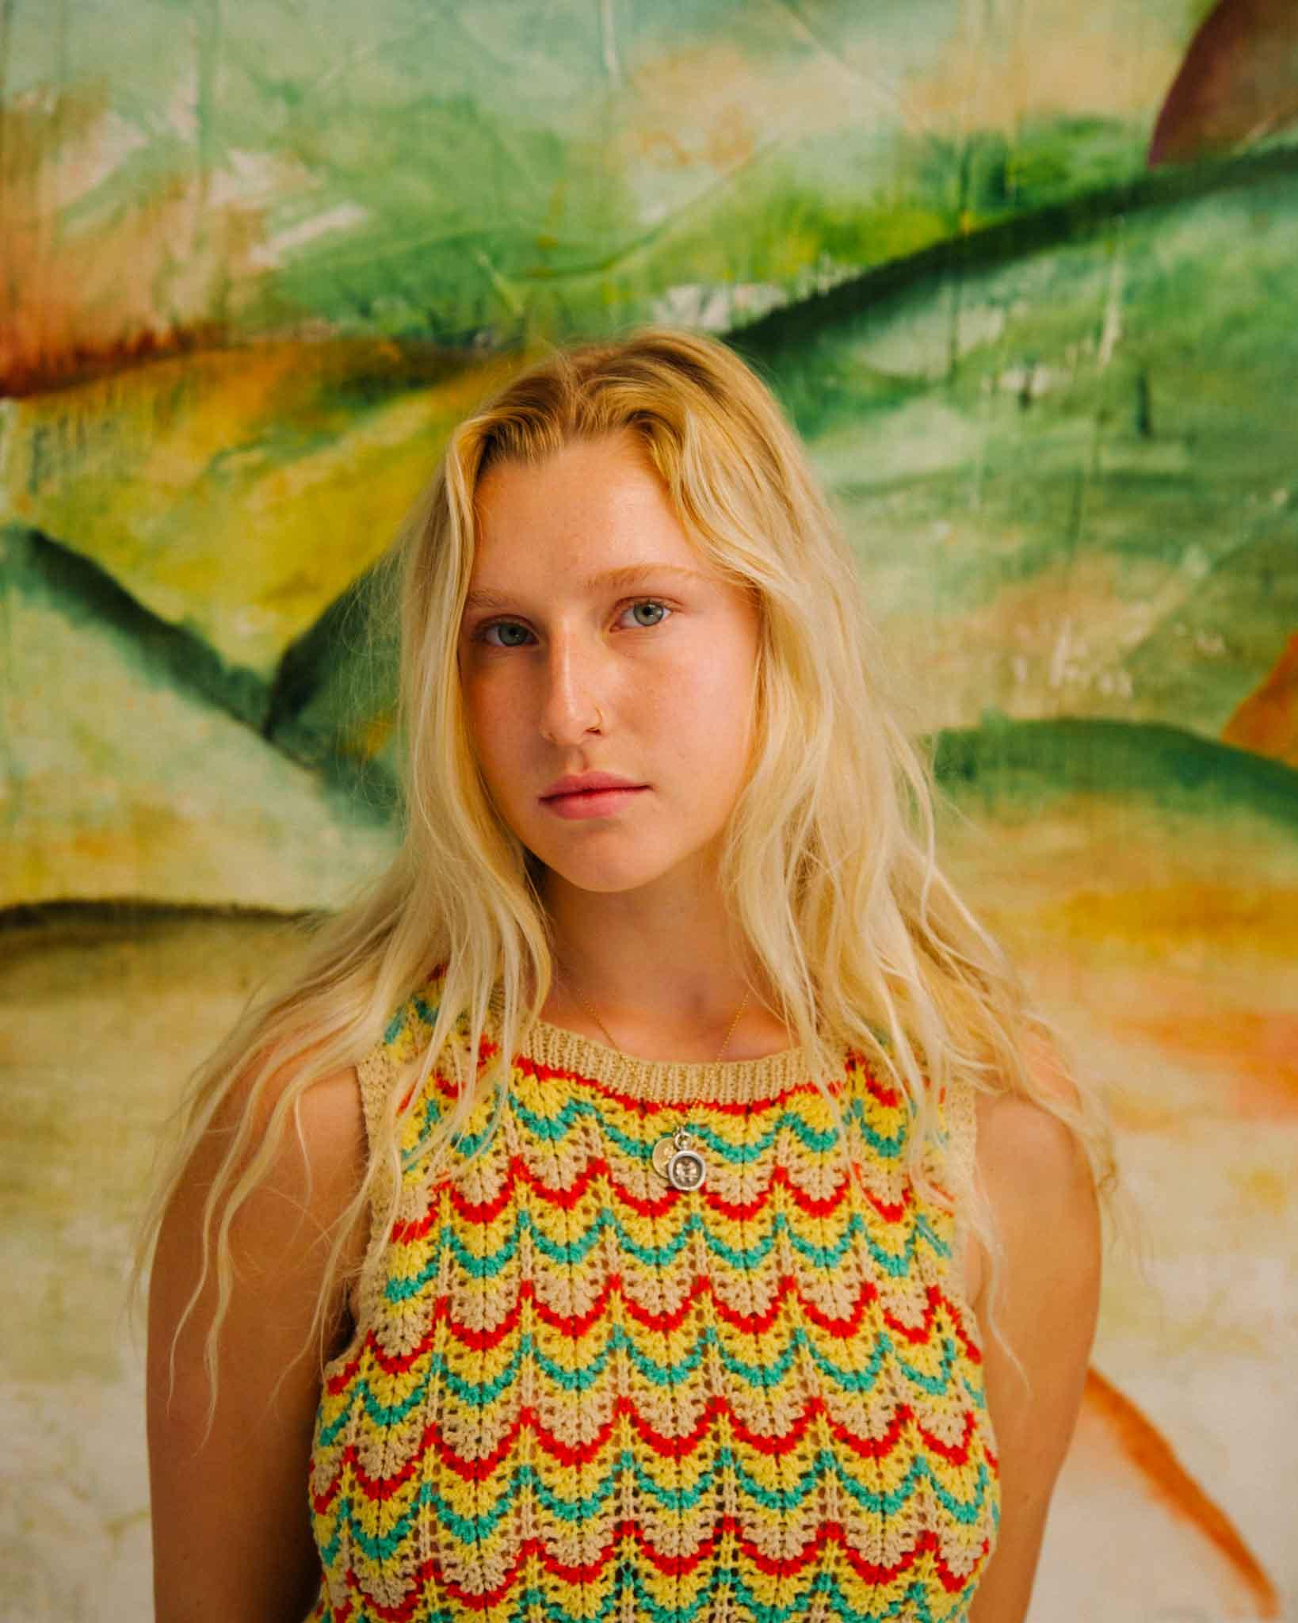
Photo credit: Katie Silvester

“Marten places herself in the company of Nick Drake, John Martyn, Kate Bush and Joni Mitchell - not just stylistically, but in terms of emotional pull she can apply with just a few piano chords and some half heard vocals” - Sunday Times Culture

“A gentle and reserved masterpiece” - The Line Of Best Fit

“A striking sensory experience. All signs point towards a colourful future for this talented teen” - DIY

“Marten fashions her own world of fragile darkness” - Evening Standard

“With a depth of feeling and conviction in her voice… Billie Marten is truly gifted” - GLAMOUR

“...talent beyond measure and a wisdom well beyond her tender years” - Wonderland

“Unbelievably beautiful” - Independent

“...spellbinding” - NYLON

“A sublime song” - Notion

“A breath of fresh air” - Yuck Magazine

Listen to ‘Creature Of Mine’ HERE

Watch the ‘Creature Of Mine’ music video HERE

Billie Marten has today shared her new single ‘Creature Of Mine’, taken from her upcoming third album Flora Fauna - out May 21 on new label home Fiction Records. The track premiered as Annie Mac’s much-coveted Hottest Record In The World on BBC Radio 1 last night and follows the sensational ‘Garden Of Eden’ in providing a taster of the new record and Marten’s growth as an artist. Marten has also announced a UK tour for later in the year, which includes a date at London’s EartH on 30 September. Pre-order Flora Fauna on all formats HERE.

Raised in the rolling hills of North Yorkshire on artists such as Nick Drake, Joni Mitchell, Joan Armatrading, and Kate Bush, Marten’s critically acclaimed debut album Writing of Blues and Yellows, was released in 2016 when she was still just 17, while its follow-up Feeding Seahorses By Hand was similarly lauded in 2019.Recorded with Rich Cooper in London, Marten’s new material blends those signature hushed, resonant vocals with a rapid pulse and rich instrumentation, her inspirations now stretching from krautrockers Can, to Broadcast, Arthur Russell, and Fiona Apple.

Speaking about new single ‘Creature Of Mine’, Marten explains: “It’s an end of the world, post-apocalyptic scenario - you get to choose one thing, one person to leave it with. It’s a love song to a stranger and a polite request to momentarily leave Earth when it’s all too much.”

To coincide with the single’s release, Marten has also shared the music video for ‘Creature Of Mine’ created with Joe Wheatley. She explains: “Joe and I wanted this video to represent that needless search for something other than what you have. Something intangible and elusive, something also quite beautiful and abstract to pair with the song - an inconclusively painted picture.”

Alongside her nomination for the BBC Sound of 2016, support throughout Marten’s burgeoning career has rolled in from the likes of The Evening Standard, The Independent and The Sunday Times Culture. Flora Fauna’s lead single ‘Garden Of Eden’ - which was her first since 2019 - was met with rapturous praise in January 2021, drawing in national airplay from the likes of Annie Mac, Jack Saunders, Sian Eleri, Arielle Free and Gemma Bradley at BBC Radio 1, Dermot O’Leary and Jo Whiley on BBC Radio 2, and landing playlist spots at BBC Radio 6 Music (currently on the A-List) and Radio X (C-List). The track was also lauded by Clash, DIY, Dork, NME, Notion, Stereogum, The Forty Five The Guardian, The Line Of Best Fit, and many more tastemakers.

Built on the minimalist acoustic folk foundations she made a name for herself with, Marten’s upcoming third album Flora Fauna is a more mature, embodied album fostered around a strong backbone of bass and rhythm. Shedding the timidity of previous work in favour of a more urgent sound, the songs mark a period of personal independence for Marten as she learned to nurture herself and break free from toxic relationships - and a big part of that was returning to nature. “I wasn’t really treating myself very well, it was a bit of a disruptive time. All these songs are about getting myself out of that hole - they’re quite strong affirmations. The name Flora Fauna is like a green bath for my eyes. If the album was a painting, it would look like flora and fauna - it encompasses every organism, every corner of Earth, and a feeling of total abundance.”

***

See Billie Marten live in 2021:

Sep 16 | Stereo, Glasgow
Sep 17 | O2 Academy, Leicester
Sep 18 | Jericho Arms, Oxford
Sep 19 | Leadmill, Sheffield
Sep 21 | Castle & Falcon, Birmingham
Sep 24 | Brudenell Social Club, Leeds
Sep 28 | The Portland Arms, Cambridge
Sep 29 | Academy 3, Manchester
Sep 30 | EartH, London

Billie Marten - Flora Fauna - out 21/05/2021 on Fiction Records

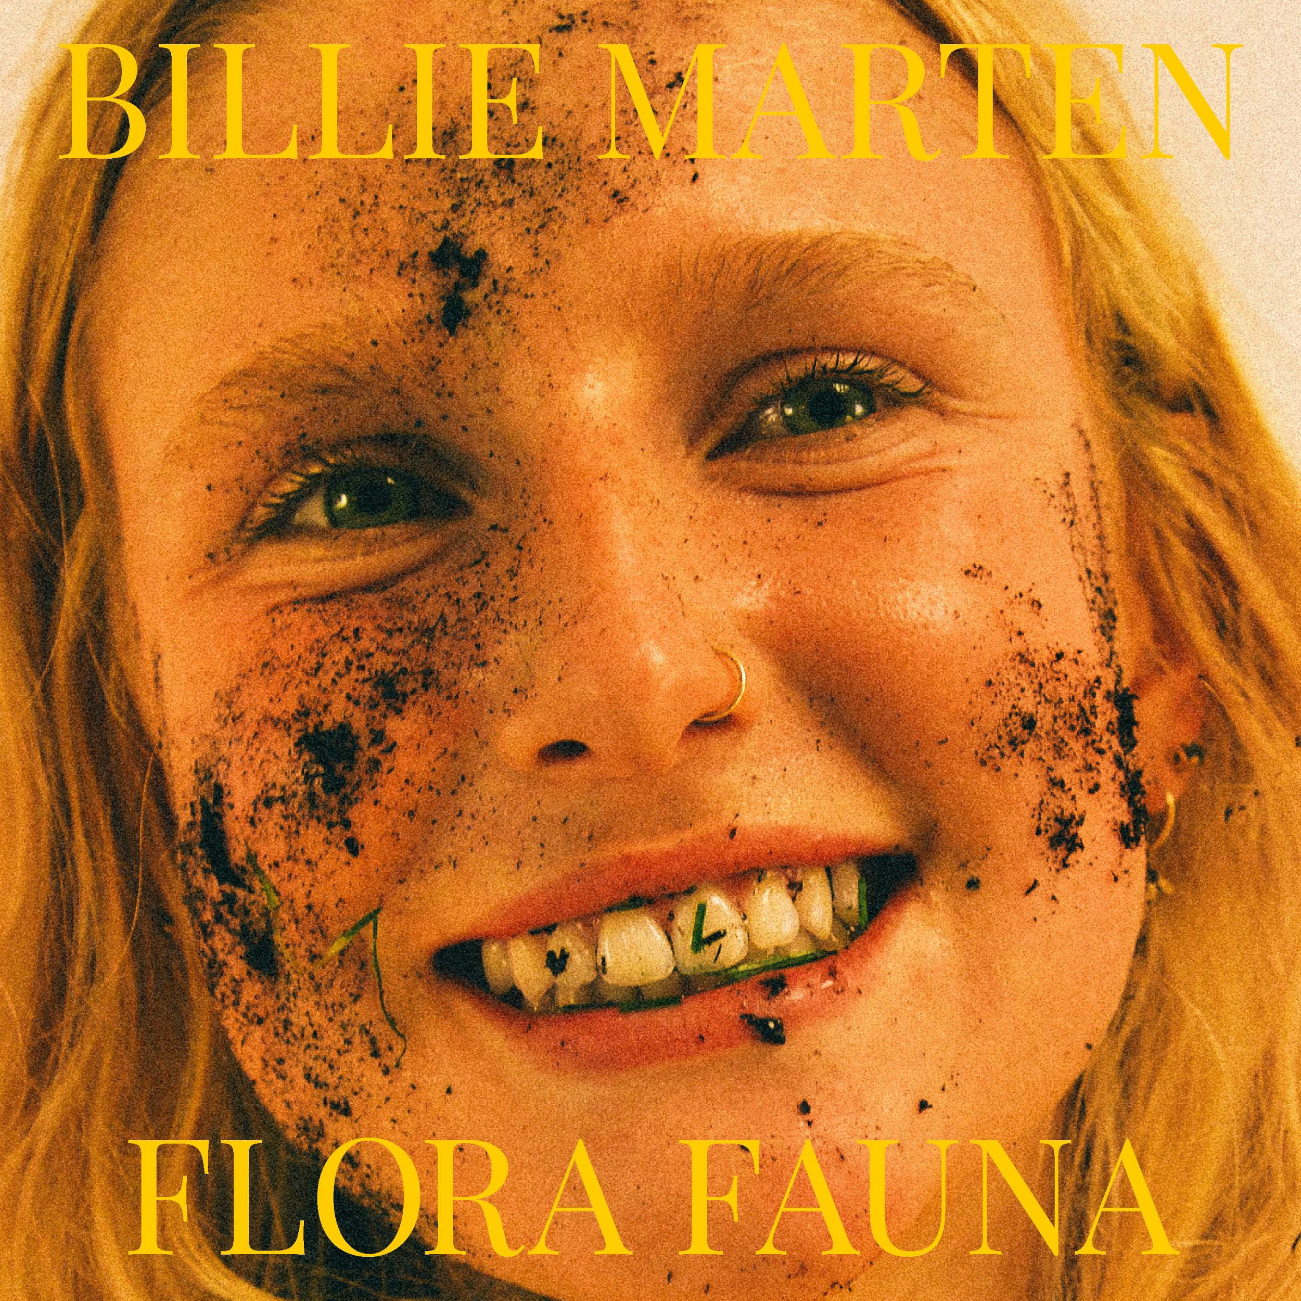

1. Garden Of Eden
2. Creature Of Mine
3. Human Replacement
4. Liquid Love
5. Heaven
6. Ruin
7. Pigeon
8. Kill The Clown
9. Walnut
10. Aquarium
For more information and press enquiries please contact

Jenny Entwistle
Jenny@chuffmedia.com

