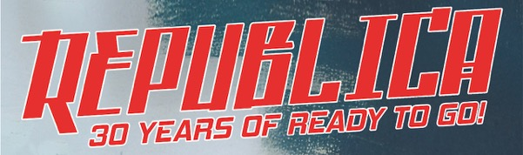

UK TOUR ANNOUNCED FOR OCTOBER / NOVEMBER 2026
Britpop trailblazers Republica have announced a major UK tour this autumn, marking 30 years since their explosive rise as one of the late 90s’ defining acts. Running across October and November 2026, the tour will see the band bring their unmistakable ‘techno-pop, punk rock, electronica’ sound back to stages nationwide.
Fronted by the iconic Saffron, Republica emerged alongside a wave of era-defining female-fronted bands including Catatonia, Elastica, Sleeper and Skunk Anansie, helping shape the sound and attitude of Britpop at its peak.


Their breakthrough hits Ready to Go and Drop Dead Gorgeous became instant anthems, ubiquitous across radio, MTV and global youth culture. While synonymous with the UK scene, Republica first broke America, where Ready To Go was the most added track across modern rock and alternative radio for months, with blanket playlisting and heavy MTV rotation, alongside a sold-out 65-date US tour. With over three million albums sold and a UK Top 3 debut, their impact endures, with music featured in Captain Marvel, Yellowjackets and Ted Lasso.

That resurgence has brought a renewed spotlight with Saffron recently performing as part of Alex James’ Britpop Orchestra, placing Republica back at the centre of the cultural conversation.

Renowned for their high-energy live shows, the band have played major festivals including Glastonbury Festival and Reading and Leeds Festivals, and continue to perform worldwide, including halftime performances from Saffron during the FIFA World Cup in Qatar.
The anniversary tour opens on 16 October at Strings, Isle of Wight, before travelling across the UK, including a London date at The Garage on 28 November, and closing in Bristol on 29 November.
Saffron said: “It’s incredible to think it’s been 30 years. These songs still feel as urgent and exciting as they did back then—we can’t wait to celebrate with everyone.”
As Britpop finds a new generation, Republica’s 30th anniversary tour is both a celebration and a reminder of just how powerful that sound still is.
Full tour dates:
16-Oct-26 Isle of Wight Strings
17-Oct-26 Southampton The Brook
23-Oct-26 Kendal Brewery Arts Centre
24-Oct-26 Sheffield Network 2
29-Oct-26 Frome Cheese & Grain
30-Oct-26 Birmingham Hare & Hounds
31-Oct-26 Leeds Brudenell
05-Nov-26 Tunbridge Wells Forum
06-Nov-26 Brighton Chalk
07-Nov-26 Norwich UEA
12-Nov-26 Guildford Boileroom
13-Nov-26 Exeter Phoenix
14-Nov-26 Cambridge Mash
15-Nov-26 Cardiff Globe
20-Nov-26 Manchester Gorilla
21-Nov-26 Glasgow Oran Mor
26-Nov-26 Nottingham Rescue Rooms
27-Nov-26 Bedford Esquires
28-Nov-26 London The Garage
29-Nov-26 Bristol Thekla
Tickets on sale via https://linktr.ee/republicaofficial

For all media enquiries contact warren@chuffmedia.com on 07762130510

