JAMES B PARTRIDGE
PHENOMENAL DEMAND SEES PRIMARY SCHOOL BANGERS 2026 TOUR EXTEND WITH BRAND-NEW AUTUMN DATES

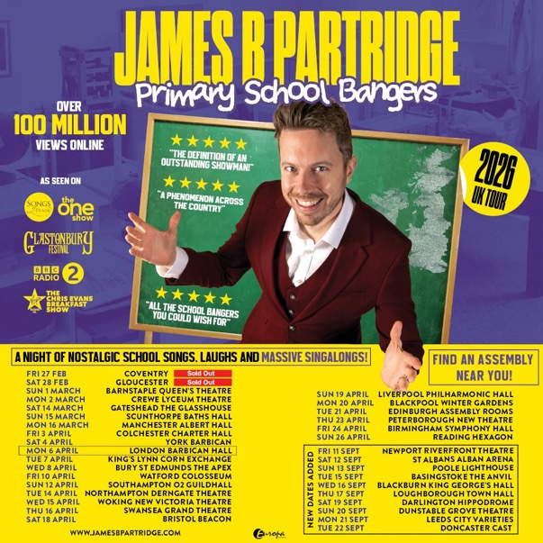

All media assets are available here.

Viral sensation and Britain’s favourite school teacher James B Partridge is heading back on the road in 2026 and following extraordinary demand, he’s bringing the Primary School Bangers Tour back for an encore this September with new shows at venues including Newport Riverfront Theatre, St Albans Arena, Poole Lighthouse and Leeds City Varieties. As tickets for the spring dates fly out and with another incredible summer ahead, these brand-new autumn shows have been added to meet the overwhelming appetite for one of the UK’s most joy-filled live experiences.

The Primary School Bangers Tour has become a nationwide celebration of the songs that soundtracked our school days, the ones sung in assembly halls up and down the country. From mass singalongs to heart-on-sleeve nostalgia, the show taps into a shared experience that unites generations, all delivered with James’s warmth, humour and unmistakable feel-good energy.

The tour first visits theatres and concert halls across the UK in April 2026, marking James’s most ambitious live production to date. Audiences can expect uplifting assembly classics, full-voiced communal singing and the pure joy of rediscovering songs everyone thought they’d forgotten (but somehow still know every word to).

Fresh from the hugely successful Big Christmas Assembly Tour, which saw the majority of concert halls and theatres sell out across the UK, James’s momentum continues to build.

What began as a handful of playful performances for his pupils has grown into a genuine national phenomenon. From viral social media fame to a field-closing Glastonbury set (featured on BBC festival highlights), James has become the UK’s most beloved musical nostalgia act, all while continuing to teach primary school children during the week.

With appearances on Chris Evans’ Virgin Radio Breakfast Show, BBC Radio 2, The One Show and Songs of Praise: The Big School Assembly Singalong, James has shown that his unique blend of humour, heart and harmony resonates with audiences of every generation.

This isn’t just a tour, it’s a collective singalong, decades in the making.
The Primary School Bangers Tour comes to theatres this spring… and due to phenomenal demand, returns this September.
Newly added dates:
11-Sep-26 Newport Riverfront Theatre
12-Sep-26 St Albans Albans Arena
13-Sep-26 Poole Lighthouse
15-Sep-26 Basingstoke Anvil Arts
16-Sep-26 Blackburn King Georges Hall
17-Sep-26 Loughborough Town Hall
19-Sep-26 Darlington Hippodrome
20-Sep-26 Dunstable Grove Theatre
21-Sep-26 Leeds City Varieties
22-Sep-26 Doncaster Cast
Tickets on sale
via jamesbpartridge.com

Facebook: @JamesBPartridgeOfficial / Instagram: @jamesbpartridge
Twitter (X): @jbpartridge / TikTok: @jamesbpartridge

Primary School Bangers Spring 2026 Tour

14-Mar-26 Gateshead Glasshouse
15-Mar-26 Scunthorpe Baths Hall
16-Mar-26 Manchester Albert Hall
3-Apr-26 Colchester Charter Hall
4-Apr-26 York Barbican
6-Apr-26 London Barbican
7-Apr-26 King's Lynn Corn Exchange

8-Apr-26 Bury St Edmunds Apex Theatre
10-Apr-26 Watford Colosseum

12-Apr-26 Southampton O2 Guildhall
14-Apr-26 Northampton Derngate Theatre
15-Apr-26 Woking New Victoria
16-Apr-26 Swansea Grand Theatre
18-Apr-26 Bristol Beacon
19-Apr-26 Liverpool Philharmonic Hall
20-Apr-26 Blackpool Winter Gardens (Arena)
21-Apr-26 Edinburgh Assembly Rooms
23-Apr-26 Peterborough New Theatre
24-Apr-26 Birmingham Symphony Hall
26-Apr-26 Reading Hexagon

For more on info contact warren@chuffmedia.com 07762 130510

