GOOD NEIGHBOURS ANNOUNCE WORLD TOUR
UK DATES THIS OCTOBER
TICKETS ON SALE NOW

LISTEN TO NEW SINGLE ‘DAISIES’ NOW
LISTEN / WATCH
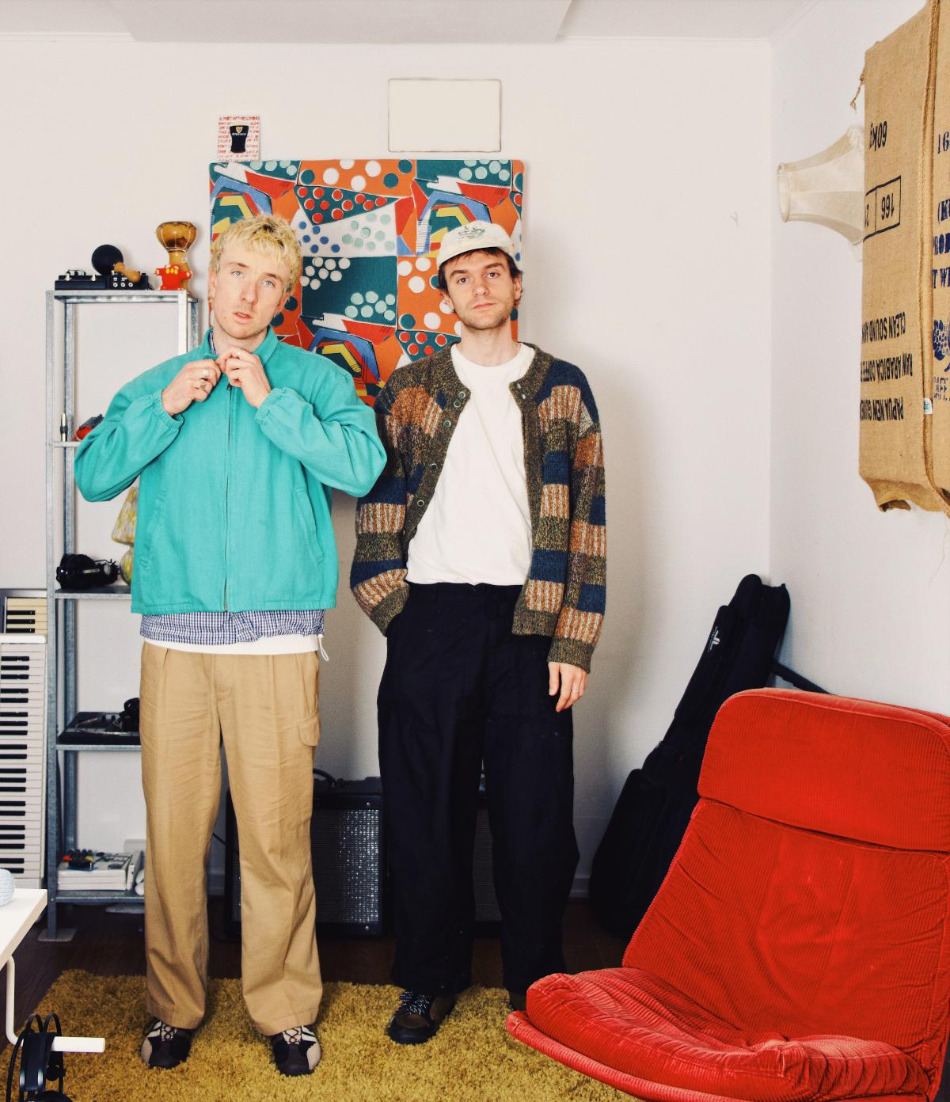

Praise for ‘Daisies’
“Ripe for summer playlist use, it’s a dizzying alt-pop statement, reaching to that killer chorus” - Clash
“A surefire hit for the mainstream and underground alike” - Wonderland
“Capturing the sound of summer with a ferocious, almost punk energy and a soaring chorus” - DIY

Following the release of their third single ‘Daisies’, rising duo Good Neighbours announce their world tour, with UK dates starting this October after their summer festival appearances. Tickets are on sale now. For more information go HERE.

Good Neighbours last month released ‘Daisies’ a “low self-esteem anthem” named BBC Radio 1’s Hottest Record and was premiered by Jack Saunders. Paired with the new song is a live performance video of ‘Daisies’ filmed at the band’s sold-out show at Village Underground in London. Watch HERE.
‘Daisies’ follows ‘Keep It Up’ a rousing pep-talk of a song and their huge, breakout debut single, ‘Home’ - the first true viral success of the year, amassing more than 270 million global streams, officiating it as the most streamed debut single globally from a new artist in 2024. ‘Home’ entered the singles charts in 13 countries including the UK (#26) and the Billboard Hot 100 (for 11 weeks) and has spent 17 weeks in the Top 10 on Billboard’s Hot Rock Songs chart, along with impressive radio airplay on nearly 150 stations in the US across all formats, landing the song at No. 10 at AAA and in the Top 15 at Alternative Radio.

Last week, Good Neighbours shared their cover of Sabrina Carpenter’s hit single ‘Espresso’, for Triple J’s Like A Version. Watch the special performance HERE.

At home in the UK, Good Neighbours sold out The Sebright Arms in November 2023, off the back of one SoundCloud demo. In February of this year, they packed out Hackney’s The Victoria for their second-ever headline, and the next day, they sold out London’s Lexington in under an hour. Due to such demand, they added another London show at Village Underground, which quickly sold out as well.

Good Neighbours are Scott Verrill and Oli Fox.
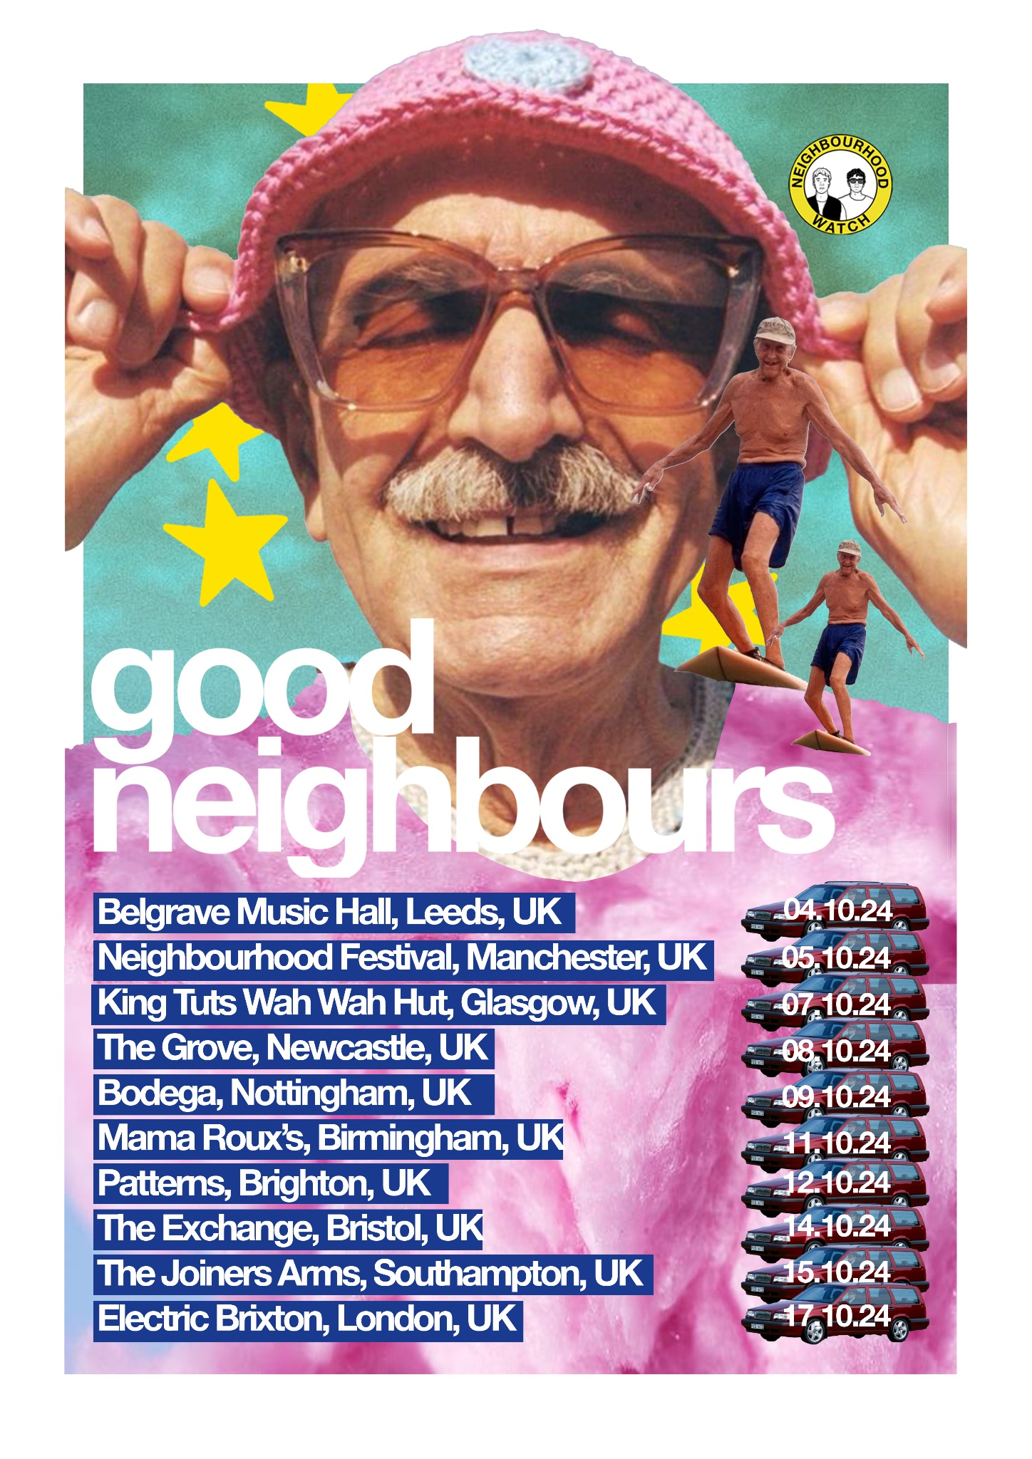

UK DATES

18th August – All Points East – London, UK*
23rd August – Leeds Festival – Leeds, UK*
25th August – Reading Festival – Reading, UK*

4th October – Belgrave Music Hall – Leeds, UK+
5th October – Neighbourhood Festival – Manchester, UK*
7th October – King Tuts Wah Wah Hut – Glasgow, UK+
8th October – The Grove – Newcastle, UK+
9th October – Bodega – Nottingham, UK+
11th October – Mama Roux’s – Birmingham, UK+
12th October – Patterns – Brighton, UK+
14th October – Exchange – Bristol, UK+
15th October – The Joiners – Southampton, UK+
17th October – Electric Brixton – London, UK+

+ Headline Show
*Festival Performance

About Good Neighbours:
Good Neighbours are a band born out of small towns and spare time. Scott and Oli have neighbouring studios at their building in East London, and first began making music for the project together out of desire to make something positive and unpolished in a scene where most music felt quite mellow and intimate. Over the course of 2023, they began making music for the love of it, and only by summer realise they needed to create a band to release their songs under. With an urge to rekindle the early 2000s excitement of bands like Passion Pit and MGMT, Good Neighbours is a nod to classic songwriting and raucous production, inspired by A24, friendship and a cinematic approach to music.

Follow Good Neighbours
TIKTOK | INSTAGRAM | TWITTER/X | FACEBOOK | YOUTUBE

For more information and press enquiries please contact
Jenny Entwistle
Jenny@chuffmedia.com

