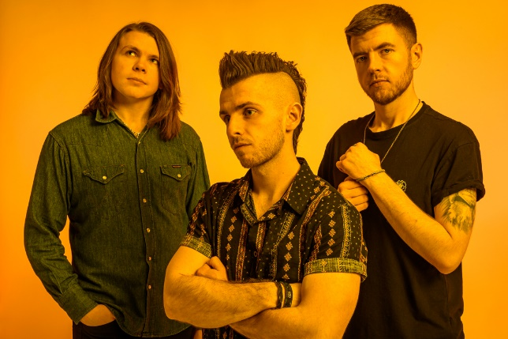

NEW ALBUM
CALL THIS A REALITY
OUT 27TH JAN 2023

OCTOBER TOUR DATES
INCLUDING THE VIRGINMARYS SUPPORT

“Innovative & profoundly enjoyable with melodies that seep into your brain” - NME
“bags of confidence and some impressive, intelligent song writing” - BBC Radio Scotland
“ballsy Scottish rockers Anchor Lane stir things up” - Planet Rock

Prior to the release of their debut album ‘Casino’ in 2020, Glasgow based Anchor Lane had been building a following with to their relentless gigging schedule. The album garnered rave reviews across the board and went straight into the Official UK Rock Albums Chart at Number 9, scoring the band their first Top 10. It was also Top 20 in the Official Scottish Albums Chart and Top 50 in the Official UK Independent Albums Chart.

Appearing at festivals such as Download, Isle of Wight, Stone Free and Belladrum etc. - along with notable guest spots with acts like Eagles of Death Metal, Tremonti and Cheap Trick, Anchor Lane were denied the opportunity to tour the release of ‘Casino’ due to the global pandemic. The band turned this into a positive when, amongst several live streams for their fans, they used the time to dig deeper into the song writing process, which has resulted in a brand new collection of songs.

Whilst citing a wide range of influences including Nothing But Thieves, Royal Blood, Don Broco, Bring Me The Horizon and Band of Skulls. Conor, Lawrence and Graeme have been recording their new material in Glasgow with producer Bruce Rintoul (Twin Atlantic, Fatherson, Vukovi). The results of which will see the release of their sophomore album entitled ‘Call This A Reality?’ out 27th January ‘23.

A welcome return to the road this year has already seen the band wow fans on the festival circuit including a triumphant set at Download as well as debuts at Steelhouse and Call of the Wild following three successful tours around the UK in in 2022 already! October will see the band out on tour again to coincide with the release of the single ‘Stutter’, a first taste of their forthcoming album – these dates are a mix of headline shows along with supporting The Virginmarys.

12-Oct-22 Blackpool The Waterloo
14-Oct-22 Huddersfield The Parish w/ The Virginmarys
15-Oct-22 Lancaster The Pub
16-Oct-22 Reading Face Bar w/ The Virginmarys
19-Oct-22 Hull Polar Bear w/ The Virginmarys
20-Oct-22 Nottingham Rough Trade w/ The Virginmarys
23-Oct-22 Newport The Patriot
24-Oct-22 Bristol Louisiana w/ The Virginmarys
25-Oct-22 London New Cross Inn
27-Oct-22 Birmingham Hare & Hounds w/ The Virginmarys
28-Oct-22 Newcastle St. Doms w/ The Virginmarys

For more on info contact warren@chuffmedia.com

