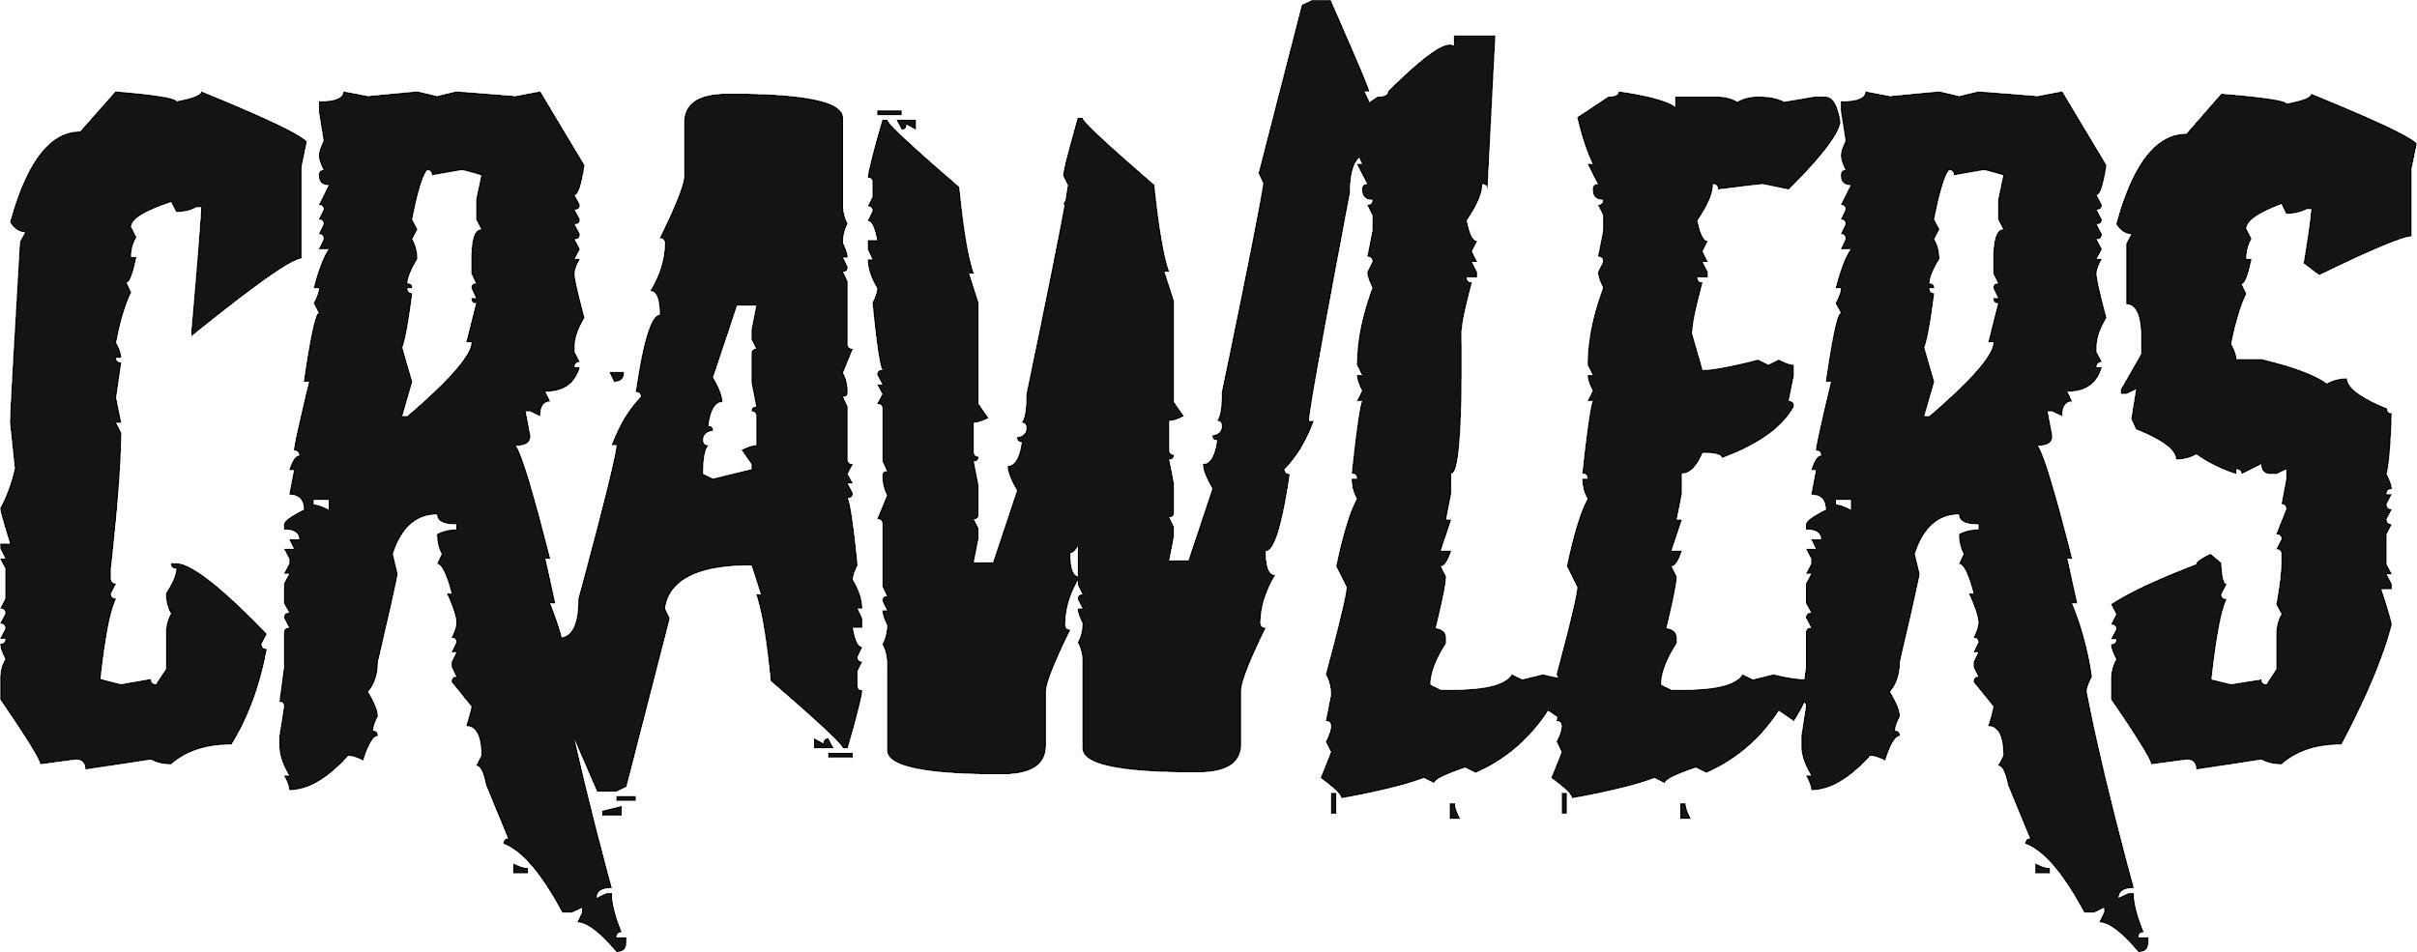

ANNOUNCE BIGGEST TOUR TO DATE
WITH UK HEADLINE SHOWS IN OCTOBER & NOVEMBER

CRAWLERS have today announced details of a UK headline tour in October and November. After selling out their debut UK tour in a day and announcing their first US dates throughout June, the band have a jam-packed summer of festivals from TRNSMT, to Lollapalooza to Reading & Leeds, before playing their biggest tour yet.
The hotly tipped Liverpool four-piece will play 10 cities in the UK and Ireland, including a show at London’s Scala on November 2nd.
The dates are:

OCTOBER
Mon 31st Bristol Thekla

NOVEMBER
Tue 1st Brighton Patterns
Wed 2nd London Scala
Fri 4th Manchester Club Academy
Sat 5th Leeds Brudenell Social Club
Sun 6th Glasgow Saint Lukes
Mon 7th Nottingham Rescue Rooms
Wed 9th Sheffield O2 Academy 2
Thurs 10th Liverpool O2 Academy 1
Fri 11th Newcastle Northumbria University Reds Bar

Tickets will go on general sale on Thursday 14th April at 9am HERE
For details of a special fan pre-sale, head to the official CRAWLERS store now HERE

CRAWLERS are Holly Minto (vocals and trumpet), Amy Woodall (lead guitar), Liv Kettle (bass guitar) and Harry Breen (drums). Since their inception, CRAWLERS have been putting the work in, gigging across Merseyside, working on their song writing and steadily building an impressive following on social media. Their debut EP - released through Modern Sky/Lab Records in October – has clocked up over 40 million combined streams and spawned their first hit with ‘Come Over (Again)’, which crashed into the Official UK Singles Chart thanks to fan power alone. To date it has racked up over 26 million streams on Spotify, 1.6 million views on YouTube and was highlighted as a Radio One ‘Tune of the Week’. Following this, their latest single ‘I Can’t Drive’ has emerged with rave reviews across press and radio (Jack Saunders premiere and ‘Tune of the Week’) as well as coverage across The Times, NME, DIY CLASH, Dork, Kerrang and more.

CRAWLERS embark on their first UK tour this month with the quartet playing to over 1,000 fans in their hometown alone.

Connect with CRAWLERS:
INSTAGRAM
TWITTER
FACEBOOK

For more information and press enquiries please contact
Jenny Entwistle
Jenny@chuffmedia.com

