Rag‘n’Bone Announces Autumn
UK Tour Dates
‘Life By Misadventure’ released April 23rd on Columbia
Also plays 3 SOLD OUT London Jazz Cafe Shows - June 27th, 28th & 29th

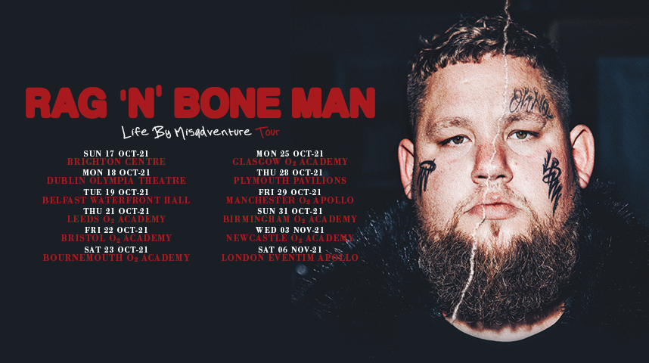

Rag‘n’Bone Man’s spectacular return continues today with the announcement of UK autumn dates, kicking off with a big hometown arena show at the Brighton Centre, also including London’s Eventim Apollo on November 6th. Tickets on pre-sale March 23rd, and on general sale March 26th here.

The shows are set to promote Rag ‘n’Bone Man’s highly anticipated new album ‘Life By Misadventure’ - out April 23rd on Columbia - which is one of the most eagerly anticipated albums of the year. His latest single, the sublime
‘All You Ever Wanted’, continues to blow up off the back of its’ Radio 1 & Radio 2 playlist spots, racing to #1 in both the Airplay and iTunes charts.

Rag ‘n’ Bone Man recently turned in all -star performances on Later...with Jools Holland and Ant & Dec’s Saturday Night Takeaway.
Tickets on pre-sale March 23rd, and on general sale March 26th here.
October
Sun 17th Brighton, Brighton Centre
Mon 18th Dublin, Olympia Theatre
Tue 19th Belfast, Waterfront Hall
Thu 21st Leeds, O2 Academy
Fri 22nd Bristol, O2 Academy
Sat 23rd Bournemouth, O2 Academy
Mon 25th Glasgow, O2 Academy
Thu 28th Plymouth, Pavilions
Fri 29th Manchester, O2 Apollo
Sun 31st Birmingham, O2 Academy Birmingham
November
Wed 3rd Newcastle, O2 Academy
Sat 6th London, Eventim Apollo
His 2017 landmark debut ‘Human’ was a phenomenal success; a 4x platinum album which shot to #1 week of release in the UK, became the fastest-selling album by a male artist for the entire decade and earned him BRIT and Ivor Novello Awards.

If that’s a hard act to follow, Rag‘n’Bone Man tore up the rule book and went to Nashville to write and record what would become ‘Life By Misadventure’, returning to the UK just before the pandemic first erupted. While a dose of heavy blues and soul lives within some of these new tunes, the majority of this new album finds Rag‘n’Bone Man taking a huge step forward as an artist, a songwriter, and a singer capable of showcasing tremendous warmth and real emotion with every breath.

“Life By Misadventure’ is the perfect tonic for these times and an incredible collection of emotional songs to touch us when we need it most. It’s an album of depth and soul, about growing up and moving forward. Enjoy the trip.

https://www.ragnboneman.com

For more information and press enquiries please contact
Jenny Entwistle
Jenny@chuffmedia.com

